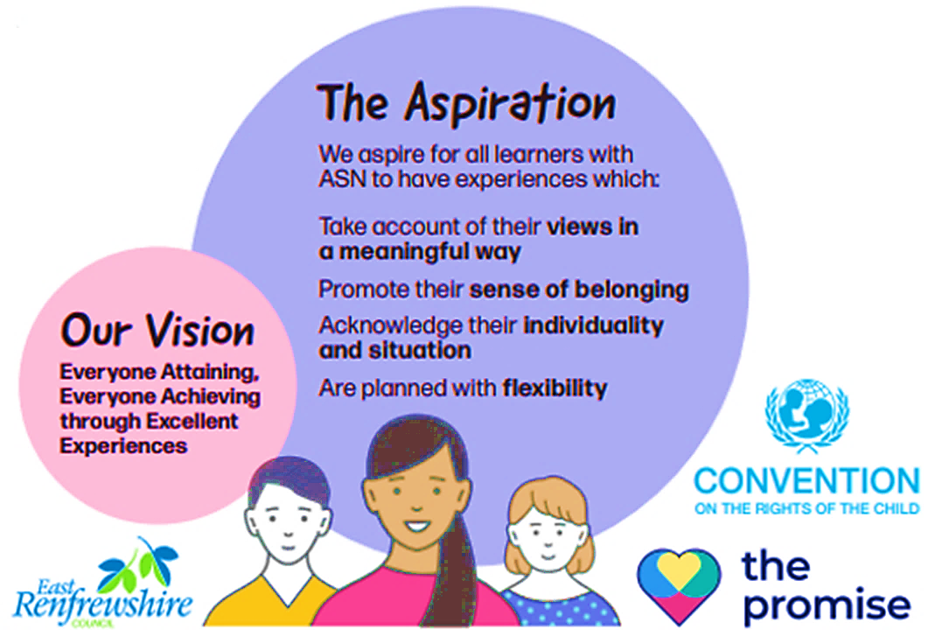
Additional Support for Learning and Wellbeing
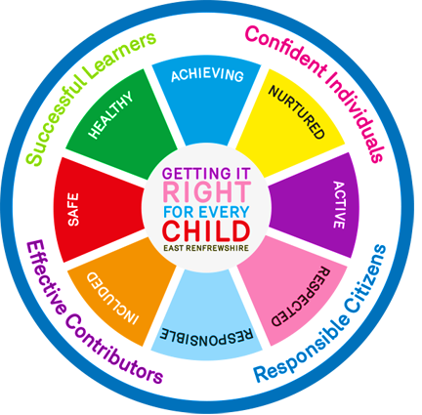



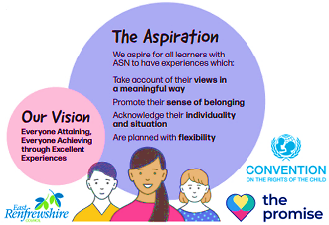  My Additional Support for Learning Profile |  |  |  | <Insert Pupil Photo>  Optional
My Name is: |  | My Date of Birth Is: |  | <Insert Pupil Photo>  Optional
I Live With: |  | I am in: | 0-3 / Ante Pre / Pre School  P1/2/3/4/5/6/7/S1… | <Insert Pupil Photo>  Optional
My Key Person / Teacher is: |  | My Pastoral Support / Named Person is: |  | <Insert Pupil Photo>  Optional
My Profile Was Updated on: |  | My Profile Will Be Reviewed on: |  | <Insert Pupil Photo>  Optional
My Strengths – These are the things that I am good at and enjoy
What is working well for me right now?
I think I am good at:

My parents / carers think I am good at:

My key adults / teachers think I am good at:

My Needs – These are the things I need help with
What challenges or barriers am I currently facing? How can these be reduced or overcome?
I think I need help with:

My parents / carers think I need help with:

My key adults / teachers think I need help with:

My Supports - These will help me to make progress during this year
Key GIRFEC Questions:
What is getting in the way of my Wellbeing? Do you have all the information you need to help me? What can you do now to help me? What can the elc / school do to help me? What additional help, if any, may be needed from others? What have I or my family suggested might help?

Key Areas To Consider:  - SHANARRI Wellbeing Indicators  - My Environment, Routines and Structures that Help Me  - My Skills and Learning Profile (e.g. Motor, Communication, Thinking, Relationships)  - My Motivations - What is my level of engagement and involvement in learning and school life?  - My Emotional Literacy and Regulation  - My Specific Medical / Additional Support Needs | Evidence to Consider:  - Circle Inclusive Classroom Scale (Learner & Practitioner Views)  - Child Participation Scale (Practitioner & Parent / Carer Views)  - Other Agency Assessments  - Early Years / ASN Tracker  - Leuven Scale | Wellbeing Research to Consider:  - Self Determination Theory: What would support my sense of autonomy / independence and feeling like I have some control in my learning? What would help me to feel connected to my peers and staff? What would support my sense of achievement and success?
Support Strategies That Will Help Me In The Long Term:

Be Well Survey Response (Optional Page – Remove if Not used Within Establishment)

(Copy & Paste Individual Pupil Profile Data and Radar Graph From Excel)
 |  |  | Wellbeing Indicators |  |  |  |  |  |  |  | Resilience Indicators
 | School Belonging | Resilience | Safe | Healthy | Achieving | Nurtured | Active | Respected | Responsible | Included | Emotional Awareness and Control | Empathy | Flexible Thinking | Impulse Control | Reaching Out | Realistic Optimism | Self Efficacy
Me
My Stage
My School

My Wellbeing Plan
Do I Need Help To Be Safe?
What is My Target? | What help will I get? | Who will help me? | How am I getting on with my target?
I can / I have / I am…
Do I Need Help To Be Healthy?
What is My Target? | What help will I get? | Who will help me? | How am I getting on with my target?
I can / I have / I am…
Do I Need Help To Achieve?
What is My Target? | What help will I get? | Who will help me? | How am I getting on with my target?
I can / I have / I am…
Do I Need Help To Feel Nurtured?
What is My Target? | What help will I get? | Who will help me? | How am I getting on with my target?
I can / I have / I am…
Do I Need Help To Be Active?
What is My Target? | What help will I get? | Who will help me? | How am I getting on with my target?
I can / I have / I am…
Do I Need Help To Feel Respected?
What is My Target? | What help will I get? | Who will help me? | How am I getting on with my target?
I can / I have / I am…
Do I Need Help To Be Responsible?
What is My Target? | What help will I get? | Who will help me? | How am I getting on with my target?
I can / I have / I am…
Do I Need Help To Feel Included?
What is My Target? | What help will I get? | Who will help me? | How am I getting on with my target?
I can / I have / I am…

What has gone well this term? (Optional Section)

My Team:
Name | Role | Address | Contact Details
 | Parent / Carer
 | Parent / Carer
 | Head Teacher / Head of Centre
 | Depute Head Teacher / Head of Centre
 | Additional Support Needs (ASN) Coordinator / Principal Teacher of Pastoral Support
 | Class Teacher / Child Development Officer
 | Pupil Support Assistant
 | Educational Psychologist | 211 Main Street, Barrhead, G78 1SY | 0141 577 8510
 | Social Worker / Speech and Language Therapy / Sensory Support Service / Healthier Minds / Third Sector Support Worker

INTERNAL ONLY - Information About My Plan That the School Needs to Keep Updated (Not for distribution unless requested)
My GIRFEC Staged Intervention Level
ASN Profile |  | One (Education) |  | Two (Education) |  | Three (Multi-Agency or Statutory) |  |  |  | 
Do I currently have a Coordinated Support Plan (CSP): |  |  |  |  |  | Yes |  | No | 
Should a Coordinated Support Plan (CSP) be considered?  Key Criteria: One or more External Agency is involved, and likely to be involved for more than twelve months +  complex or multiple factors are evident + Level of contact from external agency is frequent or intensive, with assessment and planning implications for education. (See CSP Guidance for further information) |  |  |  |  |  | Yes |  | No

Record of Additional Supports and Interventions (Optional Section)
Support / Intervention | Stage and Term | Current or Previous

Relevant ASN Categories for SEEMIS (Optional Section)
ASC |  | ADHD |  | Asylum / Refugee Related |  | Bereavement
Care Experienced (Current LA) |  | Care Experienced (Previously LA) |  | Child Protection |  | English as an Additional Language
Family Related |  | Hearing Related |  | Illness / Medical Related |  | Interrupted Learning
Language and Communication Related |  | Learning (Intensive) |  | Learning (General) |  | Learning (Specific e.g Dyslexia)
Mental Health Related |  | Physical / Motor Related |  | Visual Related |  | Nurture (SEBN)
Other Additional Support Need |  | Social Work Related |  | Young Carer |  |  | a

GIRFEC Education Framework for Wellbeing Support and Staged Intervention (Revised 2026)
Stage | Lead Practitioner | Key People | Assessment & Planning | Review Cycle
UNIVERSAL WELLBEING | Head Teacher / Head of Centre and Senior Leadership Team | All Children, Young People and Staff | Wellbeing Indicators  ELC / School Improvement Plan  Up, Up and Away / Circle | Annually
ASN PROFILE | Named Person (ASN Coordinator or PT Pastoral), Child Development Officer(s) (CDOs) / Teacher(s) | Individual Children, Young People, Parents / Carers, CDOs / Teachers, Pupil Support Team | Key Questions  Wellbeing Indicators  ASN Profile | Shared and agreed annually or where new information arises / change is required.
A Wellbeing Concern is raised with the Named Person. Needs may be considered met through universal supports or ASN Profile, but if not proceed to Stage One
STAGE ONE:  MY WELLBEING PLAN | Named Person (ASN Coordinator or PT Pastoral) and CDO(s) / Teacher(s) | Individual Children, Young People, Parents / Carers, CDOs / Teachers, Pupil Support Team | Key Questions  Wellbeing Indicators  My Wellbeing Plan | Minimum of twice per academic year
A Wellbeing Concern is raised with the Joint Support Team for advice. Needs may still be considered met through ASN Profile or Stage One planning but if not and support is required from a service or agency external to the establishment, proceed to Stage Two
STAGE TWO:  MY WELLBEING PLAN | Named Person (ASN Coordinator or PT Pastoral) and CDO(s) / Teacher(s) | Individual Children, Young People, Parents / Carers, CDOs / Teachers, Pupil Support Team, Joint Support Team, and External Agency | Key Questions  Wellbeing Indicators  My Wellbeing Plan | Minimum of twice per academic year
A statutory response in line with relevant legislation or significant multi-agency coordination is required to address wellbeing concerns or needs – proceed to Stage Three
STAGE THREE:  STATUTORY OR MULTIAGENCY PLAN  (E.G. CPO, CSO, CSP, CMAP) | Lead Professional  See GIRFEC multi-agency guidance for information on who is best placed for this role. | Individual Children, Young People, Parents / Carers, Lead Professional, Named Person, CDO(s) / Teachers, Pupil Support Team and Multi-Agency Practitioners | Key Questions  Wellbeing Indicators  Resilience Matrix  My World Triangle  Child Protection Order (CPO)  Compulsory Supervision Order (CSO)  Coordinated Support Plan (CSP)  Child’s Multi Agency Plan (CMAP) | CPO – Core Group reviews every six weeks  CSO – between 3 and 12 months as determined by the Scottish Children’s Reporter Administration (SCRA). With interim CMAP Meetings.  CSP – Annually through formal review  CMAP – Every six months.  It is advised to maintain the My Wellbeing Plan internally as a record of Education’s assessment and intervention.

