

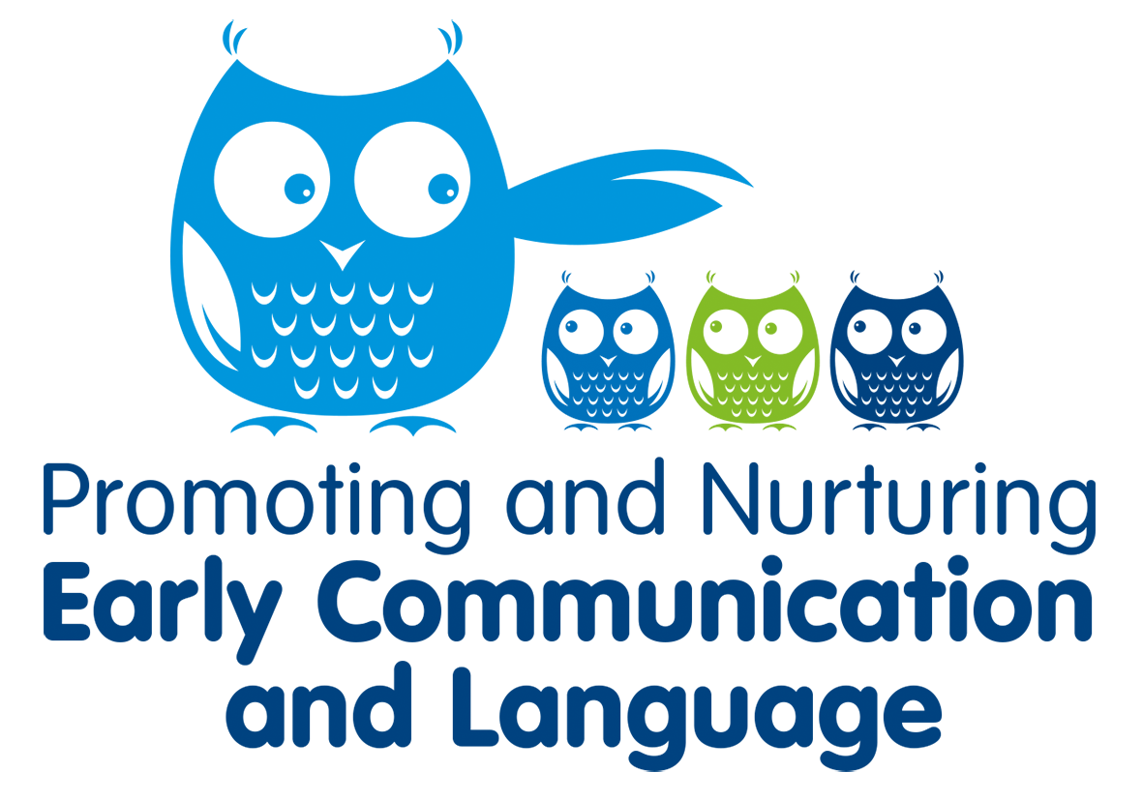

**Updated version April 2023**

Table of Contents

Introduction 3

Promoting and Nurturing Early Communication and Language Framework 4

The Self Evaluation and Validation Process 5

Validation 5

Mentoring and Support 6

Promoting and nurturing early communication and language: Early Years Indicators 7

Indicator One: 7

Indicator Two: 8

Indicator Three: 9

Indicator Four: 11

Indicator Five: 13

Appendices 14

Appendix 1: Establishment Self-Evaluation Framework 14

Appendix 2: Individual Practice Self/Peer Evaluation Tool 17

Appendix 3: Action Plan 21

Appendix 4: Resources 23

Websites: 23

Documents: 23

Appendix 5: Example schedule for validation visit 25

Appendix 6: Key Practitioners 26

# Introduction

East Renfrewshire Education and the Speech and Language Therapy Department have committed to training all early years workers on Hanen principles of language and literacy. This is in recognition of the importance of early language development on child development, wellbeing and learning. Save the Children highlighted in 2015 that in Scotland there remains a stubborn gap in language skills between poorer children and their peers. Our ambition is therefore to build upon the already established work of Hanen to enable early years establishments to provide learning experiences which are language enriching and support all the children of East Renfrewshire to develop their speech, language and communication skills.

Together, East Renfrewshire Education Department, East Renfrewshire Health and Social Care Partnership and NHS Greater Glasgow and Clyde have introduced a programme which aims to develop the capacity of all early years establishments to promote and nurture the language and communication development of all children.

Early years establishments will be validated as Promoting and Nurturing Early Communication and Language (PANECAL) when they can provide evidence of good practice in developing speech, language and communication.

Validation will be achieved through a self-evaluation and supportive assessment process. This will provide a multi-agency endorsement of an establishment’s capacity to support the development of all children’s communication skills.



# Promoting and Nurturing Early Communication and Language Framework

There are 5 key indicators which form the basis of supportive practice:

* **Indicator One:** A physical environment that enhances and promotes opportunities for speech language and communication for all children
* **Indicator Two:** Adult talk that encourages and promotes participation from all learners.
* **Indicator Three:** Adult interaction styles that are responsive to individual children’s needs
* **Indicator Four:** The use of supportive learning strategies to develop language and communication skills
* **Indicator Five:** The establishment can demonstrate a strong commitment to staff training and development to meet the speech, language and communication needs of all children and their families.

|  |  |
| --- | --- |
| This document contains practical suggestions on good practice which, if implemented, will provide evidence of how each indicator is being met. |  |
|  |  |
|  |  |

# The Self Evaluation and Validation Process

1. Complete self-evaluation framework (appendix 1) and individual practice self/peer evaluation tool (appendix 2) to identify strengths and development needs.
2. Use this information to populate an action plan (appendix 3).
3. Engage with a mentoring and, if necessary, a practice development process. This may include identifying and accessing CLPL opportunities. As practice and experience across establishments is likely to be varied, there is no single pathway or suggested training programme. However, it is recommended that practitioners in all early years’ establishments will undertake relevant professional learning, including Module 1 of the East Renfrewshire online Early Years Training. This covers the 5 PANECAL indictors.
4. When you feel ready, or indeed at any point along your learning journey, the self-evaluation framework and/ or the individual staff self-evaluation tools can be revisited and reviewed. It is helpful for the validation team to be able to see progress so having a pre and post of these can be helpful on the day of the visit. Completing the self-evaluation framework regularly before and during the mentoring period will allow you to keep on track with progress towards meeting the key indicators of good practice.
5. On site visit by 2-3 appointed assessors (Educational Psychologist, Speech and Language Therapist and/or Education Professional) for observations and interviews with staff and evaluation of a ‘portfolio of evidence’ based on the 5 key indicators of good practice. Assessors will seek evidence that practice has developed as a consequence of CLPL and training/professional enquiry.

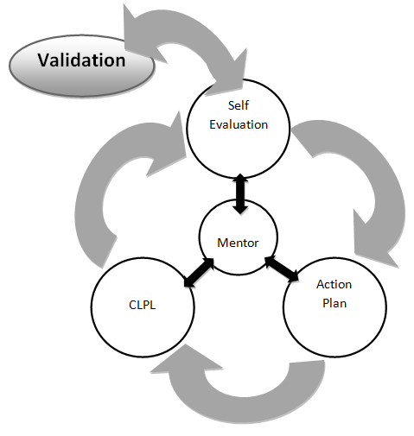

## Validation

Each of the PANECAL Key Indicators will be rated by assessors as follows:

1= not achieved, 2= developing or 3= validated

To be validated, an establishment must score 3 (validated) in three out of five indicators and 2 (developing) in the remaining indicators. **Indicator Two must be achieved for successful validation.**

# Mentoring and Support

Mentoring and support from key health and education practitioners is a core component of this framework. The role of the mentor is to support and encourage practitioners to manage their own learning and skill development to maximise the learning environment in supporting speech, language and communication. They will not necessarily deliver direct training or provide intervention in your establishment but will guide you to access the support you need. A mentor could be an Educational Psychologist, Speech and Language Therapist, QIO or peer from another establishment. When considering who can provide mentoring, you should think about who can best help you achieve the evidence requirements identified in your self evaluation.



# Promoting and nurturing early communication and language: Early Years Indicators

|  |  |  |
| --- | --- | --- |
|  | **PANECAL: Key Indicators for East Renfrewshire’s Early Years Establishments** | **NHSGG&CRGB** |
| Indicator One: **A physical environment that enhances and promotes opportunities for speech, language and communication for all children:** | | |
| **Evidence:** | Displays that include items that invite comments from children | |
| Resources that are accessible and encourage child led learning experiences | |
| Equipment that is accessible and is clearly labelled with a picture or symbol | |
| Well defined learning areas indoors and outdoors | |
| Quiet areas or areas used for story time that are less visually distracting | |
| Outdoor play that includes imaginative role play some of the time | |
| Symbols/pictures are used to aid children’s understanding | |
| A symbolised environment using recognised Boardmaker symbols for example:   * Labelling areas of the playroom and storage boxes with contents. * Display symbols of rules, routines, reminders at the relevant areas e.g. handwashing, paint table rules, snack routine. * Provide choice boards during activities and routines e.g. snack time. | |
| **Aspects which will be observed by the assessor**  The assessor will look at the environment of your setting to assess the evidence supporting this key Indicator.  **Portfolio evidence**  You may wish to include photographs of your setting in your portfolio to demonstrate your understanding of this Key Indicator especially as displays and outdoor play can vary according to the season. Remember that if your photographs include children you should get parental permission before submitting them. You may wish to include a copy of your plans if they include descriptions of displays or show how imaginative role play or language rich activities are planned for. | | |

|  |  |  |
| --- | --- | --- |
|  | **PANECAL: Key Indicators for East Renfrewshire’s Early Years Establishments** | **NHSGG&CRGB** |
| Indicator Two: **Adult talk that encourages and promotes participation from all learners.** | | |
| **Evidence:** | **Adults who** **demonstrate an approach to communication consistent with the Hanen principles:** | |
| Use simple repetitive language during everyday activities | |
| Gain children’s attention before delivering instructions | |
| Talk at an appropriate rate using short sentences | |
| Adapt language to the level of the child | |
| Model correct language when they hear a child’s incorrect vocalisation | |
| Extend the child’s vocalisations | |
| Encourage children to ask questions | |
| Use vocabulary the children can understand in everyday instructions | |
| Give children time to respond | |
| Name and describe objects and actions during play rather than asking too many questions. | |
| Use natural gesture, facial expression and tone of voice to support language | |
| Support verbal language with gestures and visuals cues | |
| Utilise a range of types of questions | |
| Support play by modelling language based on child’s activities and encouraging peer interaction | |
| Get down to the child’s level and establish eye contact when communicating | |
| **Aspects which will be observed by the Assessor:**  The assessor will spend some time observing how adults in the setting adapt their language and communication to encourage children’s language development.  **Portfolio evidence**  You may wish to include information on how you develop adult-child interaction in your setting. Evidence could include information on training and development the setting has undergone in a relevant area; using peer observation to reflect on how staff in the setting use communication strategies such as those outlined above; video clips. | | |

|  |  |  |
| --- | --- | --- |
|  | **PANECAL: Key Indicators for East Renfrewshire’s Early Years Establishments** | **NHSGG&CRGB** |
| Indicator Three**: Adult interaction styles that are responsive to individual children’s needs** | | |
| **Evidence:** | **Adults in the learning environment who use supportive approaches including:** | |
| Ensuring that all children have the opportunity to interact individually with an adult if they wish | |
| Speaking sensitively to shy or unsettled children | |
| Employing different types of communication (e.g. gestures, visuals, Makaton) to support a range of additional support needs | |
| Taking time to understand what a child’s behaviour is communicating (e.g. if they are crying, this may signify that they are anxious; if they hit, it may be that they are finding the environment or their peers overwhelming) | |
| Using positive non-verbal communication (the use of eye contact, smiling, use of a soft voice or touch) to demonstrate acceptance and warmth. | |
| Helping children to settle when they arrive | |
| Playing alongside children without always directing their play | |
| Encouraging children’s independence and self-confidence by responding positively to all efforts | |
| Facilitating shared turn taking and play | |
| Modelling activities and talking about what they are doing | |
| Modelling a range of positive behaviour and language | |
| Developing children’s emotional vocabulary by naming and describing emotions and feelings | |
| Helping children to develop and extend imaginary play | |
| Supporting outdoor play by modelling language based on the child’s activities and encouraging peer interaction | |
| Applying a flexible use of questioning appropriate to child’s stage of development (eg forced choice/closed/open) | |
| Responding positively to children’s efforts to communicate | |
| Giving clear expectations of boundaries | |
| Preparing children for expected changes to the day and transitions using visuals and clear, explicit language, where appropriate | |
| Actively supporting children in solving their problems and disputes | |
| Setting clear expectations of learning outcomes and success criteria | |
| Respecting the child’s other languages i.e. home language (if not English), sign language | |
| **Aspects which will be observed by the assessor**  The assessor will spend some time observing the approaches used by adults in the setting; they may also discuss some of these approaches with staff. As part of the observation of the adults, the assessor will notice how the children use language as well. The assessor may wish to speak to you if evidence for some of this Key Indicator is not observed.  **Portfolio evidence**  Include information in support of this indicator in your portfolio. Examples include: copies of policies such as how new children are settled in; planning documents and visual support for routines; staff training completed; video clips. | | |

|  |  |  |
| --- | --- | --- |
|  | **PANECAL: Key Indicators for East Renfrewshire’s Early Years Establishments** | **NHSGG&CRGB** |
| Indicator Four: **The use of supportive learning strategies to develop language and communication skills.** | | |
| **Evidence:** | **Adults in the learning environment who use supportive strategies consistent with the Hanen principles including:** | |
| Re-reading favourite stories with children e.g. use fun stories, encourage children to join in with familiar repeated words and phrases. Use real objects/ props/ actions to attract their attention and aid their understanding | |
| Saying rhymes and singing songs with children in various group sizes e.g. Use a lively, animated voice, facial expression, natural gesture and Makaton signs. | |
| Frequently supporting songs and stories with actions, objects or puppets | |
| Explicitly introducing new concepts and vocabulary e.g. by taking time to name, describe and demonstrate how to use items for the children, such as toys and objects at the sand or water table. | |
| Seeking opportunities to repeat and reinforce new vocabulary e.g. adapt familiar songs to provide opportunities for children to hear new words being used in a fun and repetitive way. Encourage them to join in by completing your lead-in phrases. | |
| Linking children’s spoken language with written language e.g. use visual aids/ pictures and /or symbols in the environment (such as visual timetables or choice boards) specifically draw children’s attention to the written words underneath by pointing to them as you say them. | |
| Checking children have understood instructions e.g. use clear instructions which are age and stage appropriate for individual children’s development. Keep language short and simple. | |
| Accepting non-verbal communication as well as verbal e.g. be a good role model – demonstrate effective non-verbal communication yourself and encourage and praise efforts from children. | |
| Ensuring that all children (including the least verbal) have a turn at expressing themselves in a group e.g. use objects and pictures if necessary to support choices and express feelings | |
| Encouraging children to talk about their interests e.g. become involved as a ‘play partner’ in children’s pretend play; this provides opportunities for children to take on roles and re-create personal life experiences which can be spoken about. | |
| Supporting children to speak within groups as well as during free play e.g. really engage and listen to children. Give them enough time to talk. Use eye-contact and respond positively to what they say. Repeat it back for confirmation they have been understood. | |
| Providing children with opportunities for supported conversation with their peers as well as opportunities to interact with their peers without adult intrusion e.g. create a special area such as a ‘talking table’ which has interesting new objects on it to explore. | |
| Providing opportunities to share books with their peers e.g. introduce quiet times for this away from other noise and activity. | |
| Providing opportunities to use and experience their mother tongue if this is not English e.g. engage families and / or older siblings, encourage them to record their voices for learning and also reassurance. | |
| Communicating responsively with all parents e.g. acknowledge that parents also have different preferences when it comes to communicating with nursery staff – from face to face, written diaries or telephone contacts. | |
| Encouraging hands on and experiential learning for all children | |
| Utilising multisensory approaches to learning | |
| Use ELC tracking tool to support the identification of children requiring additional support. | |
| **Aspects which will be observed by the assessor**  The assessor will spend some time observing members of staff in the setting. The assessor will be looking at how well this key Indicator is being met e.g. how staff are able to adapt what they are doing to make sure **all** children are able to access activities/ understand what is expected of them and know how they can participate.  **Portfolio evidence**  Include a copy of your plans showing the planning for storytelling, rhymes and singing; relevant policies; photos, video clips; parent feedback. | | |

|  |  |  |
| --- | --- | --- |
|  | **NHSGG&CRGB**  **PANECAL: Key Indicators for East Renfrewshire’s Early Years Establishments** |  |
| Indicator Five: **The establishment can demonstrate a strong commitment to staff training and development to meet the speech, language and communication needs of all children and their families.** | | |
| **Evidence:** | Staff have participated in relevant professional learning on child development and demonstrate a good understanding of speech and language development | |
| Consultation opportunities with specialists | |
| Reflective practice and internal support mechanisms | |
| Informal learning activities | |
| Practice changes based on self-evaluation undertaken | |
| Partnership working with parents (e.g. PoPP, Hanen workshops, curriculum groups) | |
| Self-improvement through evaluation and CLPL leads to positive impact on children | |
| CLPL that leads to positive and sustained changes in practice | |
| **Aspects which will be observed by the assessor**  The accreditor will speak to you and your staff to determine the nature of any CLPL in the area of speech, language and communication and how you have used this to develop staff and improve outcomes for children.  **Portfolio evidence**  Include documentation of any of the above activities e.g. Training Packs, Hanen ABC, minutes from JSTs, use of Educational Psychology and Speech and Language Therapy Consultation, policies on parental engagement etc, self evaluation procedures. | | |

|  |  |  |  |  |  |  |  |  |
| --- | --- | --- | --- | --- | --- | --- | --- | --- |
| Appendices | | | | | | | |  |
|  | | | **Appendix 1: Establishment Self-Evaluation Framework** | | | | | | | **NHSGG&CRGB** |
| Use this framework to measure whole establishment or individual practitioner progress towards meeting the Key Indicators.  You will need to think about and record the **evidence** for your current level of practice and to identify any next steps. There is a measure of progress for each indicator (1= not achieved, 2= developing, 3= validated). | | | | | | | | | | |
| **Name/ Establishment:** | | | |  | | **Date of audit:**  **Date of evaluation:** |  | | | |
|  | | | |
| **Indicator One:** A physical environment that enhances and promotes opportunities for speech, language and communication for all children. | | | | | | | | | | |
| **Level** | | | | | **Evidence** | **Next Steps** | | | | |
| 1 | 2 | 3 | | |  |  | | | | |
| **Indicator Two**: Adult talk that encourages and promotes participation from all learners. | | | | | | | | | | |
| **Level** | | | | | **Evidence** | **Next Steps** | | | | |
| 1 | 2 | 3 | | |  |  | | | | |
| **Indicator Three:** Adult interaction styles that are responsive to individual children’s needs | | | | | | | | | | |
| **Level** | | | | | **Evidence** | **Next Steps** | | | | |
| 1 | 2 | 3 | | |  |  | | | | |
| **Indicator Four:** The use of supportive learning strategies to develop language and communication skills. | | | | | | | | | | |
| **Level** | | | | | **Evidence** | **Next Steps** | | | | |
| 1 | 2 | 3 | | |  |  | | | | |
| **Indicator Five**: The establishment can demonstrate a strong commitment to staff training and development to meet the speech, language and communication needs of all children and their families | | | | | | | | | | |
| **Level** | | | | | **Evidence** | **Next Steps** | | | | |
| 1 | 2 | 3 | | |  |  | | | | |

|  |  |  |  |  |  |  |
| --- | --- | --- | --- | --- | --- | --- |
| **NHSGG&CRGBAppendix 2: Individual Practice Self/Peer Evaluation Tool** | | | | | | |
| Name: ELC: Date: Pre/Post: Self- evaluation Peer evaluation | | | | | | |
| **Adult talk that encourages and promotes participation from all learners** | | | | | | |
|  | Always | Usually | Sometimes | Rarely | Never | Notes: |
| I use simple repetitive language during everyday activities |  |  |  |  |  |  |
| I gain children’s attention before delivering instructions |  |  |  |  |  |  |
| I talk at an appropriate rate using short sentences |  |  |  |  |  |  |
| I adapt my language to the level of the child |  |  |  |  |  |  |
| I model correct language when I hear a child’s incorrect vocalisation |  |  |  |  |  |  |
| I extend the child’s vocalisations |  |  |  |  |  |  |
| I encourage children to ask questions |  |  |  |  |  |  |
| I use vocabulary the children understand in everyday instructions |  |  |  |  |  |  |
| I give children time to respond |  |  |  |  |  |  |
| I name and describe objects and actions during play rather than asking too many questions. |  |  |  |  |  |  |
| I use natural gesture, facial expression and tone of voice to support language |  |  |  |  |  |  |
| I support verbal language with gestures and visual cues |  |  |  |  |  |  |
| I utilise a range of types of questions |  |  |  |  |  |  |
| I support play by modelling language based on child’s activities and encouraging peer interaction |  |  |  |  |  |  |
| I get down to the child’s level and establish eye contact when communicating |  |  |  |  |  |  |

|  |  |  |  |  |  |  |
| --- | --- | --- | --- | --- | --- | --- |
| **Adult interaction styles that are responsive to individual children’s needs** | | | | | | |
|  | Always | Usually | Sometimes | Rarely | Never | Notes: |
| I ensure that all children have the opportunity to interact individually with an adult if they wish |  |  |  |  |  |  |
| I speak sensitively to shy or unsettled children |  |  |  |  |  |  |
| I use different types of communication (e.g. gestures. Visuals, Makaton) to support a range of additional support needs |  |  |  |  |  |  |
| I take time to understand what a child’s behaviour is communicating (e.g. if they are crying, this may signify that they are anxious; if they hit, it may be that they are finding the environment or their peers overwhelming) |  |  |  |  |  |  |
| I use positive non-verbal communication (the use of eye contact, smiling, use of a soft voice or touch) to demonstrate acceptance and warmth) |  |  |  |  |  |  |
| I help children settle when they arrive |  |  |  |  |  |  |
| I play alongside children without always directing their play |  |  |  |  |  |  |
| I encourage children’s independence and self-confidence by responding positively to all efforts |  |  |  |  |  |  |
| I facilitate shared turn taking and play |  |  |  |  |  |  |
| I model activities and talk about what the children are doing |  |  |  |  |  |  |
| I model a range of positive behaviour and language |  |  |  |  |  |  |
| I develop children’s emotional vocabulary by naming and describing emotions and feelings |  |  |  |  |  |  |
| I help children to develop and extend imaginary play |  |  |  |  |  |  |
| I support outdoor play by modelling language based on the child’s activities and encouraging peer interaction |  |  |  |  |  |  |
| I apply a flexible use of questioning appropriate to the child’s stage of development (e.g. forced choice/closed/open) |  |  |  |  |  |  |
| I respond positively to children’s efforts to communicate |  |  |  |  |  |  |
| I give clear expectations of boundaries |  |  |  |  |  |  |
| I prepare children for expected changes and transitions using visuals and clear , explicit language, where appropriate |  |  |  |  |  |  |
| I actively support children in solving their problems and disputes |  |  |  |  |  |  |
| I set clear expectations of learning outcomes and success criteria |  |  |  |  |  |  |
| I respect the child’s other languages (i.e. home language if not English, sign language) |  |  |  |  |  |  |

|  |  |  |  |  |
| --- | --- | --- | --- | --- |
| **NHSGG&CRGBAppendix 3: Action Plan** | | | | |
| Use this framework to formulate a whole establishment or individual practitioner action plan to help progress towards meeting the Key Indicators. | | | | |
| **Name/ Establishment:** |  | **Date:** |  | |
| **Indicator One:** A physical environment that enhances and promotes opportunities for speech language and communication for all learners. | | | | |
| **Current Level** | **What do we need to do?** | | | **Where will we get help?** |
| 1 2 3 |  | | |  |
| **Indicator Two**: Adult talk that encourages and promotes participation from all learners | | | | |
| **Current Level** | **What do we need to do?** | | | **Where will we get help?** |
| 1 2 3 |  | | |  |
| **Indicator Three:** Adult interaction styles that are responsive to individual children’s needs. | | | | |
| **Current Level** | **What do we need to do?** | | | **Where will we get help?** |
| 1 2 3 |  | | |  |
| **Indicator Four:** The use of supportive learning strategies to develop language and communication skills. | | | | |
| **Current Level** | **What do we need to do?** | | | **Where will we get help?** |
| 1 2 3 |  | | |  |
| **Indicator Five**: The establishment can show a strong commitment to staff training and development to meet the speech, language and communication needs of all children and their families | | | | |
| **Current Level** | **What do we need to do?** | | | **Where will we get help?** |
| 1 2 3 |  | | |  |
|  | | | | |

## Appendix 4: Resources

### Websites:

* ER Early Years Training modules:

<https://blogs.glowscotland.org.uk/er/earlyyearsasnclpl/>

* Talk to your baby: [www.literacytrust.org.uk/talktoyourbaby](http://www.literacytrust.org.uk/talktoyourbaby)
* I CAN: [www.ican.org.uk](http://www.ican.org.uk)
* AFASIC: [www.afasic.org.uk](http://www.afasic.org.uk)
* Learning and Teaching Scotland: [www.ltscotland.org.uk](http://www.ltscotland.org.uk)
* Talking Point: [www.talkingpoint.org.uk](http://www.talkingpoint.org.uk/)
* British Stammering Association: [www.stamma.org](http://www.stamma.org)
* Bookbug: <http://www.scottishbooktrust.com/bookbug>
* Hanen: <http://www.hanen.org/Programs/For-Educators/ABC-and-Beyond.aspx>
* Hanen: <https://sway.office.com/zNSdNCLHcXNhEAU4?ref=email>
* Play@Home:<https://www.careandlearningalliance.co.uk/our-services/family-supporttoddlers/playhome/>
* Play Talk Read: <http://playtalkread.scot/>
* PoPP: <http://www.nes.scot.nhs.uk/education-and-training/by-discipline/psychology/multiprofessional-psychology/psychology-of-parenting-project.aspx>
* Professor Colwyn Trevarthen videos: <http://www.educationscotland.gov.uk/learningandteaching/earlylearningandchildcare/prebirthtothree/nationalguidance/conversations/colwyntrevarthen.asp>
* Healthier Minds: East Renfrewshire’s Framework for supporting the health and wellbeing of children and young people

<https://blogs.glowscotland.org.uk/er/healthierminds/>

* East Renfrewshire Psychological Service’s Meeting Learners’ Needs website; Resources and Guidance for all education staff

<https://blogs.glowscotland.org.uk/er/meetinglearnerneeds/>

* NHS: Kids Independently Developing Skills: [www.nhsggc.org.uk/kids](http://www.nhsggc.org.uk/kids)
* East Renfrewshire Early Years Practitioners GLOW group <https://glowscotland.sharepoint.com/sites/EastRenfrewshireCouncil/Early%20Years/SitePages/Home.aspx>

### Documents:

* Realising the Ambition: <https://education.gov.scot/improvement/learning-resources/realising-the-ambition/>
* Pre-birth to Three Guidelines and multimedia resource: <http://www.educationscotland.gov.uk/learningandteaching/earlylearningandchildcare/prebirthtothree/nationalguidance/index.asp>
* Issue 9 I CAN Talk 9: Children with severe SLCN: <http://www.ican.org.uk/~/media/Ican2/Whats%20the%20Issue/Evidence/ICAN_TalkSeries9.ashx>
* Issue 7: Speech Language and Communication Needs and the Early Years <http://www.ican.org.uk/~/media/Ican2/Whats%20the%20Issue/Evidence/7%20Speech%20Language%20and%20Communication%20Needs%20and%20the%20Early%20Years.ashx>
* Issue 4: Language and Social Exclusion <http://www.ican.org.uk/~/media/Ican2/Whats%20the%20Issue/Evidence/4%20Language%20and%20Social%20Exclusion%20pdf.ashx>
* Issue 3: The Cost to the Nation of Children's Poor Communication - Scotland Edition <http://www.ican.org.uk/~/media/Ican2/Whats%20the%20Issue/Evidence/3%20ICT%20Cost%20to%20the%20nation%20Scotland.ash>
* ‘Universally Speaking’ document <https://ican.org.uk/i-cans-talking-point/professionals/tct-resources/universally-speaking/>

### Video Clips:



* Hanen What role do parents play in early language development?

<https://www.youtube.com/watch?v=2ln-nJmdTVs>

* Hanen Why Interaction matters pt 1

<https://www.youtube.com/watch?v=KAFcJVJHLCU>

* Hanen Why interaction matters part 2

<https://www.youtube.com/watch?v=QJAgWdYM_og>

* Hanen Games to help our child with Autism to communicate

<https://www.youtube.com/watch?v=kJc0ZohTpMI>

* Hanen- Creating more learning opportunities for your child with Autism

Encourage joint engagement- observe, join in, imitate, follow their lead, have fun

<https://www.youtube.com/watch?v=fEEBcaplgNo>

* Hanen Encourage your child to talk with Music

<https://www.youtube.com/watch?v=Gnd7joNP_gI>

* Hanen- Understanding leads to first words

<https://youtu.be/Pz6sle4QxWQ>

* Hanen-building sound awareness with room on the broom- rhyme, listen and find one like it

<https://youtu.be/H5_BTFSakE4>

* Communicative temptations- South Tees NHS Speech Therapy

<https://youtu.be/rWNQWFGWYZw>

Appendix 5: Example schedule for validation visit

(Please note this can be amended to suit the individual establishment)

|  |  |  |  |
| --- | --- | --- | --- |
| **Time** | **Activity** | **Establishment** | **Validation Team (VT)** |
| 9am | Arrive | Room to be identified for VT  Provide VT with relevant evidence | Read through portfolio of evidence |
| 9.30am | Scoping exercise | Nursery will present self-evaluation evidence |  |
| 10.30am | Initial observations |  | Spend time on nursery floor observing adult interactions, environment, outdoor area etc. |
| 11.15am | Break |  | Meet back in room and share observation notes. Identify key areas of evidence still to be gathered. Seek any additional evidence from staff. |
| 11.30am | Observations |  | As above |
| 12.15pm | Lunch | - | - |
| 1pm | Collate Feedback |  | Discuss strengths/ areas for development and populate feedback report  Might identify further areas for observation in afternoon i.e. pick up time, specific group time etc. |
| 3pm | Initial verbal feedback provided * |  |  |

*Written feedback (and certificate) may be provided at a later date

## 

## Appendix 6: Key Practitioners

**East Renfrewshire Education Department**

Rosamund Rodrigez

Quality Improvement Officer

211 Main Street

Barrhead G78 1SY

Tel: 0141 577 3222

**Speech and Language Therapy**

Katie Walters and Laura Dow

Department of Speech and Language Therapy

Barrhead Health and Care Centre

213 Main Street

Barrhead G78 1SW

Tel: 0141 800 7117



**Educational Psychology Service**

Siobhan Drummond and Gillian Thorburn

East Renfrewshire Educational Psychology Service

211 Main Street

Barrhead G78 1SY

Tel: 0141 577 8510