Pages have been amended and added to support school closure and returning to school. Arrange pages to suit needs of the pupil. Printed in booklet form.
My Social Distancing Story

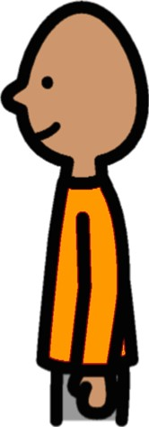
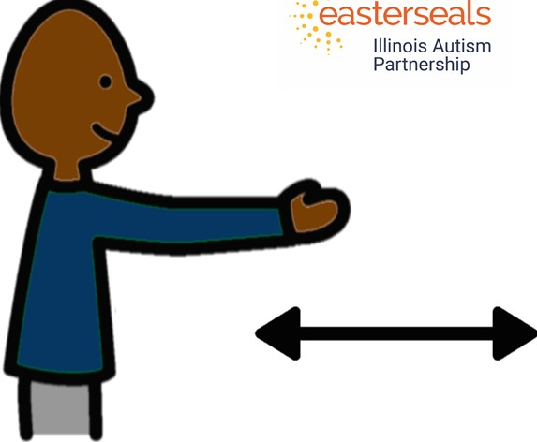
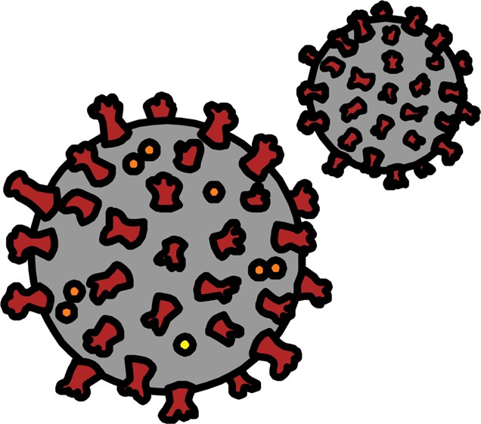
A lot of people are talking about something called Coronavirus.
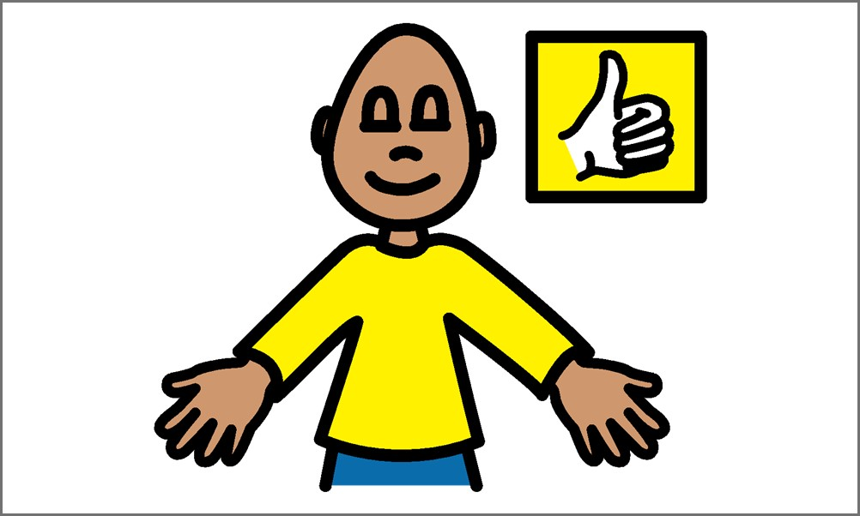Everyone is working hard to feel safe and be healthy.
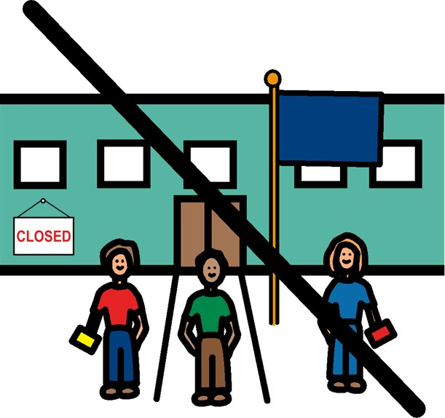
My school is closed right now.
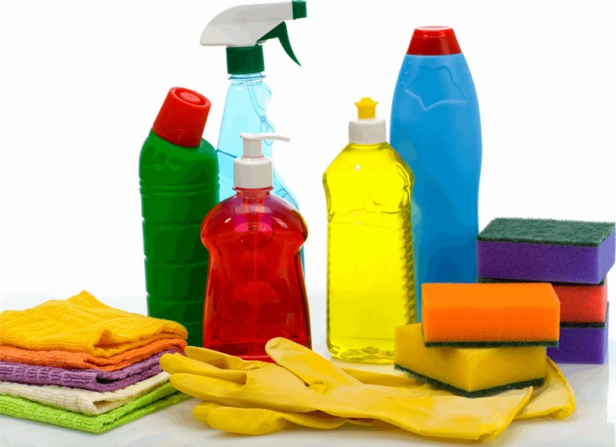
My school is closed because it is being cleaned.
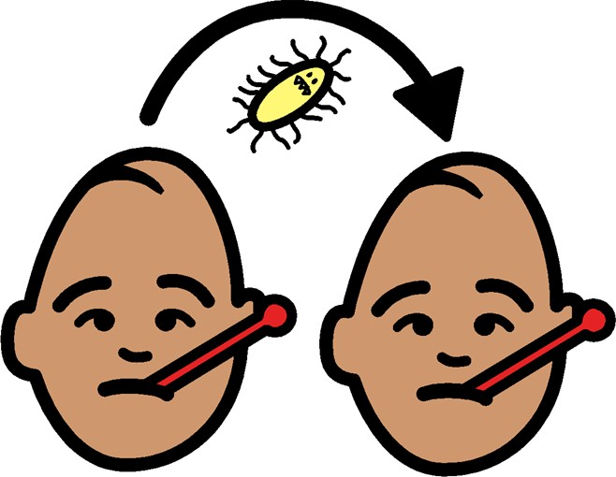
The Coronavirus germs spread VERY easily.
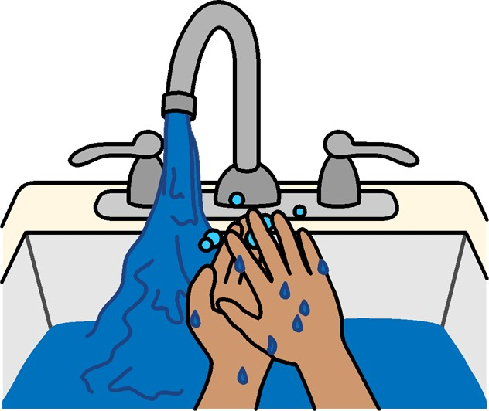
I need to wash my hands A LOT so that I can stay healthy.
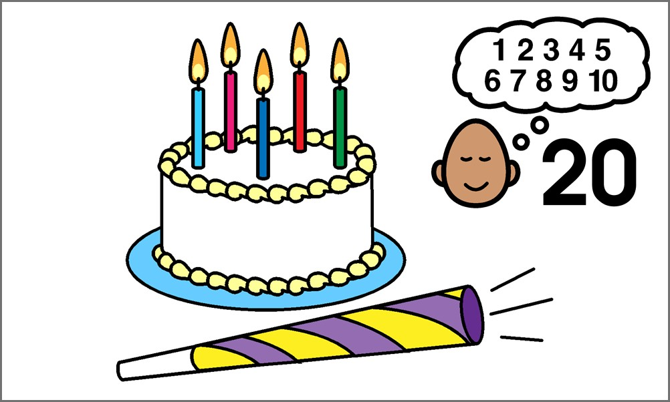
When I wash my hands,
I can sing "Happy Birthday," or count to 20!
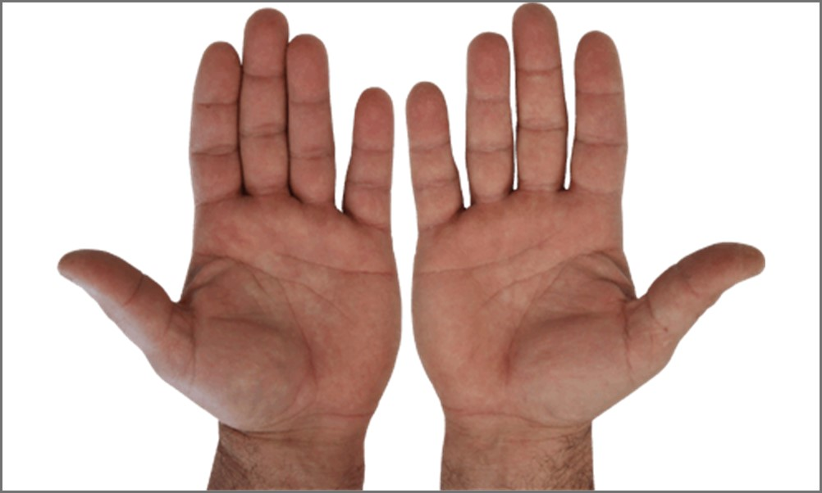
This will make sure my hands are clean and I stay healthy.
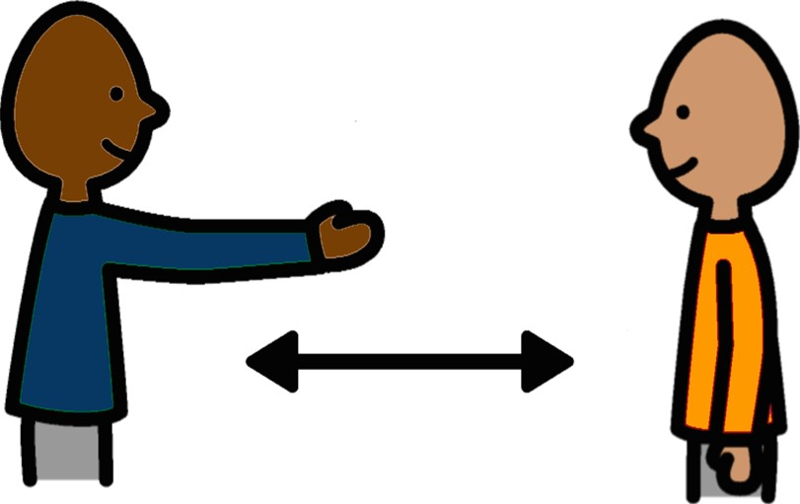
Another thing I can do to stay healthy and safe is called social distancing.
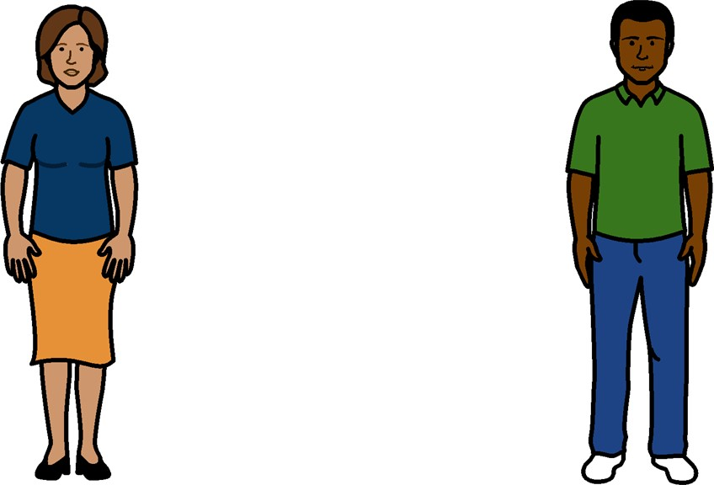
Social distancing means I cannot be close to other people.
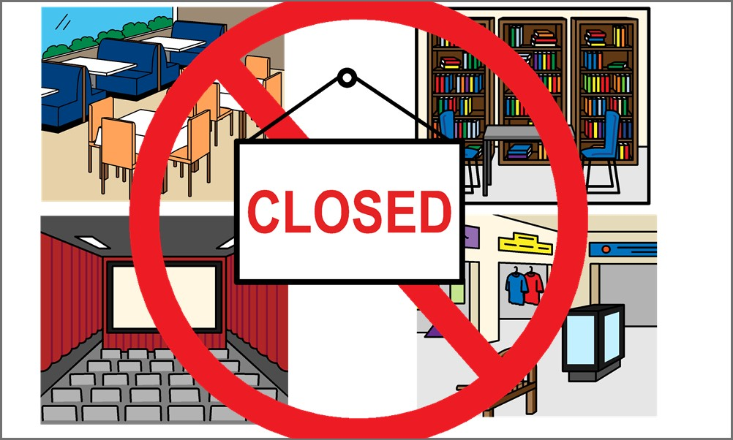
Social distancing also means that crowded public spaces like restaurants, libraries, theatres, and other places might be closed just like my school.
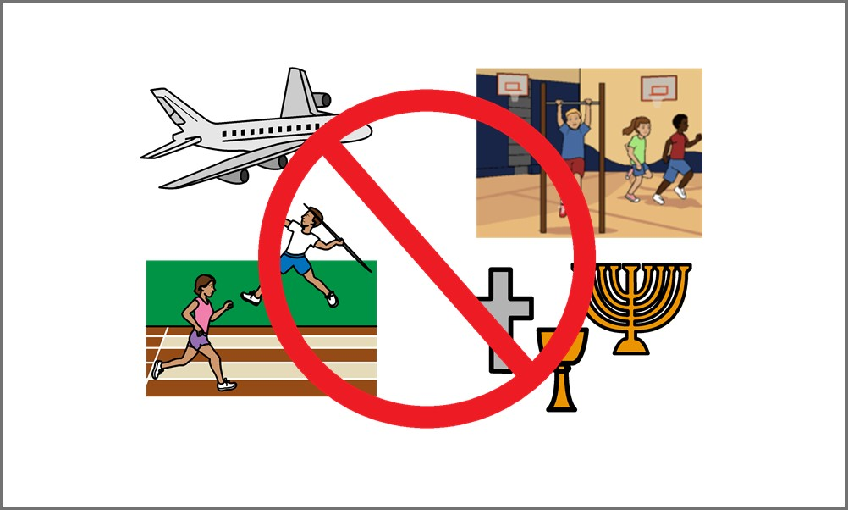
Fun activities or events might be cancelled. This is so we can all stay healthy and safe.

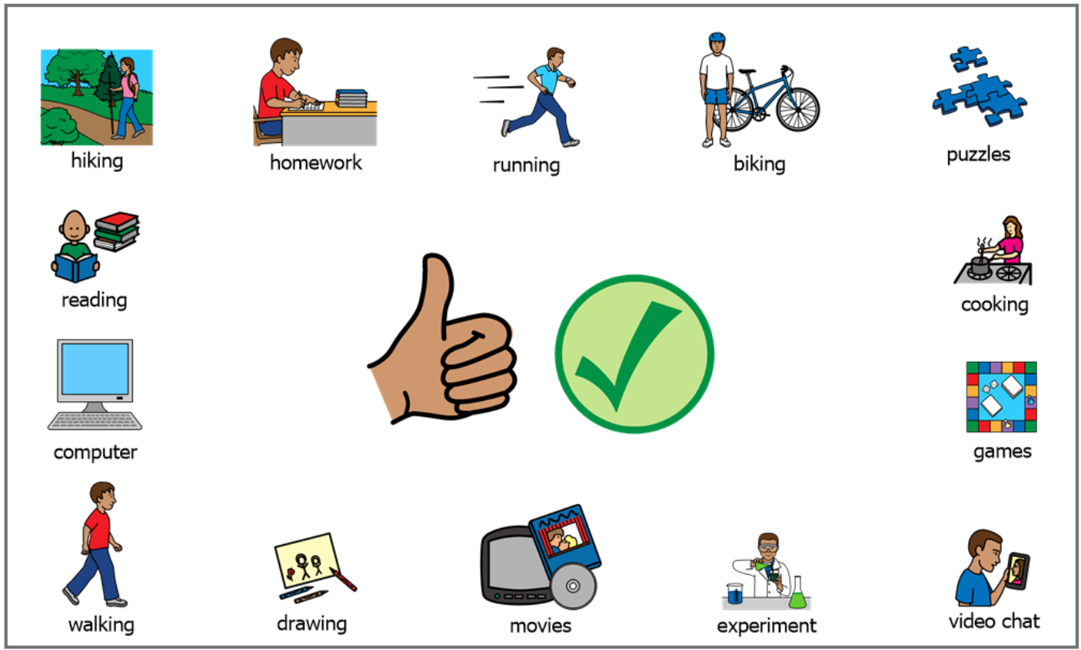

These are some things that I CAN do!

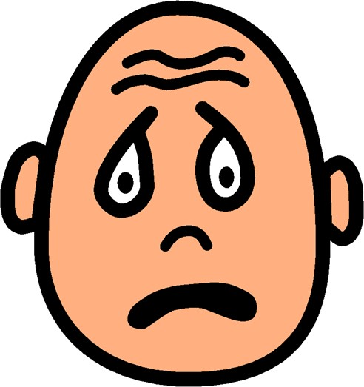

Social distancing might make me feel worried or sad.

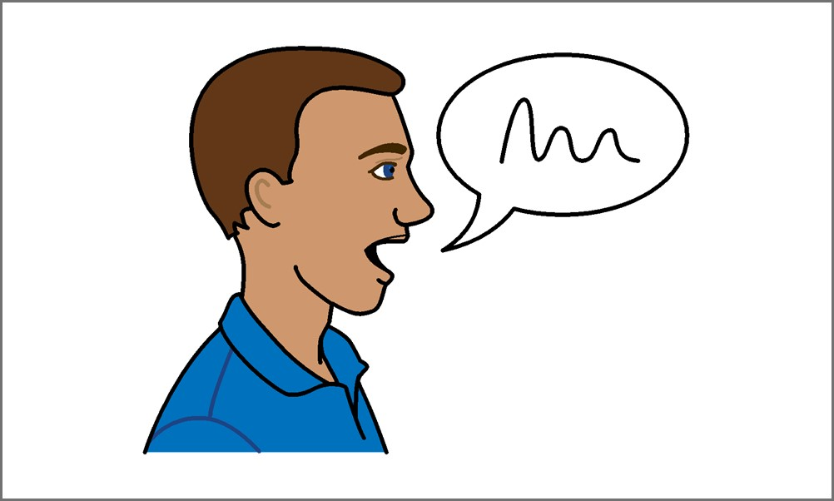

If I feel this way, I can always talk to someone that will help make me feel better.

Social distancing will help keep everyone happy, healthy, and safe!
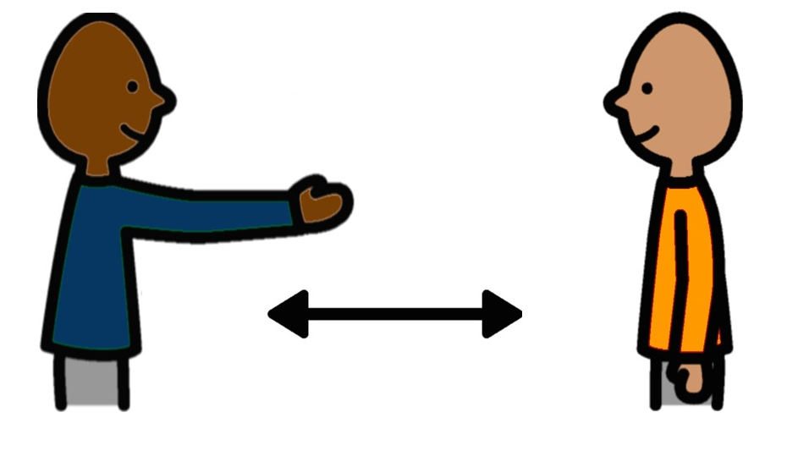
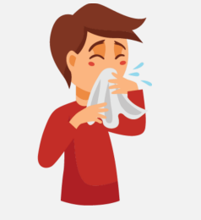
It is important to catch my coughs and sneezes.

This will help to keep us safe.

I can use my hand or a tissue to cover my mouth when I need to cough or sneeze.

If I use a tissue I throw it the bin.

I can use my elbow to catch a cough and sneeze.

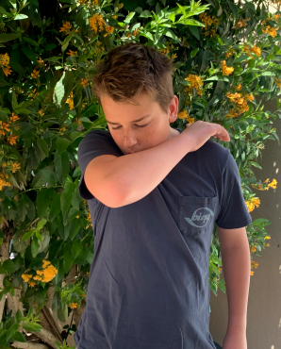
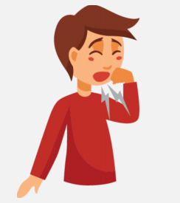

I wash my hands after I cough or sneeze.

