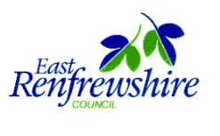

Symbolising the Environment

Implementation Instructions

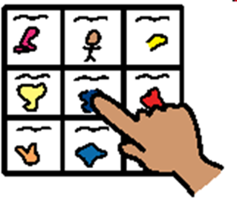

Contents

- Introduction
- Framework for Self-Evaluation and Accreditation
- Self-Evaluation and Accreditation Process
- Preparation for Symbolising the Environment
- Self-Evaluation and Accreditation Toolkit
- Appendices
Appendix 1 Training and Information Materials
Appendix 2 Key Practitioners Involved in Pilot Programmes
Appendix 3 Links and Resources

- Introduction
In order to support primary schools and early years provisions in providing inclusive, communication friendly environments for children and young people, East Renfrewshire Education committed to the funding of Boardmaker Studio software for establishments in the Local Authority. This software is designed to allow practitioners to access and adapt a range of Picture Communication Symbols in order to support learning and teaching, particularly for children with Additional Support Needs. Picture Communication Symbols are a library of colour and black and white drawings that represent over 18,000 words, phrases and concepts. These have been found to be more ‘transparent’ than other symbol libraries in that their meaning can be recognised more easily and thus Boardmaker Studio software was chosen to support the use of symbols in the schools. Symbols have been found to support learning in the following ways:
- Promoting the development of communication skills
- Providing support for the completion of tasks and following instructions
- Supporting children through transition times and changes to routines
- Promoting the development of children’s organisational skills
- Supporting children to retain information

Funding for Boardmaker Studio was introduced in recognition that it would be beneficial for children and young people who access specialist provisions in the local authority to experience consistency and be able to access the same symbols at mainstream placements. It was also acknowledged that symbols from Boardmaker Studio are successfully being used to support learning and teaching for all pupils in other local authorities across Scotland and the Educational Psychology Service has liaised with professionals who have employed a similar way of working.
Together, East Renfrewshire Educational Psychology Service as well as staff rom Carlibar Communication Centre have developed a bank of adapted symbols for use in schools and supported the implementation of these. This is referred to as the ‘Symbolisation’ project. During the 2014/2015 and 2016/2017 school sessions, pilot programmes of using symbols in mainstream primary schools and nurseries were run. These were supported by staff from the Educational Psychology team as well as the school staff involved and a member of the Speech and Language Therapy team in East Renfrewshire.
This document provides guidelines around the implementation of Symbolisation in schools and early years provisions and offers advice around how to progress through three categories of Symbolisation: bronze; silver; gold.

- Framework for Self-evaluation and Accreditation
Schools and early years establishments will be accredited when they are able to provide evidence of the use of symbols throughout the establishment to support communication and learning. Accreditation will be achieved through a self-evaluation and accreditation process.
The three categories of symbolising the environment are a progressive scale. Each of these has several indicators which must be achieved in order to meet the criteria for Bronze, Silver or Gold accreditation. A similar type of accreditation scale for symbolising the environment in primary schools and early years establishments has been employed by Fife Council. The accreditation framework was developed by Sandra Miller and Jane Donnelly at Fife Augmentative and Alternative Communication Support Team (FAACT). This accreditation system has been adapted to the context of schools and early years establishments in East Renfrewshire Council. There are three main categories:
Bronze: Symbols displayed around the establishment and classroom environment in order to promote understanding of areas, organisation and key concepts.
Silver: Bronze accreditation maintained and symbols being regularly referred to throughout the daily routine to communicate ideas and instructions. Parental support provided where appropriate.
Gold: Bronze and Silver accreditation maintained and symbols fully embedded throughout the whole establishment and in each class with evidence of their use on a daily basis to support the teaching of the curriculum. Staff open to sharing best practice with other establishments.
Bronze, Silver and Gold categories each have indicators, some of which have practical examples of what these may include. These are not exclusive and many establishments will have their own practices that enable them to evidence how indicators are being met. Symbols that meet the requirements for each indicator should be accessed from the bank of symbols available through the Symbolisation Project Glow Group.

- Self-evaluation and Accreditation Process
This process involves three stages:
- Completion of the self-evaluation framework to identify the key areas of strength and areas for development. An action plan should be developed from this.
- Engagement with staff from Educational Psychology and/or Speech and Language Therapy services around self-evaluation and action planning. This may include identifying and accessing Career Long Professional Learning (CLPL) and engaging in Practitioner Enquiry.
- A visit from an assessor who will accredit the evidence and action planning with a signature.
Each of the Symbolising the Environment indicators will be rated:
1 not achieved; 2 developing; 3 achieved
To be validated for each category (Bronze, Silver or Gold), three out of the four indicators must be achieved and the remaining indicator must be developing.

- Preparation for Symbolising the Environment
Establishments should ensure that preparation for Symbolising the Environment takes place before implementation.
There should be:
- a designated member of the teaching staff appointed as coordinator to lead the project
- a designated staff member(s) appointed to generate the symbols, build up resource library etc.
- staff should join the Symbolisation Project Glow Group (see appendix 1)
- designated time for the coordinator to have consultation with establishment staff as well as other staff such as members of the Educational Psychology team and Speech and Language Therapy team
- designated time for establishment staff to have access to training materials around the rationale for using symbols and how to implement them (see appendix 1)
  - designated time for symbol generation
  - a central area and system for symbol storage, including request forms, templates etc.
  - reprographic, Velcro and laminating equipment available
  - system in place to ensure new staff are made aware of symbols use

 |  |  | - Symbolising the Environment Accreditation  Self-evaluation Toolkit |  |  |  |  | Bronze Level
Use this framework to measure whole establishment or individual class progress towards meeting the Key Indicators for achieving a Symbolised Environment.

You will need to think about and record the evidence for the current level of symbol use and to identify any Action Plan. There is a measure of progress for each indicator (level) (1= not achieved, 2= developing, 3= achieved).

Name/ Establishment: |  |  |  |  |  | Date:
Indicator One: The main areas of the school or early years establishment are labelled with symbols. For example, the gym hall, medical room, toilets etc.

Level |  |  |  |  | Evidence | Action Plan
1 | 2 | 3
Indicator Two: The classroom/nursery room is labelled with symbols. For example, cupboards, trays and areas.
Level |  |  |  |  | Evidence | Action Plan
1 | 2 | 3
Indicator Three: The daily routine is communicated through the use of a visual timetable. This should be referred to throughout the day and be displayed clearly where all children can see it.

Level |  |  |  |  | Evidence | Action Plan
1 | 2 | 3
Indicator Four: Symbols to support listening skills should be displayed clearly and referred to during activities which require listening skills to be used.

Level |  |  |  |  | Evidence | Action Plan
1 | 2 | 3

 |  |  | Symbolising the Environment Accreditation  Self-evaluation Toolkit |  |  |  |  | Silver Level
Name/ Establishment: |  |  |  |  |  | Date:
Indicator One: Practitioners should have access to visual cue cards to wear on their person. This should include key individual symbols that can be used to support communication with individual or groups of children.

Level |  |  |  |  | Evidence | Action Plan
1 | 2 | 3
Indicator Two: Frequent routines should be communicated through a visual sequence of instructions. For example, snack routine, getting ready to go outside, teeth brushing.

Level |  |  |  |  | Evidence | Action Plan
1 | 2 | 3
Indicator Three: School or nursery initiatives should be symbolised. For example, restorative practice, Curriculum for Excellence displays, ECO schools information.

Level |  |  |  |  | Evidence | Action Plan
1 | 2 | 3
Indicator Four: Parental involvement: when parents access advice from staff around supporting their child at home, symbols should be suggested and provided where appropriate. For example, if a parent accesses advice around supporting their child around the homework routine, getting ready for nursery routine etc.
Level |  |  |  |  | Evidence | Action Plan
1 | 2 | 3

 |  |  | Symbolising the Environment Accreditation  Self-evaluation Toolkit |  |  |  |  | Gold Level
Name/ Establishment: |  |  |  |  |  | Date:
Indicator One: Symbols in use throughout the whole establishment and evidence of their use on a daily basis within every class.
Level |  |  |  |  | Evidence | Action Plan
1 | 2 | 3
Indicator Two: Symbols should be used to enhance teaching of the curriculum. For example, symbol prompts for literacy and numeracy activities, symbols used to support understanding or new vocabulary, symbols used to support the development of emotional literacy.
Level |  |  |  |  | Evidence | Action Plan
1 | 2 | 3
Indicator Three: School literature should include the use of symbols where appropriate.
Level |  |  |  |  | Evidence | Action Plan
1 | 2 | 3
Level |  |  |  |  | Evidence | Action Plan
1 | 2 | 3
Indicator Four: Staff from school should participate in sharing information with staff from other schools going through the accreditation process. For example, supporting practitioner visits to their establishment in order to demonstrate best practice.

Level |  |  |  |  | Evidence | Action Plan
1 | 2 | 3

Appendix 1 Training and Information Materials

East Renfrewshire Symbolisation Project Glow Group
https://glowscotland.sharepoint.com/sites/EastRenfrewshireCouncil/symbolisationproject/Shared%20Documents?viewpath=%2Fsites%2FEastRenfrewshireCouncil%2Fsymbolisationproject%2FShared%20Documents
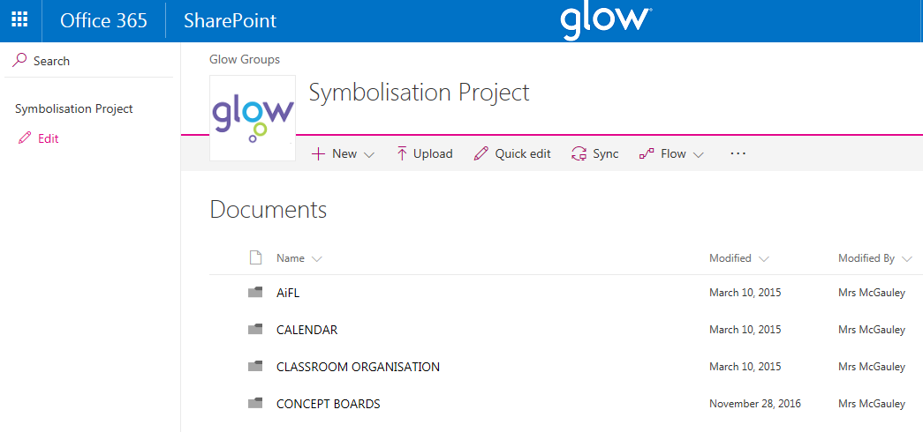

Symbolising the Environment Training: Rationale

Symbolising the Environment Training: Implementation

Symbolising the Environment Training: Rationale and Implementation Combined (shorter version)

Appendix 2 Key Practitioners Involved in Pilot Programmes
Phase 1 (2014/2015)
Annie McGauley (Depute Head Teacher, Carlibar Communication Centre)
Siobhan Wilson (Educational Psychologist)
Christine McGovern (Educational Psychologist)
Chris Atherton (Senior Educational Psychologist)

Phase 2 (2016/2017)
Educational Psychology Team
Jennifer Norval (Trainee Educational Psychologist)
Chris Atherton (Senior Educational Psychologist)

Carlibar Communication Centre
Annie McGauley (Depute Head Teacher)

Speech and Language Therapy Team
Lyndsay Dickson (Speech and Language Therapist)

Netherlee Primary School
Claire Edgar (Principal Teacher, Symbolisation Coordinator)
Julie Roberts (Depute Head Teacher)
Joanne Mann, Joanne McLeish, Anne-Marie McDermott, Vari Malone, Kirsten Mclean, Linda Bell (Primary 1 class teachers)
Elaine… (Pupil Support Assistant, Symbols Generator)

Netherlee Nursery
Angela Kerr (Principal Teacher)
Victoria Wheelan (Class Teacher)
Margaret … (Pupil Support Assistant, Symbols Generator)

Busby Primary School
Julie Oswald (Depute Head Teacher, Symbolisation Coordinator)
Maria Cairnie, Lindsey McNeil (Primary one class teachers)
Patricia … (Pupil Support Assistant, Symbols Generator)

Busby Nursery
Sandra Curran (Class Teacher, Symbolisation Coordinator)
Lynne Small (Child Development Officer, Symbols Generator)

Appendix 3: Links and Resources
Call Scotland: Communication, Access, Literacy and Learning
http://www.callscotland.org.uk/home/

The Communication Trust
https://www.thecommunicationtrust.org.uk/

National Autistic Society: Environment and Surroundings
http://www.autism.org.uk/environment

Talking Point: Adapting the Environment
http://www.talkingpoint.org.uk/teachers/adapting-environment

I CAN – the Children’s Communication Charity
www.ican.org.uk

Information on Fife Symbols Inclusion Project
http://www.autismtoolbox.co.uk/resources/topic-resources/visual-supports/

Warwickshire Symbols Inclusion Project
http://symbolsinclusionproject.org/index.htm

