**Kirkhill Primary School**

**Getting it Right for Me**



Name: _______________________________________________

Class: ________________________________________________

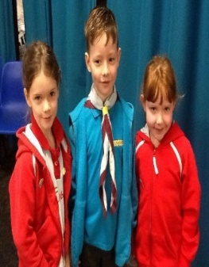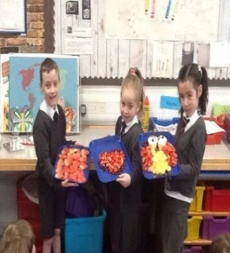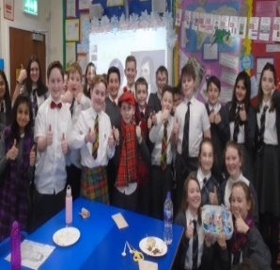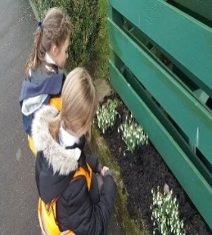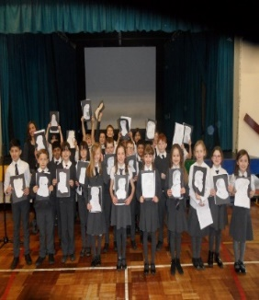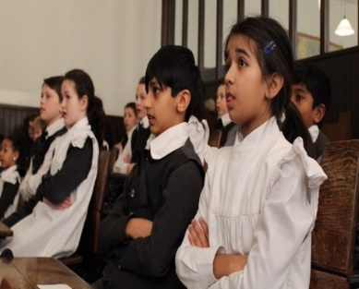

**Getting it Right for Me**

**All About Me**

**My age:   
My birthday:**

**My friends in school:**

**My friends out of school:**

**My family:**

**Important things my teacher should know about me…**

* **What I like about school**
* **What I worry about**
* **My hobbies**
* **My favourite foods and drinks**

**Important things you need to know about how to help me in class…**

* **Things I like**
* **Things I worry about**
* **Things I need help with**
* **Who I like to sit next to**
* **Things that help me with my learning**

**My Three Key Adults**

**If you have a worry in school, who would you feel comfortable talking to?**

**1.**

**2.**

**3.**

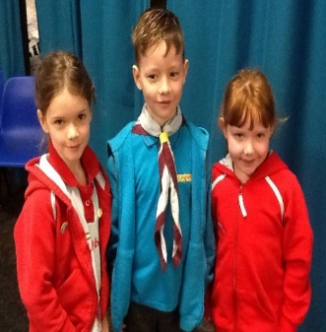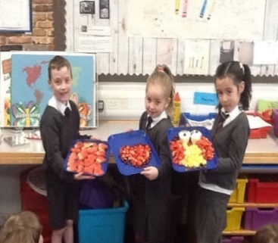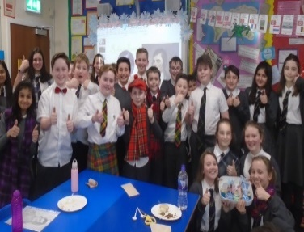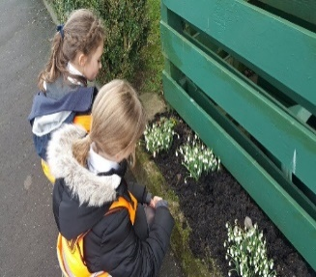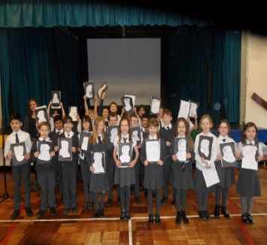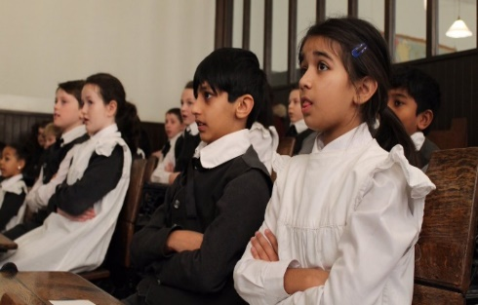

**My Health and Wellbeing Self-Assessment**

Please complete the Wellbeing Wheel to show how healthy and well you feel. If you have any worries, please remember to talk to one of your key adults.

**Term 1 - Blue  
Term 2 - Green  
Term 3 - Red**



|  |
| --- |
| **Term 1 Comments** |
| **Term 2 Comments** |
| **Term 3 Comments** |