My New Class

My name is XXX and I go to Carlibar primary and the CCC.
At the end of June, it will be the summer holidays.
Every year after the summer holidays we move into a new primary class. All boys and girls have to go to school to learn new things.
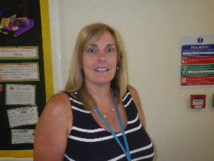
I will be in Primary 3 and my teacher will be
Mrs XXX.
There are lots of people who will be there to help me to get to know my new friends and learn my new classroom routines.

I will go to CCC on a Monday, Tuesday, and Wednesday morning.

I will be in the Silver room with Mrs XXX.

 | Monday | Tuesday | Wednesday | Thursday | Friday
Morning | CCC SILVER ROOM | CCC SILVER ROOM | CCC SILVER ROOM
Afternoon

Then I will go to my Primary 3 class in Carlibar at 11.45.

I will eat my lunch with my friends in Primary 3. I will try hard to sit at the table and eat all my lunch.
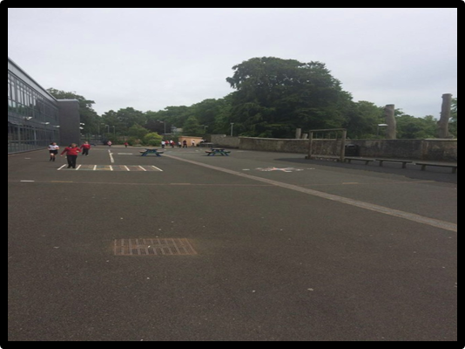
At lunchtime, I will spend some of the time in the big playground. There will be adults in the playground with me. I can ask them for help if I need to. I can always go to SMT if I need a break.

The bell will go when it is the end of lunchtime and I must try to stop playing and walk to my quiet space.

