Anxiety Books for Kids (from Children to Teens)
by The Jenny Evolution 2 Comments
When your child has anxiety, you can feel lost on how to help them and teach them how to help themselves. In my family, we read many of these anxiety books for kids to help my son.
From books from your children to teens, I wanted to offer suggestions of where to start no matter what the age of your child. You can find these anxiety books for kids at your local library or purchase them through the affiliate links provided for your convenience.
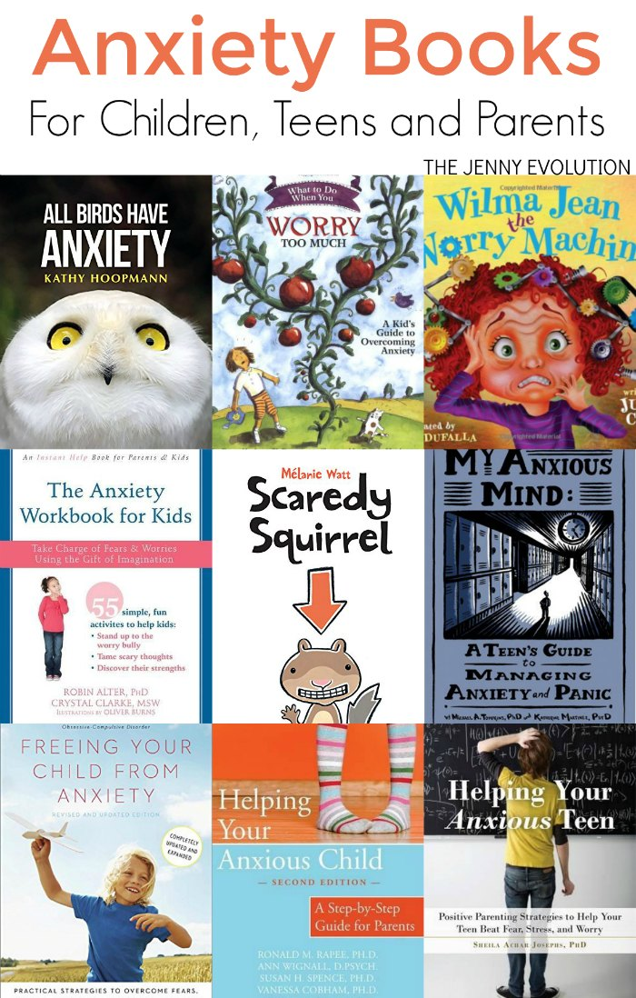

Anxiety Books for Kids
I’ve broken this list into multiple sections:
- picture books about anxiety.
- workbooks for kids
- books to help teens with anxiety.
- recommendations for books parents can read about anxiety

Picture Books about Anxiety
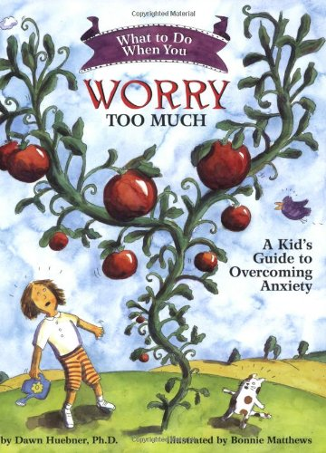
What to Do When You Worry Too Much: A Kid’s Guide to Overcoming Anxiety: An interactive self-help book designed to guide 6-12 year olds and their parents through the cognitive-behavioral techniques most often used in the treatment of generalized anxiety. Engaging, encouraging, and easy to follow, this book educates, motivates, and empowers children to work towards change. It includes a note to parents by psychologist and author Dawn Huebner, PhD.
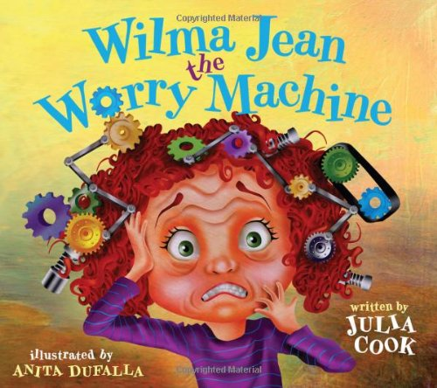
Wilma Jean the Worry Machine: Anxiety is a subjective sense of worry, apprehension, and/or fear. It is considered to be the number one health problem in America. Although quite common, anxiety disorders in children are often misdiagnosed and overlooked. Everyone feels fear, worry and apprehension from time to time, but when these feelings prevent a person from doing what he/she wants and/or needs to do, anxiety becomes a disability. This fun and humorous book addresses the problem of anxiety in a way that relates to children of all ages. It offers creative strategies for parents and teachers to use that can lessen the severity of anxiety. The goal of the book is to give children the tools needed to feel more in control of their anxiety.
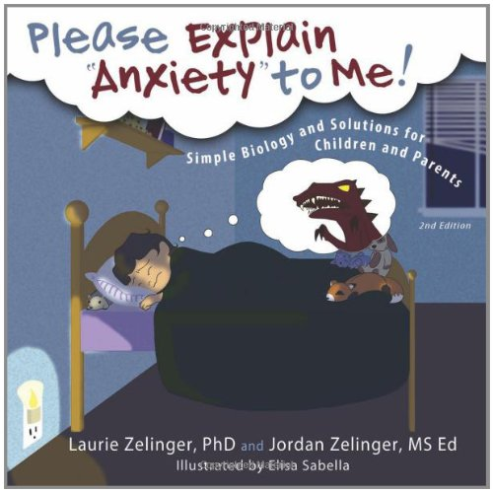
Please Explain Anxiety to Me! Simple Biology and Solutions for Children and Parents: This book translates anxiety from the jargon of psychology into concrete experiences that children can relate to. Children and their parents will understand the biological and emotional components of anxiety responsible for the upsetting symptoms they experience.
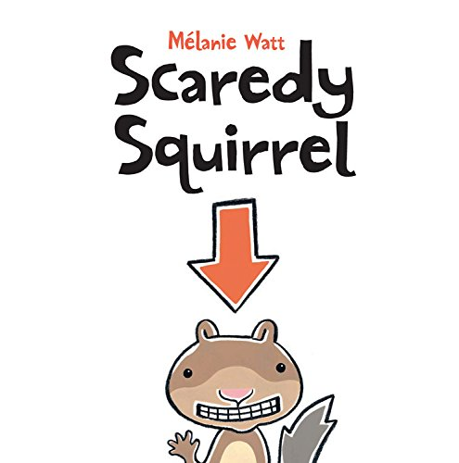
Scaredy Squirrel: Scaredy Squirrel never leaves his nut tree. It’s way too dangerous out there. He could encounter tarantulas, green Martians or killer bees. But in his tree, every day is the same and if danger comes along, he’s well-prepared. Scaredy Squirrel’s emergency kit includes antibacterial soap, Band-Aids and a parachute. Day after day he watches and waits, and waits and watches, until one day … his worst nightmare comes true! Scaredy suddenly finds himself out of his tree, where germs, poison ivy and sharks lurk. But as Scaredy Squirrel leaps into the unknown, he discovers something really uplifting …
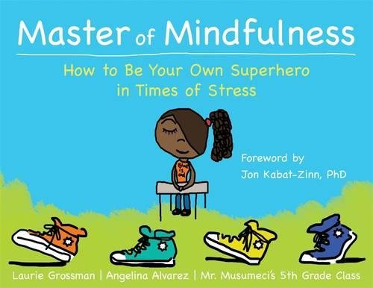
Master of Mindfulness: How to Be Your Own Superhero in Times of Stress: Do you ever feel angry, disappointed, or stressed out about family problems, school, bullies, or trouble with friends? If so, mindfulness can help. Master of Mindfulness is a unique and empowering book written for kids by kids, with cool illustrations and tips that show you how to be confident, get focused, stay calm, and tap into your own inner strength so that you can be your own superhero—no matter what life throws your way!
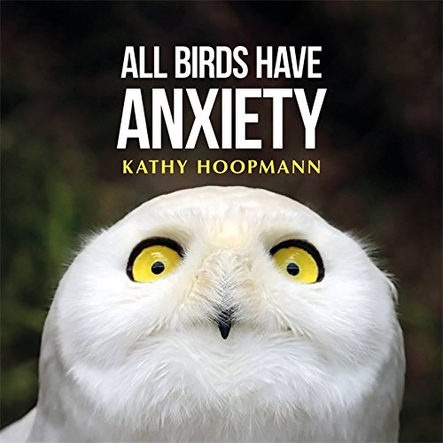
All Birds Have Anxiety: Life as a bird can be stressful! From worrying about airplanes, windows, and getting enough worms to eat, it is clear that birds can be anxious beings. Through a light-touch, quizzical depiction of bird behavior, All Birds Have Anxiety uses colorful images and astute explanations to explore with gentle humor what it means to live with anxiety day-to-day, and how to begin to deal with it.
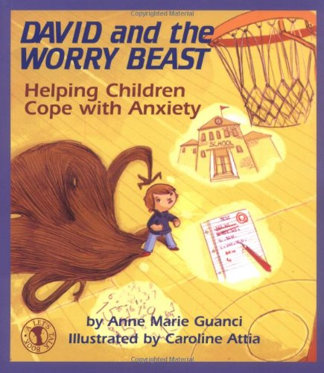
David and the Worry Beast: Helping Children Cope with Anxiety: Learning to deal with anxiety is an important step in a child’s healthy emotional growth. Conquering fears, and not avoiding them, is the lesson imparted in this story. David could not stop thinking about the basket he had missed at the end of the big game. He was worried that he might do it again. He was worried that his team mates would be angry with him. He was worried that his parents would not be proud of him. He was also worried about an upcoming math test. In fact, David was worried a lot…

ANXIETY WORKBOOKS FOR KIDS
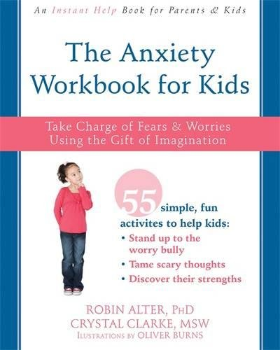
The Anxiety Workbook for Kids: Take Charge of Fears and Worries Using the Gift of Imagination: The Anxiety Workbook for Kids is a fun and unique workbook grounded in evidence-based CBT and designed to help children understand their anxious thoughts within a positive framework—a perspective that will allow kids to see themselves as the highly imaginative individuals they are, and actually appreciate the role imagination plays in their anxiety. With this workbook, children will learn that, just as they are capable of envisioning vivid scenarios that fuel their anxiety, they are capable of using their imagination to move away from anxious thoughts and become the boss of their own worries.
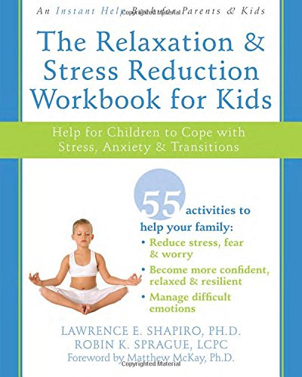
The Relaxation and Stress Reduction Workbook for Kids: Help for Children to Cope with Stress, Anxiety, and Transitions: The Relaxation & Stress Reduction Workbook for Kids, written by two child therapists, offers more than fifty activities you can do together as a family to help you and your child replace stressful and anxious feelings with feelings of optimism, confidence, and joy. You’ll learn proven relaxation techniques, including deep breathing, guided imagery, mindfulness, and yoga, and then receive guidance for teaching them to your child. Your child will also discover how taking time to do art and creative projects can create a sense of fulfillment and calm. By completing just one ten-minute activity from this workbook each day, you’ll make relaxation a family habit that will stay with both you and your child for a lifetime.
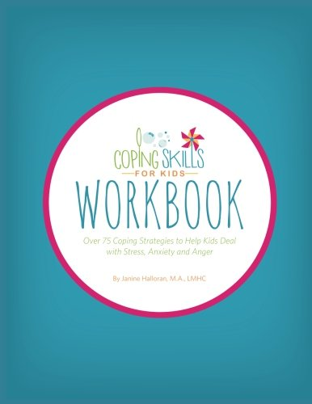
Coping Skills for Kids Workbook: Over 75 Coping Strategies to Help Kids Deal with Stress, Anxiety and Anger: The Coping Skills for Kids Workbook is designed to help kids learn and practice coping skills to deal with anxiety, stress and anger. The workbook includes: Over 75 Coping Skills for Kids to try with more than 20 Printables/Worksheets to help Links to Coping Skills for Kids YouTube Videos A Resource Collection of other helpful books and websites for families Kids can read this book on their own, or they can work through it with a family member or another trusted adult.

BOOKS ABOUT ANXIETY FOR TEENS
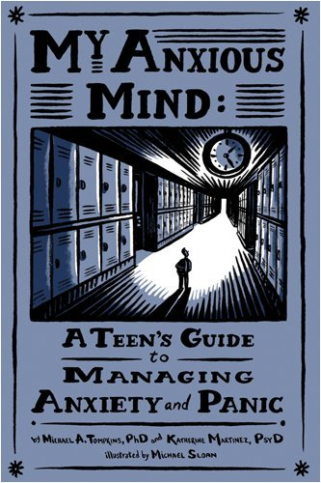
My Anxious Mind: A Teen’s Guide to Managing Anxiety and Panic: ‘My Anxious Mind’ outlines a simple and proven plan to help you understand and deal with your anxiety and panic. It is full of simple-to-use tools and strategies that easily fit into any teen’s busy routine.
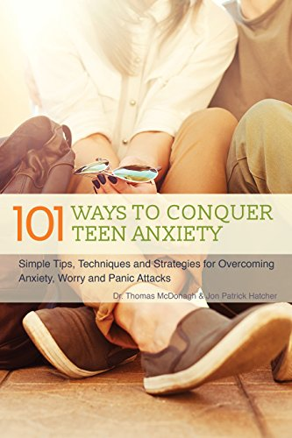
101 Ways to Conquer Teen Anxiety: Simple Tips, Techniques and Strategies for Overcoming Anxiety, Worry and Panic Attacks: Based on cognitive behavioral therapy, the most widely used and popular anxiety therapy among clinicians, “101 Ways to Conquer Teen Anxiety” offers dozens of beneficial quizzes, activities, tips and illustrations to help teens. From mindfulness meditation and the repetition of positive mantras to diaphragmatic breathing and nature walks, the activities in this book both calm the body and keep thoughts from spiraling.
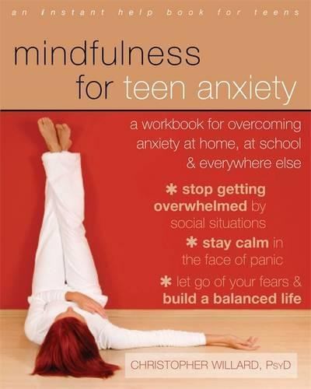
Mindfulness for Teen Anxiety: A Workbook for Overcoming Anxiety at Home, at School, and Everywhere Else: In Mindfulness for Teen Anxiety, psychologist and learning specialist Christopher Willard offers teens like you proven-effective, mindfulness-based practices to help you cope with your anxiety, identify common triggers (such as dating or school performance), learn valuable time-management skills, and feel more calm at home, at school, and with friends. You’ll learn tips for dealing with specific situations that cause anxiety, such as public speaking, social anxiety, test anxiety, and more. You’ll also learn special breathing exercises to help calm you in moments of panic, and guided visualization exercises to help you stay cool and collected, even in the tensest situations.
Anxiety Sucks! A Teen Survival Guide (Volume 1): From author Natasha Daniels — “Is your anxiety kicking your teen’s butt? Are they tired of boring, long self-help books that do anything but help? Are they annoyed by suggestions that show the author doesn’t really get anxiety? I get it. I also get anxiety. I have lived it and so have the thousands of kids I have helped in my therapy practice. Until you have lived it – you will never understand anxiety’s insidious moves. Anxiety Sucks! Teen Survival Guide is short and to the point.”
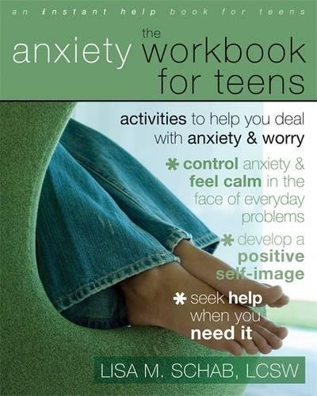
The Anxiety Workbook for Teens: Activities to Help You Deal with Anxiety and Worry: The Anxiety Workbook for Teens will show you how to deal with the day-to-day challenges of anxiety. It will help you develop a positive self-image and recognize your anxious thoughts. The workbook also includes resources for seeking additional help and support if you decide you need it. What are you waiting for? Don’t spend another minute paralyzed by anxiety.

Anxiety Books for Parents
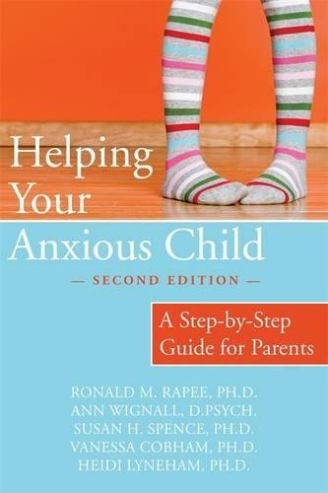
Helping Your Anxious Child: A Step-by-Step Guide for Parents: Most children are afraid of the dark. Some fear monsters under the bed. But at least ten percent of children have excessive fears and worries—phobias, separation anxiety, panic attacks, social anxiety, or obsessive-compulsive disorder—that can hold them back and keep them from fully enjoying childhood. If your child suffers from any of these forms of anxiety, the program in this book offers practical, scientifically proven tools that can help. Now in its second edition, Helping Your Anxious Child has been expanded and updated to include the latest research and techniques for managing child anxiety.
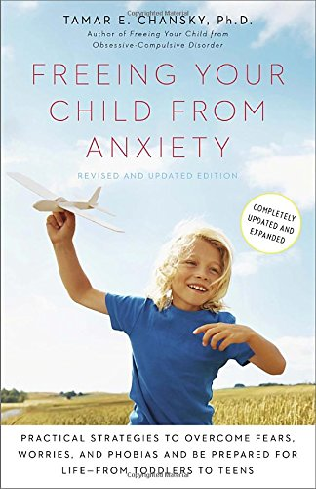
Freeing Your Child from Anxiety: Freeing Your Child from Anxiety contains easy, fun, and effective tools for teaching children to outsmart their worries and take charge of their fears. This revised and updated edition also teaches how to prepare children to withstand the pressure in our competitive test-driven culture. Learn the tips, techniques, and exercises kids need to implement the book’s advice right away, including “How to Talk to Your Child” sections and “Do It Today” activities at the end of each chapter. These simple solutions can help parents prevent their children from needlessly suffering today—and ensure that their children have the tools they need for a good life tomorrow.
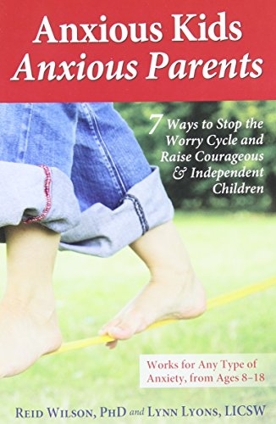
Anxious Kids, Anxious Parents: 7 Ways to Stop the Worry Cycle and Raise Courageous and Independent Children: How do you manage a child who gets stomachaches every school morning, who refuses after-school activities, or who is trapped in the bathroom with compulsive washing? From their success with hundreds of organizations, schools, and families, Reid Wilson, PhD, and Lynn Lyons, LICSW, share their unconventional approach of stepping into uncertainty in a way that is currently unfamiliar but infinitely successful. Using current research and contemporary examples, the book exposes the most common anxiety-enhancing patterns―including reassurance, accommodation, avoidance, and poor problem solving―and offers a concrete plan with 7 key principles that foster change.
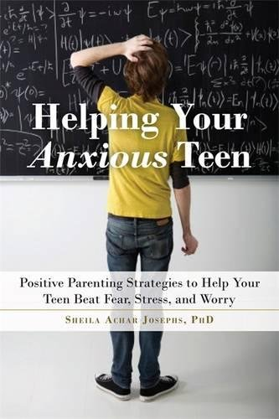
Helping Your Anxious Teen: Positive Parenting Strategies to Help Your Teen Beat Anxiety, Stress, and Worry: This powerful book, based on cutting-edge research and cognitive behavioral strategies, will help you develop the know-how to effectively manage teen anxiety. You’ll learn the best ways to support your teen in overcoming problematic thinking and fears, discover what behaviors and coping strategies unwittingly make anxiety worse, and understand how anxiety is best defeated with surprisingly counterintuitive methods. Includes step-by-step guidance, along with numerous real-life examples and exercises.
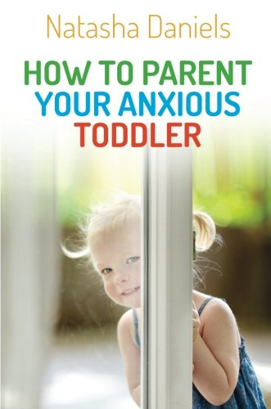
How to Parent Your Anxious Toddler: Why does your toddler get upset when his or her routine is disrupted? Why do they follow you from room to room and refuse to play on their own? Why are daily routines such as mealtimes, bath time, and bed time such a struggle? This accessible guide demystifies the difficult behaviors of anxious toddlers, offering tried-and-tested practical solutions to common parenting dilemmas. Each chapter begins with a real life example, clearly illustrating the behavior from the parent’s and the toddler’s perspective. Once the toddler’s anxious behavior has been demystified and explained, new and effective parenting approaches are introduced to help parents tackle everyday difficulties and build up their child’s resilience, independence, and coping mechanisms.

