Pupil X’s Restorative Diary
I found it difficult because… | I could tell it was difficult because I experienced… | I chose to… | The outcome was… | Things I can do to manage this better in the future… | Things staff could do to help me manage this better… | A better outcome from this would be…
(Scenario) | (Symptoms e.g. fear, anxiety, anger, too warm) | (Behaviours) | (Consequences) | (Strategies / Preferred behaviours) | (Supports) | (Preferred consequence)
The routine changed
I felt pressured / trapped
I felt alone

I felt / thought that people were looking at me
I could hear / see coins
I felt that others were being unkind
People were being too loud
The work was too hard
I wasn’t happy with my work
I had trouble thinking / I was confused
I was hurt
I needed help
I was told no
I felt that others were being unfair

Pupil X’s Restorative Conversations
What happened? | How did this make you feel?
What did you do and who was affected? | What do we need to do to now to make things better?

What happened?

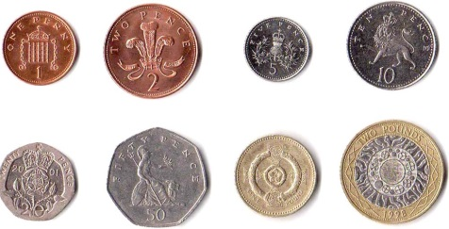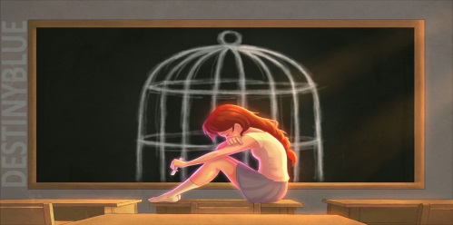
Coins Change of Plan / Routine Feeling Trapped / Under pressure

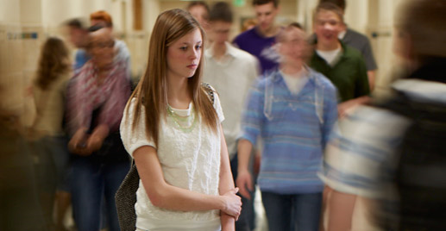
Alone People looking at me People being unkind

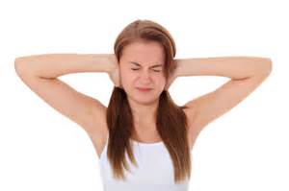
Too loud Work is too hard Not happy with work

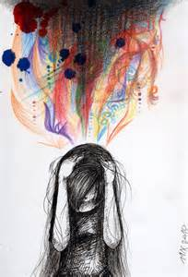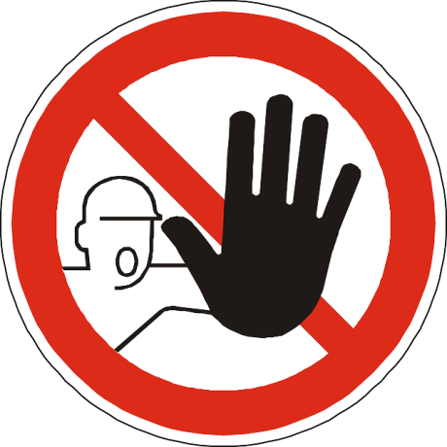
Trouble thinking / confused Hurt Not allowed / Told no

Someone is being unfair

How did this make you feel?

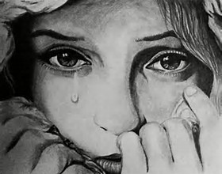
Sad Angry Annoyed

Anxious / Afraid

What did you do and who was affected?
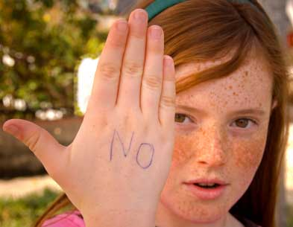
Screaming / Shouting Head Banging Crying Defiance

(Insert pictures of Pupil X and pictures of staff)

What do we need to do now to make things better?

(Agree upon restorative solutions with Pupil X and create pictures)

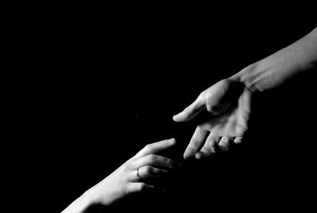
Apologise Catch up on work Make amends / reach out

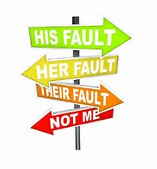
Accept responsibility

Emotional Zones

Green | Blue | Yellow | Red
Happy, Calm, Ok | Sad, Worried, Unsettled | Anxious, Fearful, Annoyed | Frustrated, Angry, Raging
I can stay here by…  Playing music  Stretching  Using Safe Spot  Relaxation / Breathing Exercises  Movement breaks  Keeping busy – doing some work  Practising CBT | I can get to Green from here by…  Using my words – talking to friends / staff  Taking a short break  Getting a drink of water  Distraction techniques and games  Relaxation / Breathing Exercises Movement breaks  Keeping busy – doing some work  Moderate Exercise  Using Safe Spot  Practising CBT | I can get to Blue from here by…  Using my words – talking to friends / staff  Asking for time out  Taking a short break  Getting a drink of water  Distraction techniques and games  Relaxation / Breathing Exercises Movement breaks  Keeping busy – doing some work  Moderate Exercise  Using Safe Spot  Practising CBT | I can get to Yellow from here by…  Time out  Deep breathing  Mindfulness exercises  Distraction  Time to talk  Rigorous exercise  Practising CBT
Where am I right now?

Feelings Thermometer

This can be used to support solution focussed conversations. Where are you now? How do you get from 7 to 6 etc.

