Breakfast scones

Ingredients

**Complexity**: Medium

125g self-raising flour

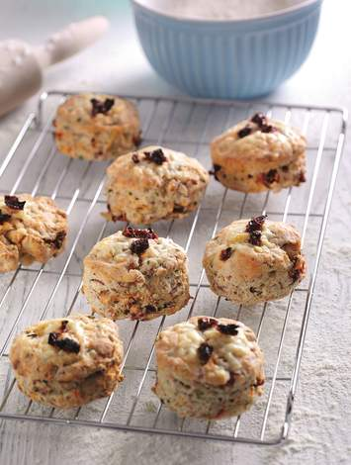100g wholemeal self-raising flour

1 x 5ml spoon baking powder

50g butter

75g smoked ham, diced

50g mature hard cheese, grated

50g sun dried tomatoes, chopped

2 x 15ml spoon chopped chives

125ml semi-skimmed milk

Equipment

Sieve, bowl, spoon, rolling pin, 6cm round cutter, baking tray.

Method

1. Preheat the oven to 220oC, Gas Mark 7.
2. Sift the flours and baking powder in a bowl. Add the butter and rub in with your fingers to resemble breadcrumbs.
3. Stir in the ham, half the cheese, all but 1 tbsp of tomatoes and the chives, then season. Mix in the milk to form a soft dough.
4. Roll out to 2cm thick on a floured work surface and using a 6cm round cutter, cut out 8 scones, placing them on a baking tray.
5. Sprinkle over the remaining cheese and chopped tomatoes. Bake for 10 minutes until golden.

**Top tips**

Mix and match the ham with bacon or pulled ham hock, use fresh tomatoes instead of sun dried and swap the herbs according to taste. Try using other types of cheese too.

**Food skills**

Sift

Mix, stir & combine

Roll out

Cut out

Bake