**Fruit pancakes**

**Ingredients**

**Complexity**: low-medium

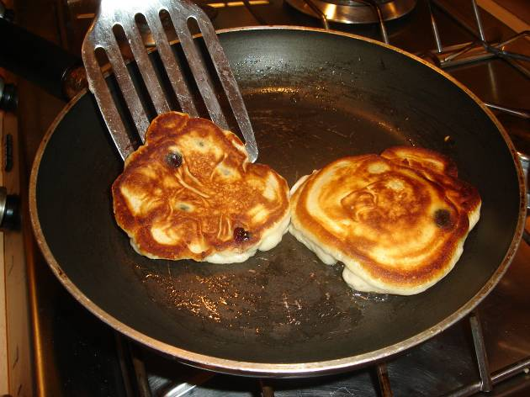50g fruit, e.g. blueberries, raspberries, banana

125g self-raising flour

1x15ml spoon sugar

1 egg

180ml semi-skimmed milk

Oil

**Equipment**

Chopping board, knife, sieve, whisk, bowl, measuring jug, non-stick frying pan, fish slice, metal spoon.

**Method**

1. Chop the fruit into small chunks
2. Sift the flour into a bowl and add the sugar.
3. Whisk in the egg and milk.
4. Stir in the fruit.
5. Heat the frying pan and add a little spray oil.
6. Pour in 2x15ml spoons of mixture for each pancake.
7. Cook for 2 minutes, until golden, and turn over.
8. Cook for a further minute.
9. Serve.

**Food skills**

* Weigh.
* Measure.
* Sift.
* Whisk.
* Fry.