Breakfast Energy Bars

Ingredients

100g butter

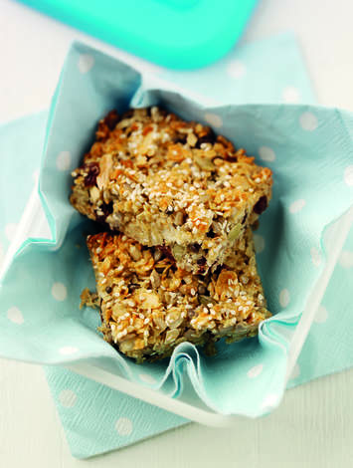100g clear honey

100g rolled oats

125g mixed seeds and fruit

50g granola

1 x 5ml spoon sesame seeds

Equipment

Saucepan, spoon, square baking tin (lined), oven gloves, cooling rack.

Method

1. Preheat the oven to 180C, Gas Mark 4.
2. Heat the butter and honey in a saucepan until the butter has melted.
3. Stir in the remaining ingredients except sesame seeds and press into a square baking tin.
4. Sprinkle over the sesame seeds.
5. Bake for 15 minutes until golden.
6. Allow to cool slightly before cutting into 12 bars.
7. Leave in the tin to cool completely before removing.

**Food skills**

Weigh

Melt

Mix, stir & combine

Bake

Cut