Come Along! Join in! Celebrate Book Week Scotland! 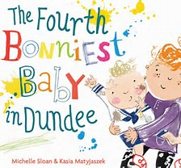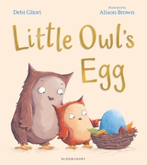
Where: Primary 1 at Eaglesham Primary School
When: 30.11.17 Time: Just after 3 o’clock
Why? Reading for fun with your child, take time to chat about books
Which book is your favourite?

