Name: Class: Primary 4 Date:

Topics: TO BE, THIS, FAMILY

- To Be

Tell me something about TO BE in Hebrew in the present. __No TO BE___
How do I say I AM BIG in Hebrew? ______ANI GADOL__
How many words did you need to say I AM BIG in English? ___3_____
How many words did you need to say I AM BIG in Hebrew? ___2__________
What is ‘Grammar’ : ______Studying how a language works
___________________________________________________________________

- This is….

- questions
What does זֶה [zeh] and זאֹת [zot] mean?
____This/This is____

Why do I have 2 of them in Hebrew to say the same thing in English? ___
__one for masculine one for feminine_______

- Cross out the wrong sentence:

זֶה ריהאנה |  | זֶה ג'סטין ביבר |  | זֶה ג'וש
זאֹת ריהאנה |  | זאֹת ג'סטין ביבר |  | זאֹת ג'וש

- Write a sentence in Hebrew for each picture

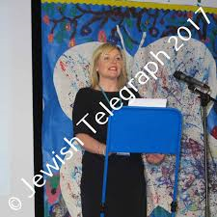 |  | 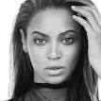
זאֹת גברת קרלטון |  | זאֹת בייונסה |  | זֶה דונלד טרומפ

- Family - Write members of the family these are in Hebrew

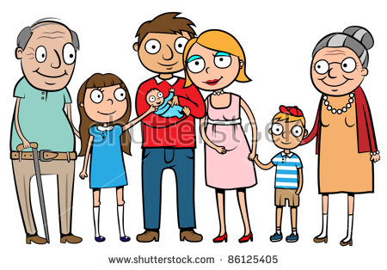
סבתא - אח - אמא - אבא - תינוק - אחות - סבא

- Reading/Writing

- write the sounds and names of these letters

Letter | Sound | Name of letter
ג | [g] | Guimel
ד | [d] | dalet
ח | [H] | Het
ט | [t] | Tet
י | [y] | Yud
ל | [l] | Lamed
מ | [m] | Mem

- write the sound of these syllables where they should be:

מִ = mee זֹ = zo פִּ= pee לָ = la הַ = ha

- Write these sounds in English
אִ = ee  סָ = sa  צֻ = tsoo  חָ = Ha  בֻּ = boo | כִ = Hee  פַ = fa  כַּ = ka  פִּ = pee  רֶ = re

- Write these sounds in Hebrew
Mo = מֹ  Ra = רַ  Sho = שֹ  Da = דַ  Fee = פִ | Go = גֹ  Ma = מַ  Zo = זֹ  Loo = לֻ  Tsee = צִ

