Name: Class: Primary 4 Date:

Topics: TO BE, THIS, FAMILY

- To Be

Tell me something about TO BE in Hebrew in the present. _________________
How do I say I AM BIG in Hebrew? ________________________
How many words did you need to say I AM BIG in English? _________________
How many words did you need to say I AM BIG in Hebrew? _________________
What is ‘Grammar’ : _______________________________________________________
________________________________________________________________________

- This is….

- questions
What does זֶה [zeh] and זאֹת [zot] mean?
________________

Why do I have 2 of them in Hebrew to say the same thing in English? __________________

- Cross out the wrong sentence:

זֶה ריהאנה |  | זֶה ג'סטין ביבר |  | זֶה ג'וש
זאֹת ריהאנה |  | זאֹת ג'סטין ביבר |  | זאֹת ג'וש

- Write a sentence in Hebrew for each picture

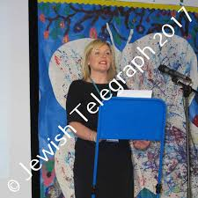 |  | 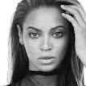

- Family - Write members of the family these are in Hebrew

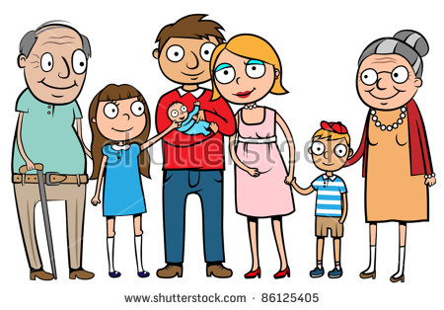

- Reading/Writing

- write the sounds and names of these letters

Letter | Sound | Name of letter
ג | [g] | Guimel
ד
ח
ט
י
ל
מ

- write the sound of these syllables where they should be:

mee ha pee la zo

מִ = זֹ = פִּ= לָ = הַ =

- Write these sounds in English
אִ =  סָ =  צֻ =  חָ =  בֻּ = | כִ =  פַ =  כַּ =  פִּ =  רֶ =

- Write these sounds in Hebrew
Mo =  Ra =  Sho =  Da =  Fee = | Go =  Ma =  Zo =  Loo =  Tsee =

