Name: Class: Primary 3 Date:

Topics: Family, Pronouns, Reading-writing

- FAMILY - write the words beside the right person:

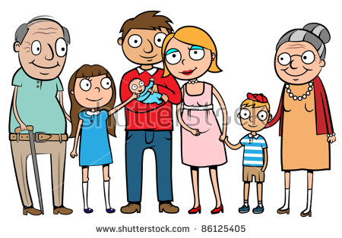
- SUBJECT PERSONAL PRONOUNS

a) fill in the blanks with the words under
 | [ani] | I
אתה | [at] | You (masculine)  You (feminine)
היא | [hoo]  [hee] | He  She
 |  | We
אתן | [atem]  [aten] | You (masculine plural)  You (feminine plural)
הם  הן | [hen] | They (masculine)  They (feminine)

אני - [hem] - אתם - הוא - [anaHnu] -

[ata] - אנחנו - אתה - את

b) Match the sentences (if you don’t understand, just look at the pronouns)
1-I am a boy |  |  | a-היא שמחה
2-You are a girl |  |  | b-אנחנו משפחה
3-We are a family |  |  | c-הם תלמידים
4-She is happy |  |  | d-אני ילד
5-They are pupils |  |  | e-את ילדה
6-He is the teacher |  |  | f-הוא המורה

- READING/WRITING

- write the sounds and names of these letters
Letter | Sound | Name of letter
ג
ד
ח
ט
ר
ל
ק

- write the sounds:
מִ = זֹ = פִּ= לָ = הַ =

- write in Hebrew:
RA = DOO = MO = ZEE=

