Name: Class: Primary 2 Date:

Topics: Family, Pronouns, Reading-writing

- FAMILY - rewrite the words under the right person:
סַבָּא – סָבְתָא - אִמָא - אַבָּא - אָח - אָחוֹת - תִינוֹק

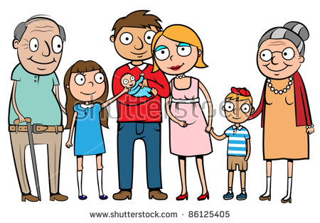

- SUBJECT PERSONAL PRONOUNS

a) fill in the blanks with the words under
אני |  | I
אתה  את |  | You (masculine)  You (feminine)
הוא  היא |  | He  She
אנחנו |  | We
אתם  אתן |  | You (masculine plural)  You (feminine plural)
הם  הן |  | They (masculine)  They (feminine)

[hen] - [hee] - [at] - [atem] - [ani]
[ata] - [hoo] - [aten] - [anaHnu] - [hem]

- READING/WRITING

- write the sounds and names of these letters
Letter | Sound | Name of letter
ג | [g] | Guimel
ד
ח
ט
י
ל
מ

- write the sounds:
מִ = זֹ = פִּ= לָ = הַ =

