Name: Class: Primary 2 Date:

Topics: Family, Pronouns, Reading-writing

- FAMILY - rewrite the words under the right person:
סַבָּא – סָבְתָא - אִמָא - אַבָּא - אָח - אָחוֹת - תִינוֹק

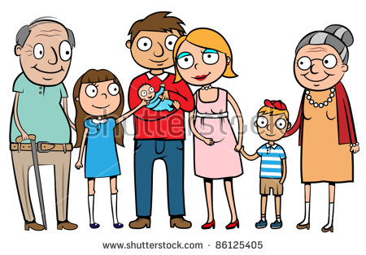

סַבָּא – אָחוֹת - אַבָּא אִמָא - תִינוֹק -- אָח - סָבְתָא

- SUBJECT PERSONAL PRONOUNS

a) fill in the blanks with the words under
אני | [ani] | I
אתה  את | [ata]  [at] | You (masculine)  You (feminine)
הוא  היא | [hoo]  [hee] | He  She
אנחנו | [anaHnu] | We
אתם  אתן | [atem]  [aten] | You (masculine plural)  You (feminine plural)
הם  הן | [hem]  [hen] | They (masculine)  They (feminine)
[hen] - [hee] - [at] - [atem] - [ani]
[ata] - [hoo] - [aten] - [anaHnu] - [hem]
- READING/WRITING

- write the sounds and names of these letters
Letter | Sound | Name of letter
ג | [g] | Guimel
ד | [d] | dalet
ח | [H] | Het
ט | [t] | Tet
י | [y] | Yud
ל | [l] | Lamed
מ | [m] | Mem

- write the sounds:
מִ = mee זֹ = zo פִּ= pee לָ =la הַ = ha

