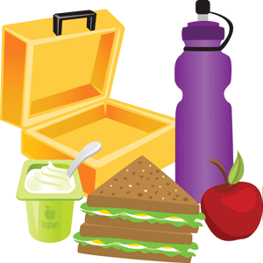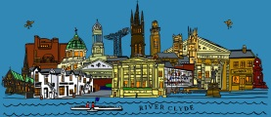

**Primary 1**

**Glasgow Trip**

We will not be visiting the gift shop on any of our stops. There is no need to bring money on the trip.

We will not be visiting the gift shop on any of our stops. There is no need to bring money on the trip.

Packet lunches and a small snack should be brought to school in a lunch box or sealable bag.

School ordered packed lunches will be provided on the day.

Packet lunches and a small snack should be brought to school in a lunch box or sealable bag.

School ordered packed lunches will be provided on the day.

We are travelling in an open top sightseeing bus. Please wear appropriate outdoor clothing such as waterproof jacket with a hood, scarf and gloves.

Children should wear school uniform on the trip.

We are travelling in an open top sightseeing bus. Please wear appropriate outdoor clothing such as waterproof jacket with a hood, scarf and gloves.

Children should wear school uniform on the trip.

**Primary 1**

**Glasgow Trip**