Higher Chemistry

Chemistry In Society Unit 3 Ink Exercise 1

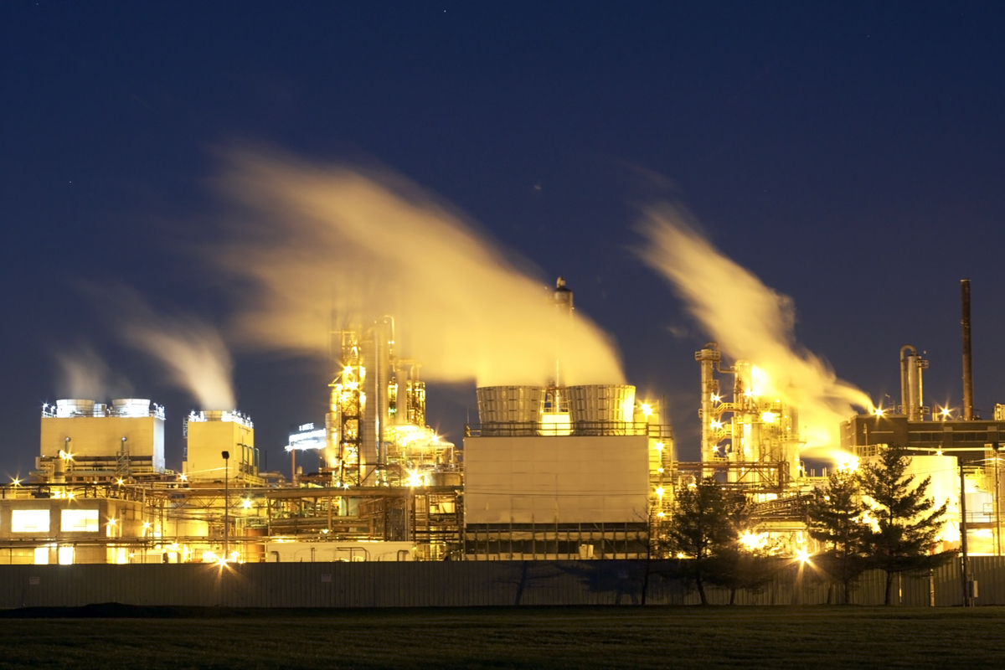

The Chemical Industry, Mole Calculations, Percentage Yield and Atom Economy

Multiple Choice 10 Marks
1.) Which of the following is the best description of a feedstock
A A consumer product such as a textile, plastic or detergent
B A Complex chemical that has been synthesised from small molecules
C A mixture of chemicals formed by the cracking of the naphtha fraction from oil
D a chemical from which other chemicals can be extracted or synthesised
2.) Which of the following is a raw material in the chemical industry
A Ammonia
B Calcium Carbonate
C Hexane
D Nitric Acid

3) 9.72g of magnesium is dropped into 300ml, 1 mol l⁻¹ sulfuric acid.
Calculate the reactant in excess and by how much
Mg + H₂SO₄ MgSO₄ + H₂O

A sulphuric acid by 0.3 moles

B magnesium by 0.4 moles

C magnesium by 0.1 moles

D sulfuric acid by 0.1 moles

4) Calculate the volume of 2.2g of helium
(take the molar volume to be 24 litres)

A 12
B 13.2
C 24
D 26.4

5) Which of the following gases has the same volume as 128.2g of sulphur
dioxide gas?
(All volumes are measured under the same conditions of temperature and
pressure)

- 2.0g of hydrogen

- 8.0g of helium

- 32.0g of oxygen

- 80.8g of neon

6) 2NO_{(g)} + O_{2(g)} → 2NO_{2(g)}

How many litres of nitrogen dioxide gas would be produced in a reaction, starting with a mixture of 5 litres of nitrogen monoxide gas and 2 litres of oxygen gas? (All volumes are measured under the same conditions of temperature and pressure.)
** HINT – work out which reactant is in excess first then calculate the volume of gas produced using the balanced equation))**

A 2

B 3

C 4

D 5

7) What volume of oxygen (in litres) would be required for the complete combustion of a gaseous mixture containing 1 litre of carbon monoxide and 3 litres of hydrogen?
(All volumes are measured at the same temperature and pressure.)

** HINT – write a balanced equation for the combustion of carbon monoxide which produces carbon dioxide and the combustion of hydrogen which produces water. Then using the mole ratio work out how much oxygen is needed for each reaction and add the volumes together **

A 1

B 2

C 3

D 4

8) The equation for the complete combustion of propane is:

C₃H_{8(g)} + 5O_{2(g)} 3CO_{2(g)} + 4H₂O_{(l)}

30cm³ of propane is mixed with 200cm³ of oxygen and the mixture is ignited.
What is the volume of the resulting gas mixture?

(all volumes are measured at the same temperature and pressure)

A 90cm³

B 120cm³

C 140cm³

D 210cm³

9.) Calcium carbonate reacts with nitric acid as follows.

CaCO_{3(s)} + 2HNO_{3(aq)} → Ca(NO₃)_{2(aq)} + H₂O_{(l)} + CO_{2(g)}

0·05 mol of calcium carbonate was added to a solution containing 0·08 mol of nitric acid. Which of the following statements is true?
**HINT – work out which of the reactants is in excess first**

A 0·05 mol of carbon dioxide is produced.

B 0·08 mol of calcium nitrate is produced.

C Calcium carbonate is in excess by 0·01 mol.

D Nitric acid is in excess by 0·03 mol.

10.) A mixture of magnesium bromide and magnesium sulfate is known to contain 3 mol of magnesium and 4 mol of bromide ions. How many moles of sulfate ions are present?

A 4

B 3

C 2

D 1

Written 15 Marks

11.) Magnesium metal can be extracted from sea water.
An outline of the reactions involved is shown in the flow diagram.

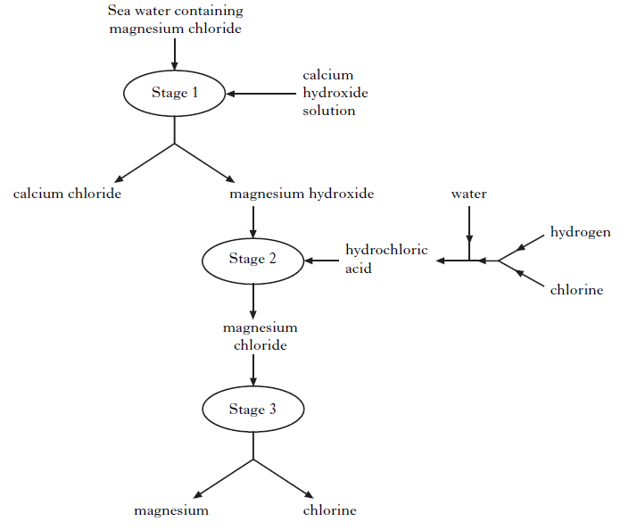

(a) Why can the magnesium hydroxide be easily separated from the calcium chloride at Stage 1? (1)

(b) Name the type of chemical reaction taking place at Stage 2. (1)

(c) Give two different features of this process that make it economical. (2)

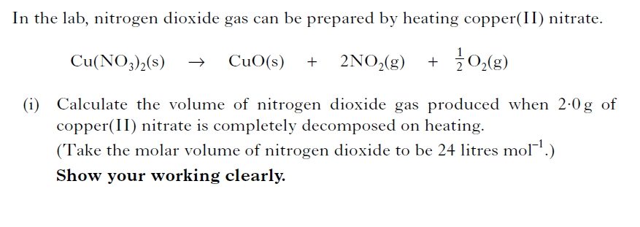
12.)
(2)
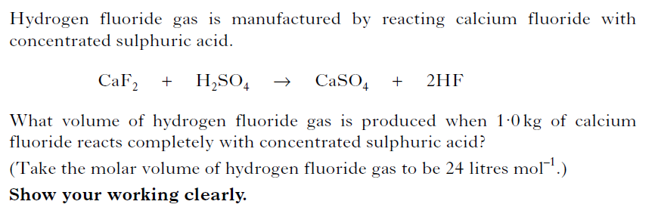
13.)

(2)
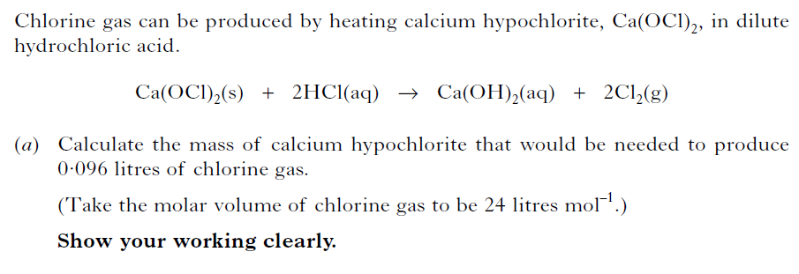
14.)

(2)
15.) In an experiment some oils were used to make soap. The oil, triolein, was reacted with sodium hydroxide.

(C₁₇H₃₃COO)₃C₃H₅ + 3NaOH 3C₁₇H₃₃COONa + C₃H₅(OH)₃
triolein sodium oleate
mass of one mole = 884 g mass of one mole = 304 g

5·0 g of triolein was dissolved in ethanol and placed in a test tube with excess sodium hydroxide. The mixture was heated to 80 ºC. The experiment produced 1·28 g of sodium oleate.

a) Calculate the percentage yield. (2)

b) Calculate the atom economy of this reaction for the production of sodium oleate (2)

c) Why is a high atom economy desired? (1)

