**National 5 Chemistry Problem Solving Booklet- Answer Scheme**

***Unit 1***

1. C
2. C- non-metals react with oxygen to make a non metal oxide 🡪 this then dissolves in water to form acids (pH <7)
3. B- calcium would react to form calcium carbonate that is insoluble 🡪 all other carbonate compounds are soluble and so would not make the water cloudy
4. C- not yet melted so still a solid, less dense that calcium chloride
5. A- gfm = mass/ moles, 12.8/0.2 = 64. Work out gfm for all 4 options, the one that matches 64 is the answer
6. D
7. D- definition of chiral is given in the question- use it!
8. D- because a solid is made in a solution you would filter the solution off to be left with the solid.
9. C
10. D
11. B
12. A *check solubility in data book- if insoluble it would be prepared by a precipitation reaction
13. 1. C and E- forms MgF2 (use SVSDF)
    2. D and E- SiF4 (use SVSDF)
14. A and C
15. A and B
16. 1. 60 seconds (when no more gas is being produced)
    2. Faster
    3. 1. 2Al(NO3)­3
       2. ­2Al 🡪 3H2  
          2 moles 🡪 3 moles  
          2 moles 🡪 72 litres (1 mole of H2is 24 litres, so 3 moles is 72 litres)  
          0.01 moles 🡪 x  
          *CROSS MULTIPLY*  
          = 0.36 litres
17. 1. Al2(Co3)3 + 6HCl 🡪 2AlCl3 + 3H2O + 3CO2
    2. 1. Because a gas is produced so mass of reaction mixture decreases
       2. 51 – 26 / 70 – 20 = 0.5 g s-1
       3. Because the reactants are being used up
18. 1. Zn + 2HCl 🡪 ZnCl2 + H2
    2. Full diagram drawn of flask with lid on and contents labelled (zinc + hydrochloric acid and copper catalyst) with delivery tube going to either a gas syringe or upside down measuring cylinder in water.
19. 1. Andalusite and Kyanite
    2. Temperature = 500-700  
       Pressure = 0.5=4 *the temp and pressure shown must go through all 3 sections on the graph!)
20. 1. As gfm increases, bond enthalpy decreases.
    2. ~ 290 kJ mol-1
    3. 1. Ca2+Cl-2
       2. 2H+ + (OH-)2 🡪 2H2O
21. 1. Because it doesn’t react with air or water etc.
    2. Neutrons = mass number – atomic number, 197 – 79 = 118
    3. CO + O2 🡪 CO2
    4. Catalyst (speeds up reaction)
    5. Hydrogen/hydroxide (because it comes from an acid)
22. 63Cu, because it is the closest to the RAM of 63.5
23. 1. *line graph* must have labels and units for 1 mark, scale going up in regular numbers for 1 mark and points plotted accurately for 1 mark.
    2. 1. 59 – 14 / 40 – 10 = 1.5cm3 s-1
       2. ~ 3 cm3 s-1
24. 1. Hydroxyl
    2. Weak acid and strong base
    3. *from passage- 99% is captured, so this means only 1% is released*  
       1% of 300 = 3 tonnes
    4. Fe3+2O2-3*use SUSDF- valency = charge*
    5. Exothermic
25. 1. Evaporating

Heating with Bunsen in an evaporating dish removes the water, leaves copper sulfate solid.

* 1. Moles = mass/gfm = 3.19 / 159.5 = 0.02 moles  
     c = moles / v 0.02 / 0.2 (volume MUST be in litres) = 0.2 mol l-1

1. 1. 2.8.6- lost an electron due to positive charge!
   2. Mg (g) 🡪 Mg+ (g) + e- *description of first ionisation energy is in the question!*
   3. Decreases as you go down a group  
      Lithium 🡪 Sodium 🡪 Potassium  
      526 🡪 502 🡪 425
2. 1. Humans can’t store potassium
   2. Moles = mass/gfm = 0.89 / 39 = 0.02 moles
   3. Lilac (page 6 of data book)
   4. K+NO3-
3. (79 x 55) + (81 x 45) / 100 = 4345 + 3645 / 100 = 79.9%
4. 1. Al3+(OH-)3 *use SVSDF, change = valency*
   2. 11.2 (16 x 0.7)
   3. Magnesium hydroxide- doesn’t fizz, is cheap, and not a lot is needed to neutralise acid- MUST explain your choice!!
5. 1. Red
   2. Line should increase towards 7 but should NEVER reach pH7 as you are only diluting a substance- not neutralising it.
6. 1. As concentration increases, freezing point decreases
   2. ~ -1.8 / -1.9 *must be a negative value!*
7. 1. Increases (Li 🡪 Na 🡪 K)
   2. Decreases
   3. Ca should be slightly shorter than K
8. 1st oxygen  
   2nd argon  
   3rd nitrogen
9. 1. Carbonate ion concentrations have decreased
   2. Helps shells develop due to presence of calcium carbonate
   3. Releases CO2 when fuels are burned
10. 1. 2
    2. Powder 🡪 lumps
    3. 0.5g
11. Method B because you are weighing the initial mass of reactants before the reaction has actually started
12. 1. Covalent (non-metals bonded in compound name)
    2. 1g absorbs 30g, so 10g absorbs 300g.
13. 1. 1. Strong acid and weak alkali
       2. 7, both strong acids and alkalis
    2. 1. Metals + acid 🡪 salt + hydrogen  
       2. Metal oxides + acid 🡪 Salt + water  
       3. Metal carbonates + acid 🡪 Salt + Water + CO2*much more detail than this is needed for 3 marks- saying what bases are, what is a neutralisation reaction etc.*
14. 1. Carbon nanotube
    2. Lithium
    3. Moles = mass/gfm = 41 / 2 = 20.5 moles

***Unit 2***

1. C
2. D
3. B – same formula but different structure
4. B – find compound similar in above group eg. double bond and hydroxyl group only.
5. C – same family of hydrocarbons
6. B – apply all of the formulas to the 4 compounds given, only 1 applies to all
7. B
8. B – melting point is 17C, so not yet liquid
9. A and D
10. [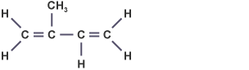](https://www.google.co.uk/url?sa=i&rct=j&q=&esrc=s&source=images&cd=&cad=rja&uact=8&ved=&url=https://www.bbc.co.uk/education/guides/zchnn39/revision&psig=AOvVaw2xihNEu0SDogJw6MDgjtQ0&ust=1512126740248449) C
11. *must have double bonds so each carbon had 4 bonds*

b. delivery tube should be going in to a test tube with a lid on that is placed in a beaker of cold water. *all the info is in the paragraph in the question*

c. i. addition  
ii. C10H16Br4 (breaks 2 double bonds)

1. Boiling point decreases when a halogen atom is added to the second carbon.  
   as you add on a halogen atom that is further down group 7, the boiling point increases.
2. 1. CnH2n – 2
   2. Pent-1-yne
   3. 1. 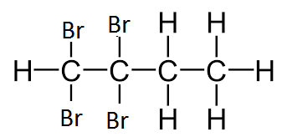 *must add on where triple bond is*
      2. Addition
3. 1. A, because as soon as you light the burner it loses mass so not a true representation.
   2. 1. If the functional group is on the first carbon atom then the energy released is greater than if it’s on the second carbon atom.
      2. ~ 3970 kJ
      3. E = c m Δ T  
         23 = 4.18 x 0.1 x ΔT  
         ΔT = 23 / 0.418 = 55⁰C
4. 1. Methoxypropane
   2. CnH2n + 2O
   3. Weak/ strong
   4. 1. 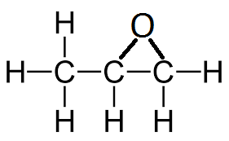Ethene
5. Butyl propanoate
6. 1. Method B can contain the energy whereas method A loses energy to surroundings.
   2. 4.18 x 0.1 x 34 = 14.21 kJ
7. 1. 101
      1. Hydrogen
      2. Because the =O would not be on the end of the molecule, it would be in the middle.
8. 1. But-2-ene
   2. Same molecular formula, different structural formula.
   3. 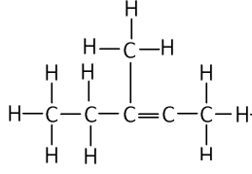
9. 1. CnH2nO2
   2. Ethanol + propanoic acid
10. 1. As number of carbons increase, the flash point increases
    2. ~ 49 ⁰C
11. 1. Between 8 – 14
    2. Ethene
    3. Benzoic acid
12. 1. As percentage increases, the density decreases
    2. 20%
13. 9 x 1.25 / 3.8 = 2.96
14. 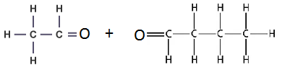 *must split where double bond is*
15. 1. Carbon dioxide
    2. 1. 100 x 70.4 / 56.3 = 125.04
       2. £130
16. 1. 36-126⁰C (pentane-octane)
    2. ~ 0.713 g/cm3
17. 1. Ethyne
    2. 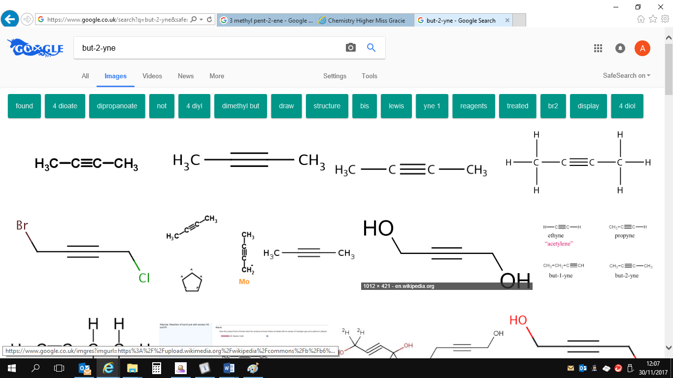
18. 1. C4H6
    2. Aromatic
19. 1. 1. Top right circle = waste gases  
          Middle right circle = Hot air  
          Bottom right circle = Iron  
          Bottom left circle = Impurities
       2. Because melting point of iron is 1538 so below this temperature iron would still be in solid state, therefore wouldn’t be able to flow.
    2. Fe2+ (aq) 🡪 Fe3+ (aq) + e-

***Unit 3***

1. 1. Iron
   2. 54%
   3. As temperature increases, percentage yield decreases.
   4. Low temperature, high pressure
2. *open ended question*
3. 1. Aluminium is less dense than iron *page 7 of data book*
   2. *open ended question*
4. 1. Aluminium or silicon or carbon
   2. Oxidation is loss of electrons  
      reduction is gain of electrons
   3. It is too reactive a metal
5. *open ended questions*
6. 1. Electrolyte- lets ions flow
   2. 10.92V
   3. Lower voltage as copper is less reactive than zinc and is closer to silver on the reactivity series.