Rates of Reaction Past Paper Questions

- The diagram below shows the energy profile for a reaction carried out with and without a catalyst.
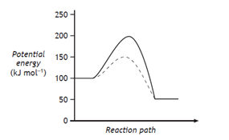
What is the enthalpy change, in kJ mol⁻¹, for the catalysed reaction?
A -100
B -50
C +50
D +100
2016 CfE

- A reaction has the following potential energy diagram.
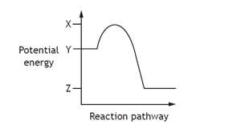
The activation energy for the forward reaction is:
A X-Y
B Y-X
C Y-Z
D Z-Y
2015 CfE,
- In which of the following will both changes result in an increase in the rate of a chemical reaction?
A A decrease in the activation energy
and an increase in the frequency of
collisions.
B An increase in activation energy and
a decrease in particle size.
C An increase in temperature and an
increase in the particle size.
D An increase in concentration and a
decrease in the surface area of the
reactant particles.
Specimen CfE
- Which of the following is not a correct statement about the effect of a catalyst?
A provides energy so that more
molecules have successful collisions.
B lowers the energy that molecules
need for successful collisions.
C provides an alternative route to the
products.
D forms bonds with reacting
molecules.
Specimen CfE

- The graph shows how the rate of a reaction varies with the concentration of one of the reactants.
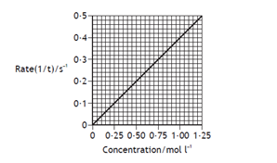
Calculate the reaction time, in seconds, when the concentration of the reactant was 0.5 mol l⁻¹.
A 0.2
B 0.5
C 2.0
D 5.0
Specimen CfE

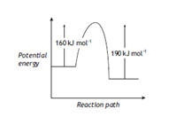
When a catalyst is used, the activation energy of the forward reaction is reduced to 35 kJ mol⁻¹. What is the activation energy of the catalysed reverse reaction?
A 30 kJ mol⁻¹
B 35 kJ mol⁻¹
C 65 kJ mol⁻¹
D 190 kJ mol⁻¹
Exemplar CfE
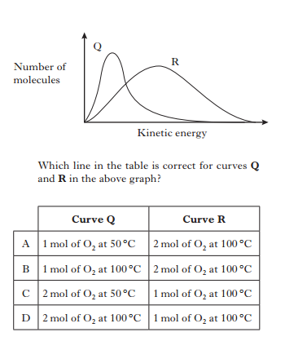
Rev H 2014
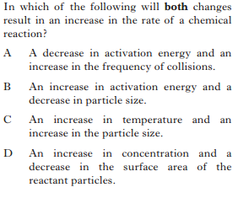

Rev H 2013
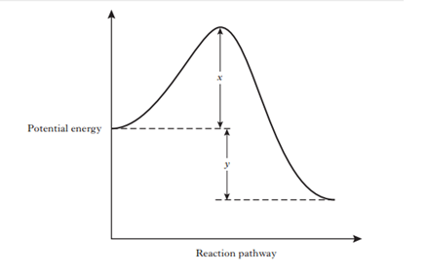
- Which of the following diagrams represents an exothermic reaction which is most likely to take place at room temperature?
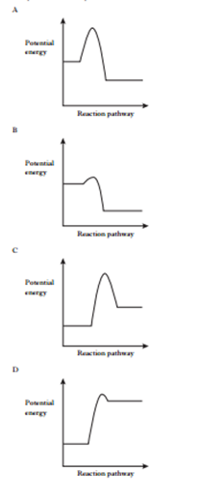
Rev H 2013

- The enthalpy change for the forward reaction
can be represented by
A X
B Y
C X+Y
D X-Y
Rev H 2012
- In a reaction involving gases, an increase in temperature results in
A an increase in energy.
B an increase in the enthalpy change.
C a decrease in the activation energy.
D more molecules per second forming
an activated complex.
Rev H 2012

11.
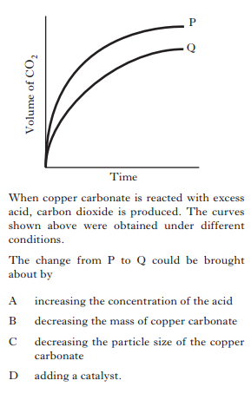
Rev H Specimen
12.
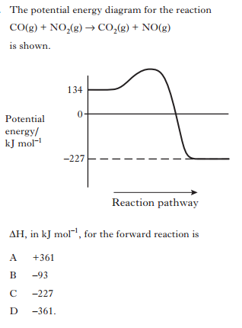 Rev H Specimen

Section B

1.
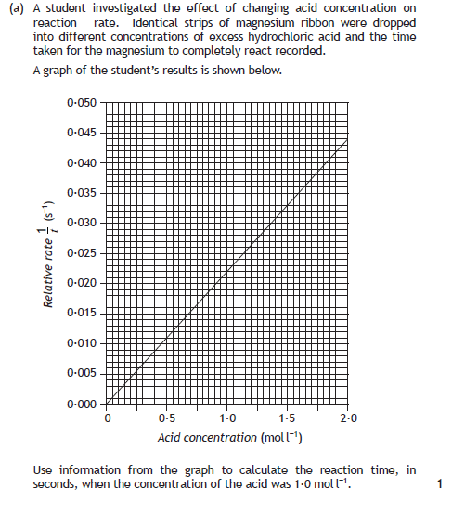
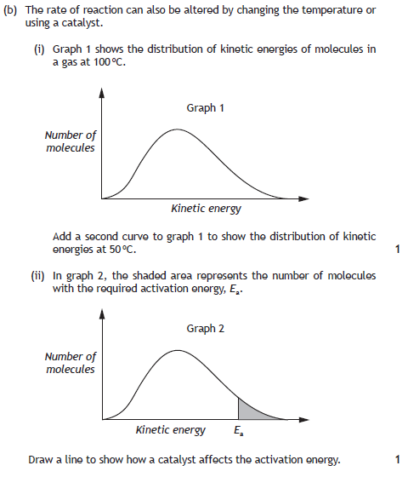

2015 CfE

2.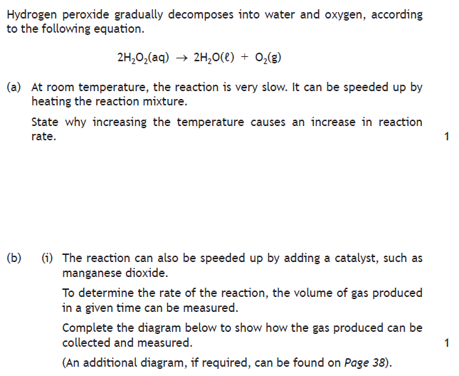
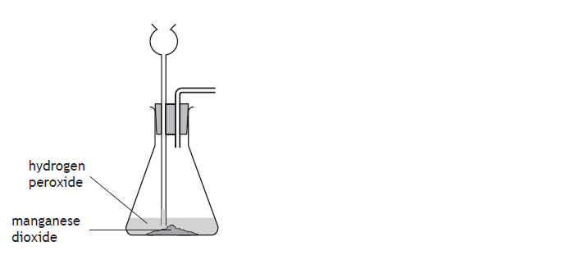
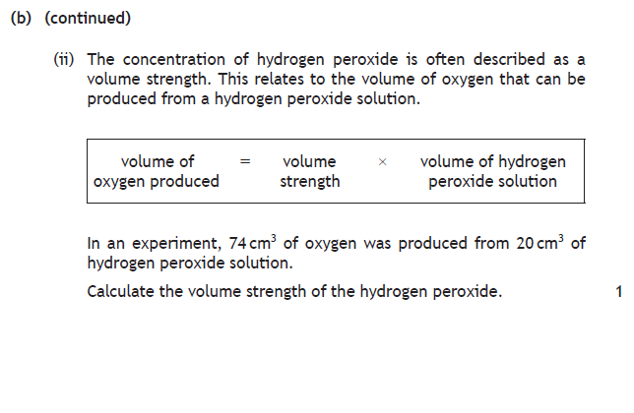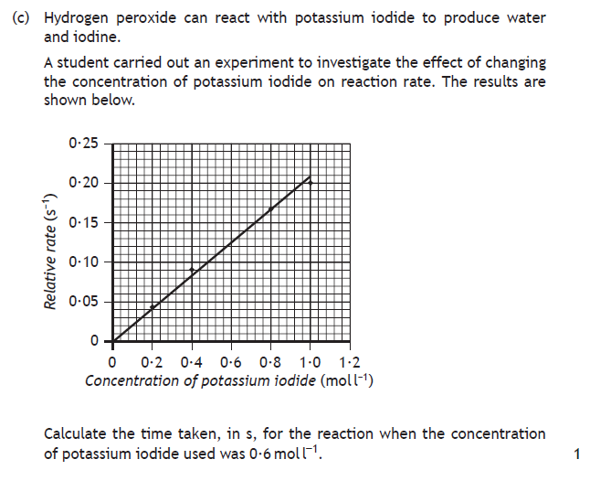2016 CfE
3.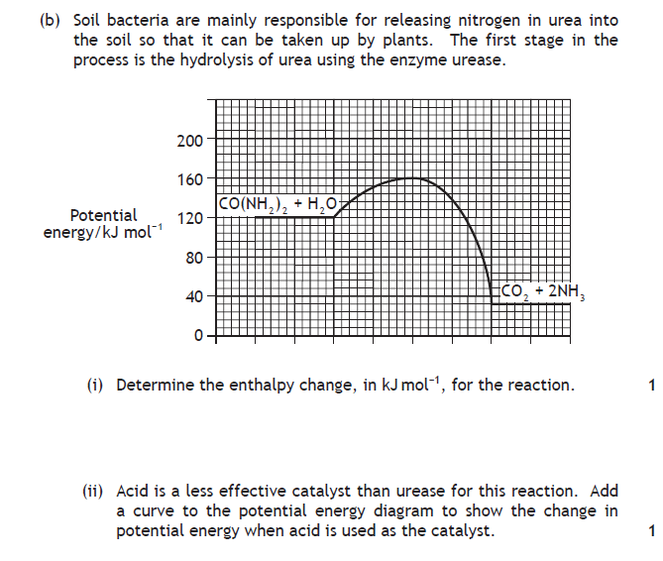Specimen CfE

4.
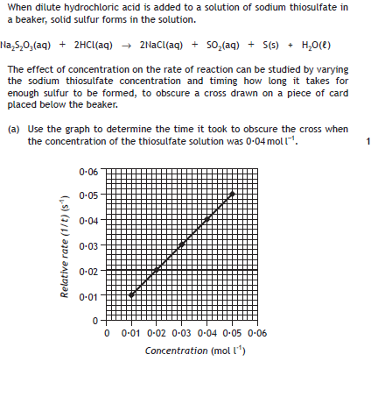
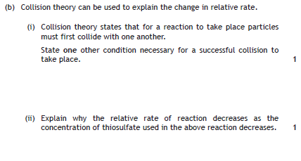Exemplar CfE

5.
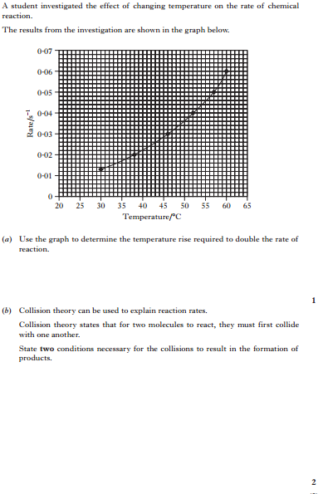 Rev H 2014
6.
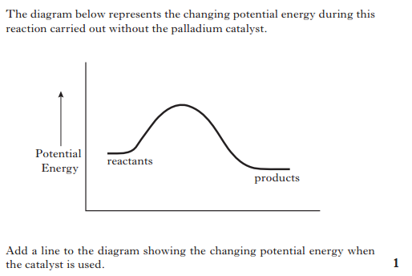
Rev H Specimen

