**Periodicity and Bonding Past Paper Questions**

**Trends in the Periodic Table**

**1.**

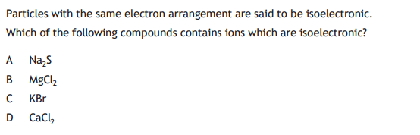CfE 2016

**2.**  
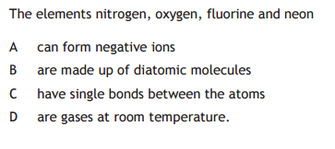  
CfE 2015

**3.**  
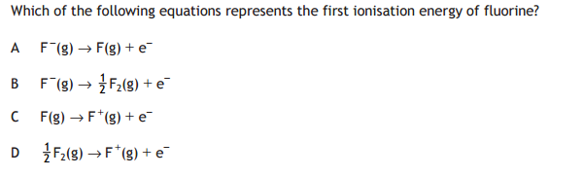CfE 2015

**4.**  
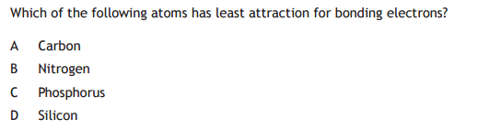CfE 2015

**5.**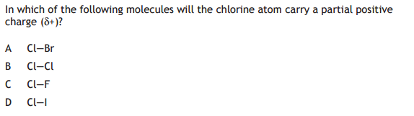  
CfE Specimen

**6.**

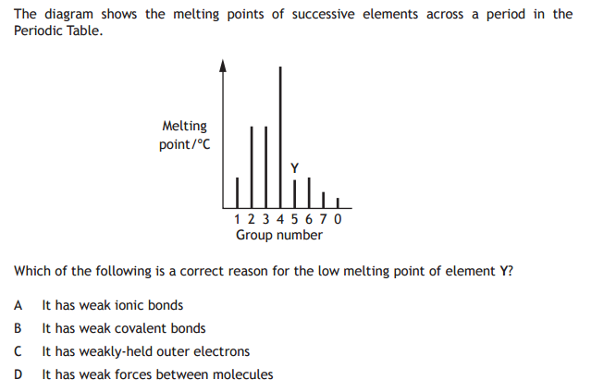

CfE Specimen

**7.**

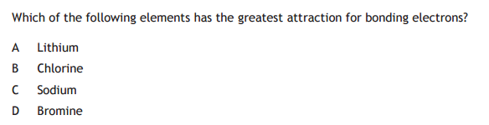

CfE Exemplar

**8.**

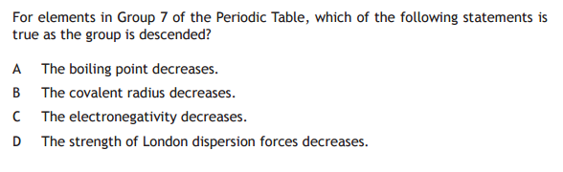

CfE Exemplar

**9.**

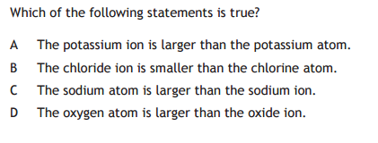

CfE Exemplar

**10.**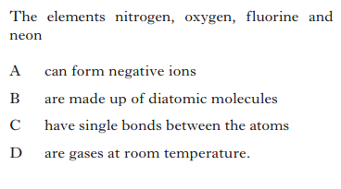

Rev H 2015

**11.**

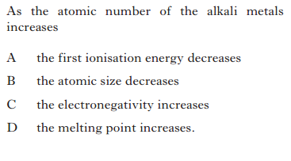  
 Rev H 2015

**12.**

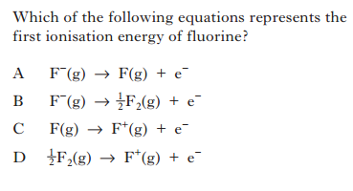

Rev H 2015

**13.**

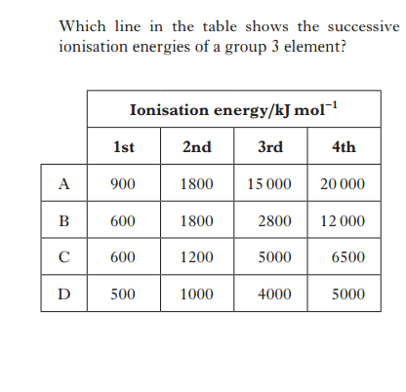

Rev H 2015

**14.**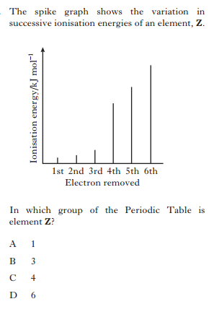

Rev H 2014

**15.**  
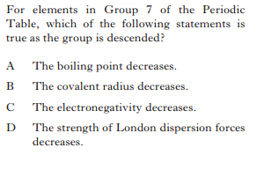

Rev H 2014

**Section B**

**1.**

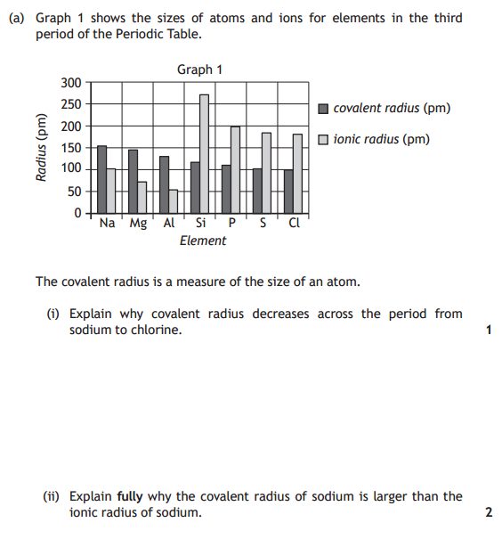

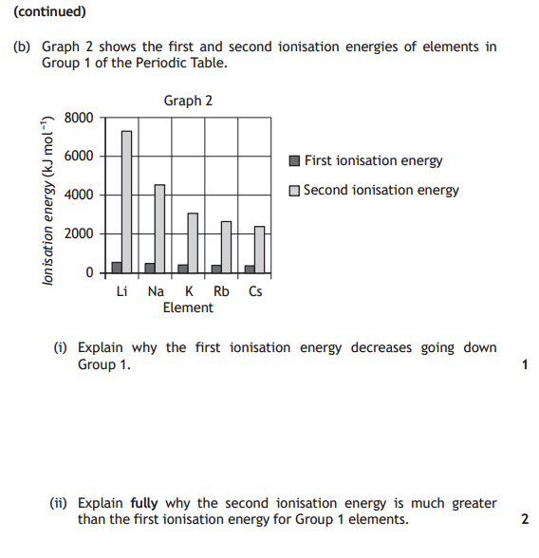

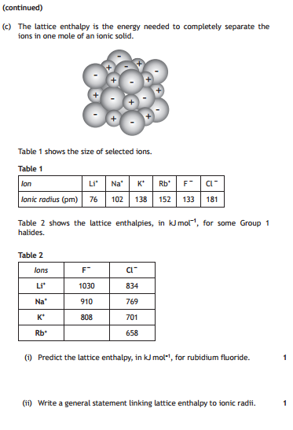 CfE 2016

**2.**

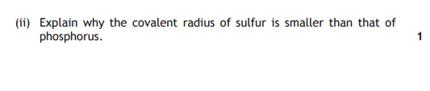

CfE 2015

**3.**

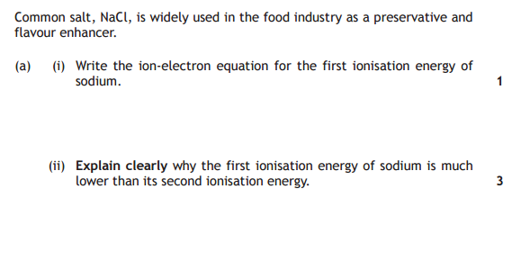

CfE Specimen

**4.**

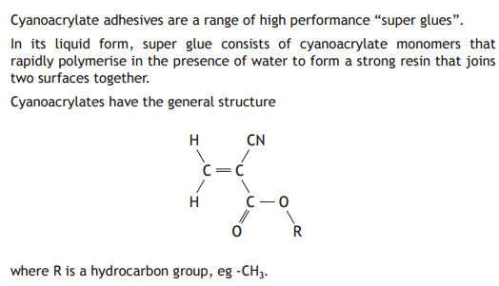

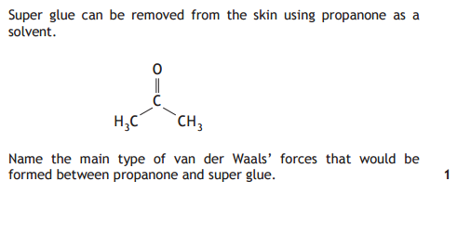

CfE Specimen

**5.**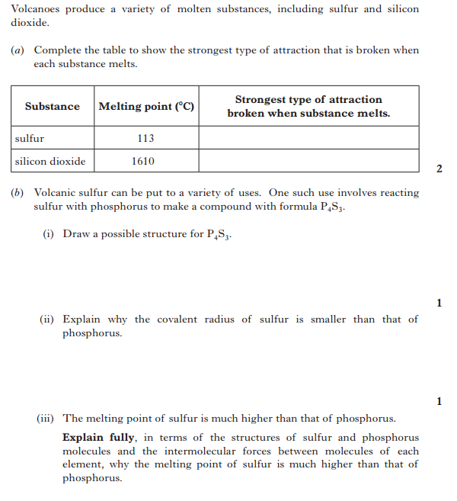

Rev H 2015

**6.**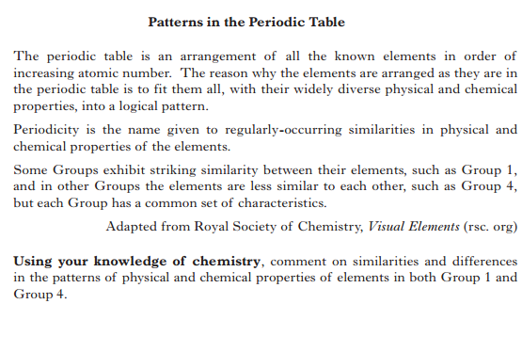

Rev H 2015

**7.**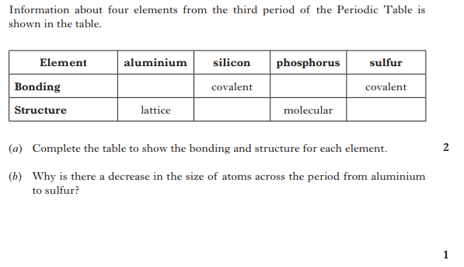

Rev H 2014

**8.**  
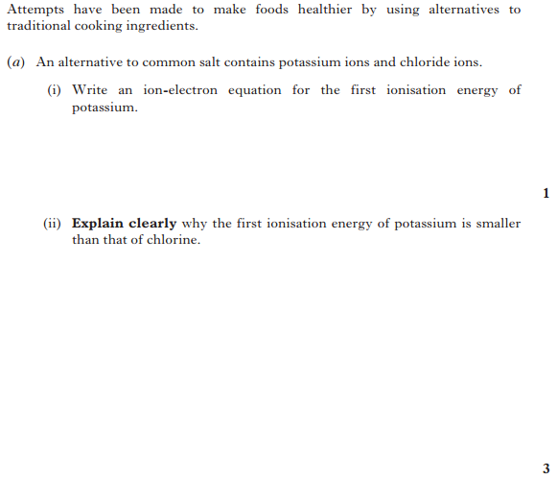

Rev H 2013

**9.**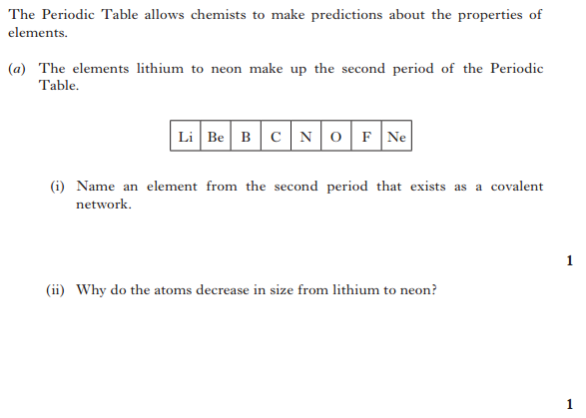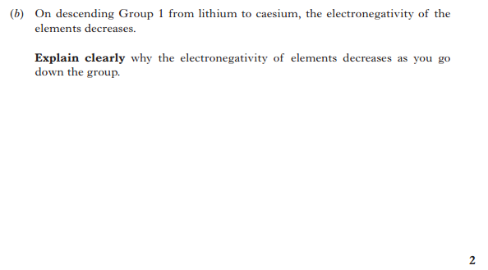

Rev H 2012

**Bonding**

**1.**  
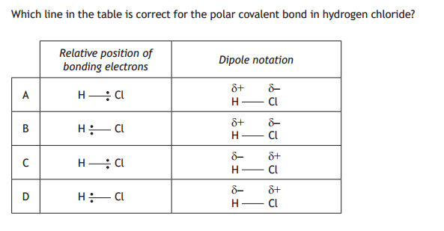  
CfE 2016

**2.**  
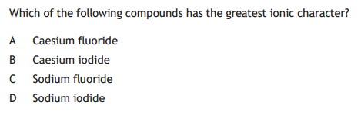

CfE 2016

**3.**

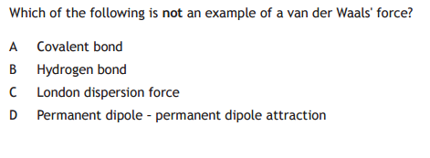  
CfE 2015  
**4.**  
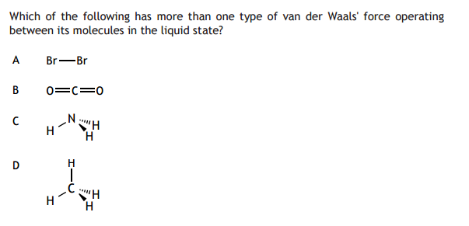

CfE 2015

**5.**  
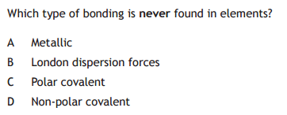  
CfE Specimen

**6.**

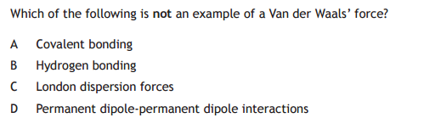CfE Specimen

**7.**  
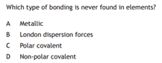  
CfE Exemplar

**8.** 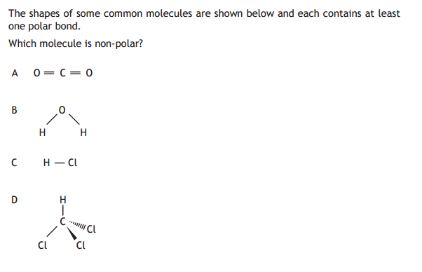

CfE Exemplar

**9.**

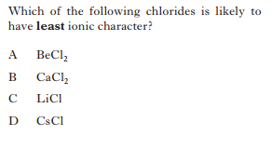Rev H 2014  
**10.**  
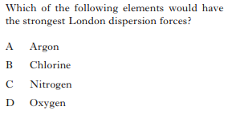

Rev H 2014

**11.**  
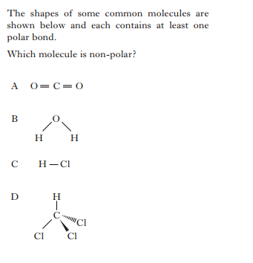Rev H 2014

**12.**

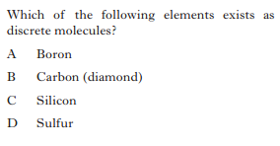

Rev H 2013

**13.**  
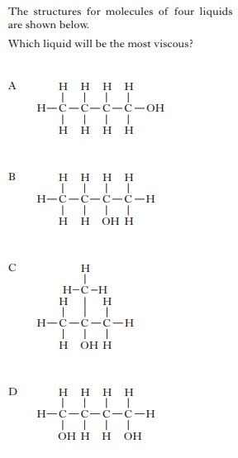

Rev H 2013

**Section B**

**1.**

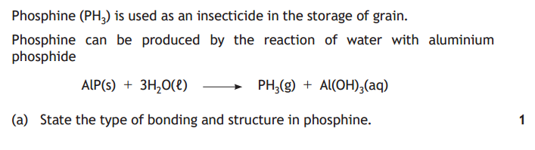  
CfE 2016  
  
**2.**

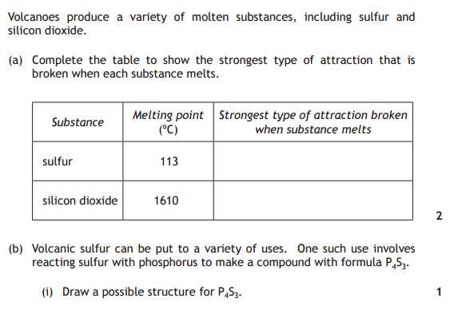

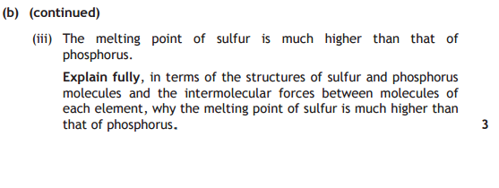   
CfE 2015  
 **3.**

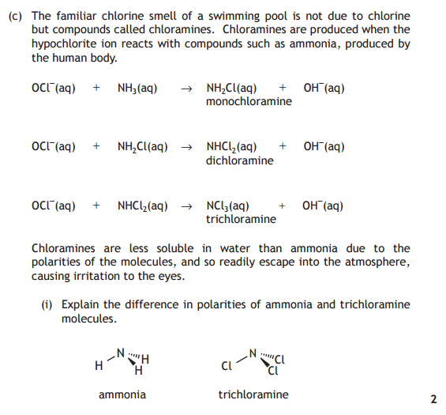  
CfE 2015

**4.**

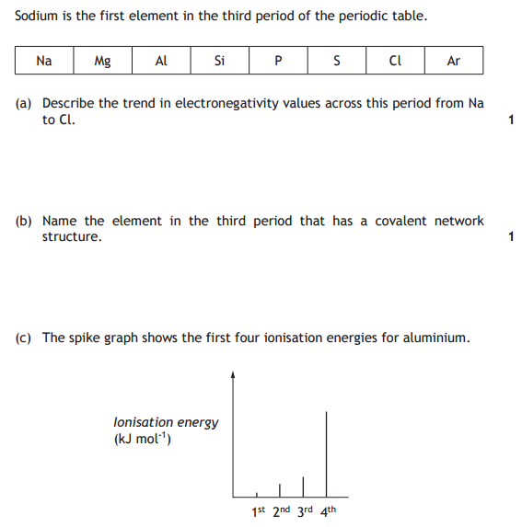 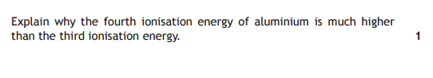

CfE Exemplar

5.

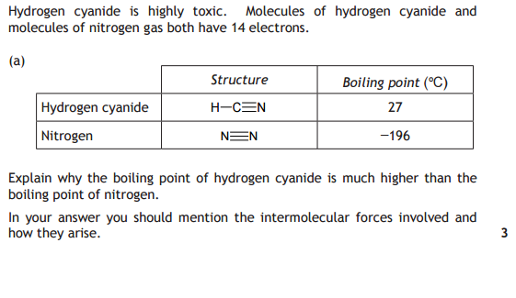

CfE Exemplar  
  
**6.**

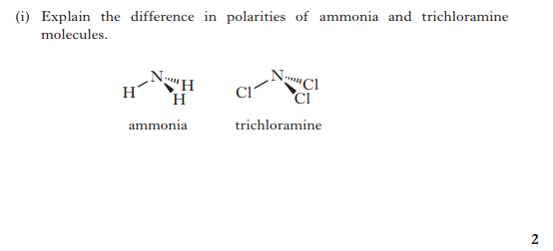

Rev H 2015

**7.**

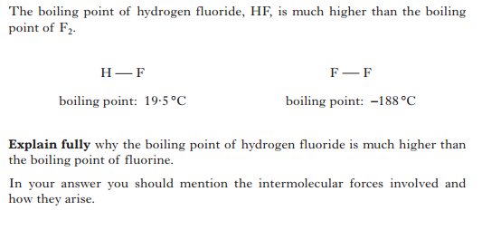   
Rev H 2014

**8.**  
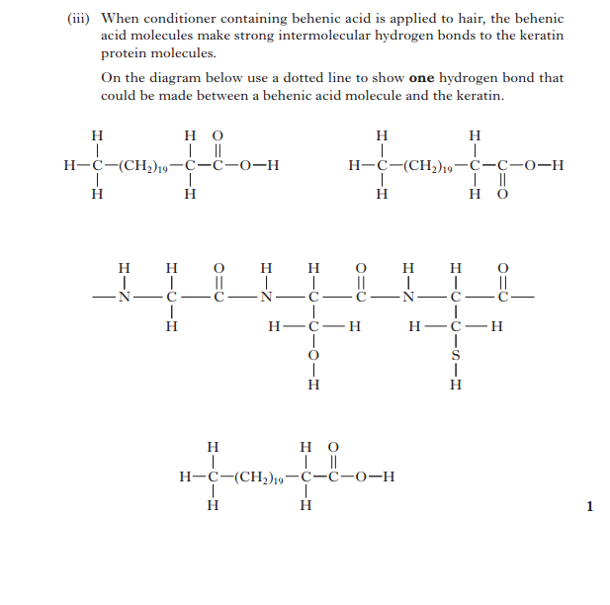  
Rev H 2014

**9.**

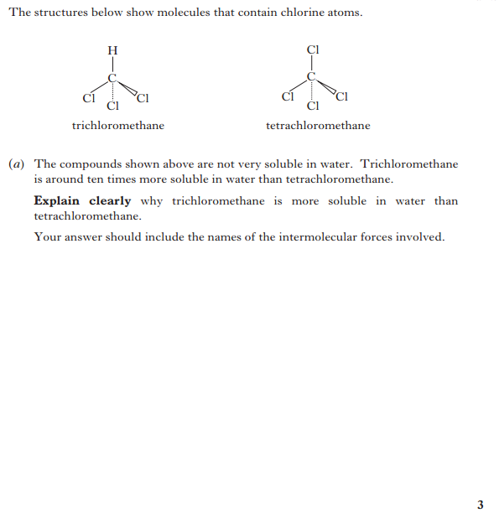

Rev H 2013

**10.**

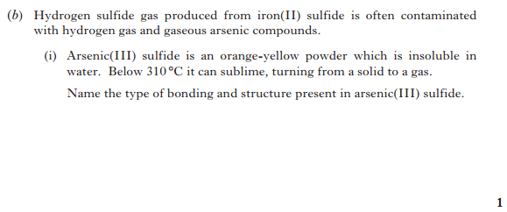  
Rev H 2013

**11.**

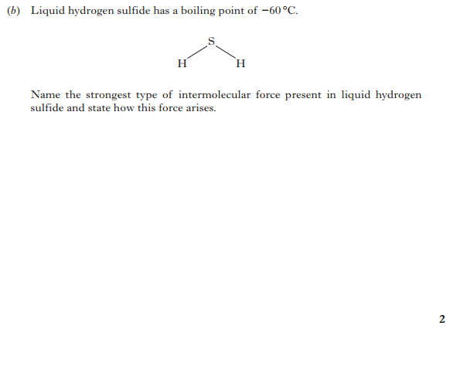

Rev H 2012