By Unit then Key Areas; Section A Questions followed by Section B (section B where covering multiple key areas are given when the last content in the question is covered – assuming order as key areas)

Researching Chemistry unit 2
Gravimetric Analysis 2
Volumetric Analysis 3
Practical skills and Techniques 4
Stoichiometric Calculations 5
Across Units 5

Researching Chemistry unit

Gravimetric Analysis
Section B Answers
Q |  | Source | Answer (from SQA Mark Scheme)
1 | 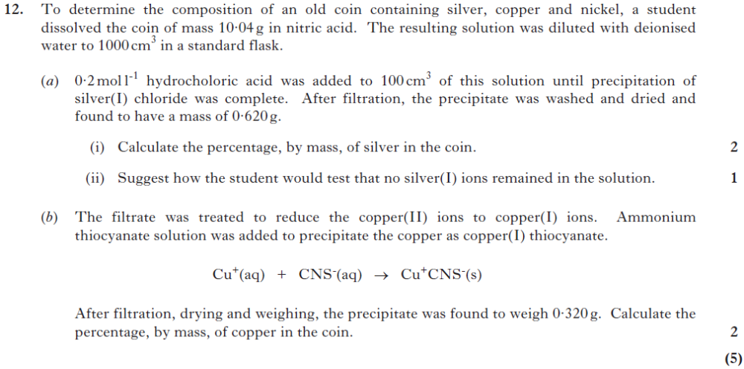 | 2014  Rev/12 | a)1 mark for  AgCl 1 mole = 143·4g  Mass of Ag in 100 cm3 =  (107·9/143·4) × 0·620 = 0·467g  1 mark for  % Ag in coin = (4·67/10·04) × 100 = 46·5 %  47/46·514/46·51  (0·467/10·04) × 100 = 4·65 % = 1  ii) Add more HCl, (no more precipitate should  form)/add more Cl− ions/add Br− ions/add I−  ions.  Any other reasonable suggestion plus result  eg add aldehyde → silver mirror  b)1 mark for  CuCNS, 1 mol = 121·6 g  Mass of Cu in 100 cm3  = (63·5/121·6) × 0·320 = 0·167 g  1 mark for  % Cu in coin = (1·67/10·04) × 100 = 16·6 %  17/16·64/16·644  1·66 % = 1

Volumetric Analysis
Section A Answers
Q |  | Source | Answer
1 | 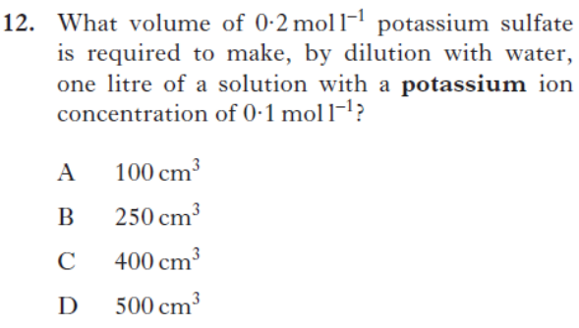 | 2013Rev/12 | B

Section B Answers
Q |  | Source | Answer (from SQA Mark Scheme)
1 | 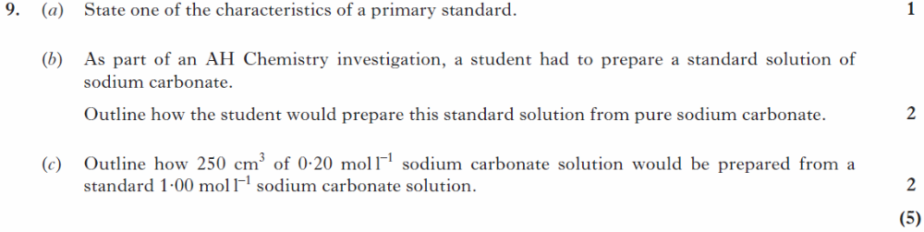 | 2013  Rev/9 | a)  Fairly high molecular mass/available in high purity/ (thermodynamically) stable/soluble in water or named solvent/soluble  b)  1. Accurately weigh required/correct mass of Na2CO3 and dissolve completely in small volume of water.  2. Transfer the solution to a standard flask, rinsing the beaker with deionised water and transferring the rinsing’s to the flask.  3. Add deionised water up to the mark adding the last few drops with a dropper.  4. Invert to mix.  (Deduct 1 mark for each error/omission up to maximum of 2 marks)  c)  Measure 50cm3 of stock solution using a pipette and transfer to a 250cm3 standard flask. Add deionised water up to the mark, stopper and invert.  (1 for correct volume, 1 for correct procedure)  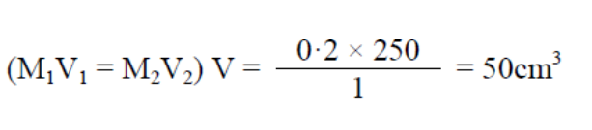
2 | 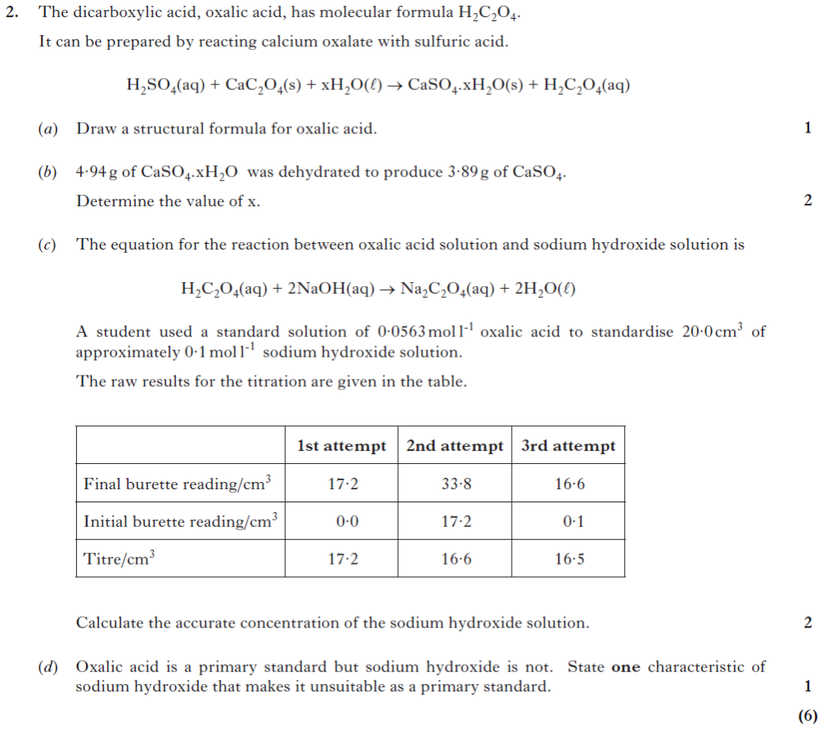 | 2014  Rev/2 | a)  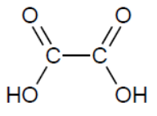HOOCCOOH/ ignore bond angles  b)  1 mark for  Number of moles of CaSO4 = 3·89/136·1  = 0·0286  Number of moles of H2O = 1·05/18  = 0·0583  1markfor  Value of x = 2  Must be a whole number.  Ignore sig figs in working.  c)  1 mark for  n for oxalic acid = 16·55 × 10−3 × 0·0563  = 9·32 × 10−4  1 mark for  c for NaOH = (9·32 × 10−4 × 2)/0·020  = 0·0932 mol l−1  0·093/0·09318/0·093177  If use non concordant (16·77 cm3)  = 0·0944 mol l−1 =1 mark  d)  Not available in high purity/not stable in solid  or solution/solid is deliquescent/hygroscopic/  low gfm/absorbs water/absorbs CO2

Practical skills and Techniques
Section A Answers
Q |  | Source | Answer
1 | 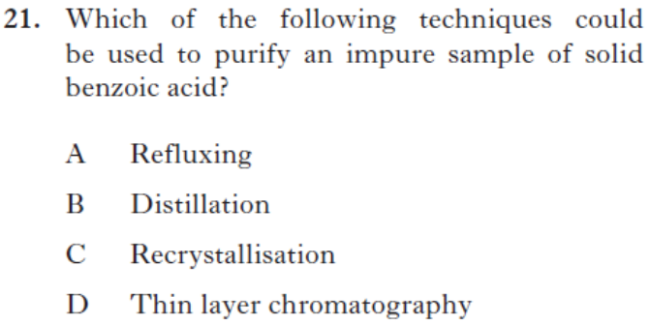 | 2013Rev/21 | C

Section B Answers
Q |  | Source | Answer (from SQA Mark Scheme)
1 | 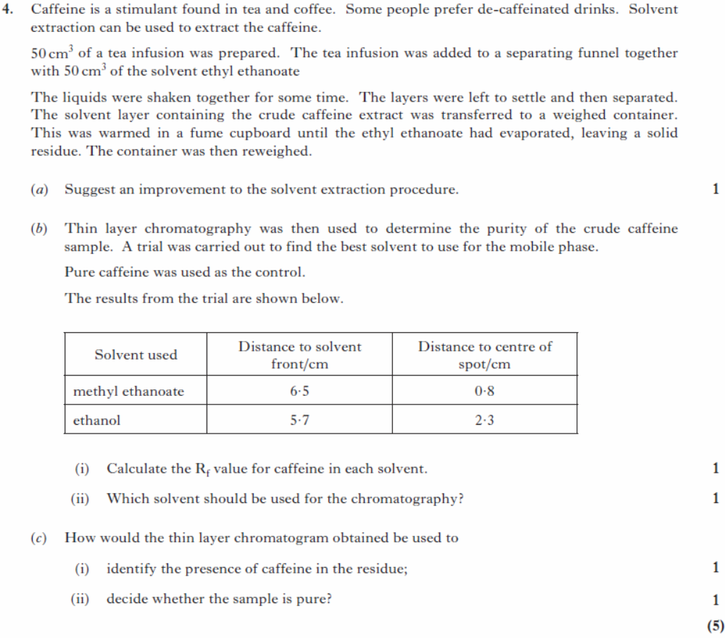 | SQP/4 | a) Carry out several extractions with smaller volumes of solvent  b)i) In methyl ethanoate, Rf=0.8/6.5 = 0.12  In ethanol, Rf = 2.3/5.7 = 0.40  Both correct for 1 mark  ii) ethanol  c)i) if the chromatogram shows a spot with the same Rf value as the pure caffeine or a spot that travels the same distance relative to the solvent front as pure caffeine (or similar correct answer)  c)ii) If there is only one spot then the caffeine extract is a single substance
2 | 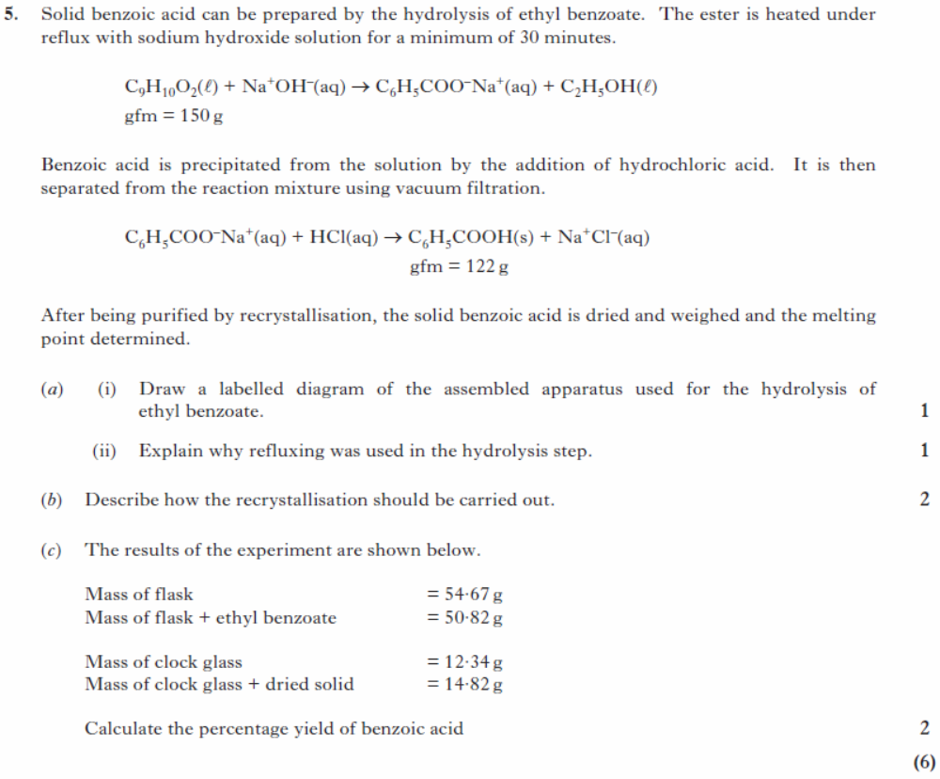 | SQP/5 | Ai) Diagram to show, as a minimum, a condenser and round bottom flask correctly assembled with the condenser, ethyl benzoate and sodium hydroxide labelled. Cooling water must be going in from lower inlet and leaving from upper outlet.  Unacceptable  Untidy diagram, unworkable system.  Cooling water travelling in wrong direction.  ii)  To prevent volatile compounds escaping  or so that the reaction mixture can be boiled without it being lost by evaporation or any similar correct answer  b)  Dissolve in (appropriate) solvent, heat (to dissolve target compound  and impurities)  filter to remove solid impurities, leave to cool.  Or all 4 points covered = 2 marks, 2 or 3 points = 1 mark  c)  1 mark for  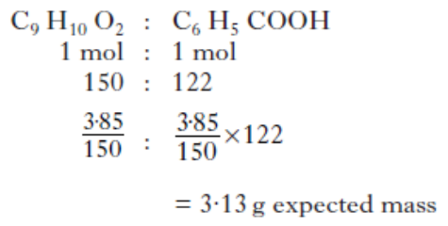  1 mark for  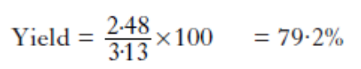
3 | 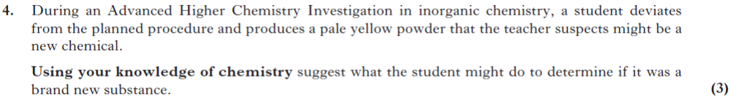 | 2014  Rev/4 | This is an open ended question.  1 mark: The student has demonstrated a  limited understanding of the chemistry  involved. The student has made some  statement(s) which is/are relevant, showing  that at least a little of the relevant chemistry is  understood.  2 marks: The student has demonstrated a  reasonable understanding of the chemistry  involved. The student makes some  statements which are relevant showing  understanding of the problem.  3 marks: The maximum available mark  would be awarded to a student who has  demonstrated a good understanding of the  chemistry involved. The student has shown a  good understanding of the chemistry involved  and has provided a logically correct answer to  the question asked. This type of response  might include a statement of the principles  involved, a relationship or an equation and an  application of these to answer the question.  This does not mean that the answer has to be  what might be termed an ‘excellent’ or  ‘complete’ answer.
4 | 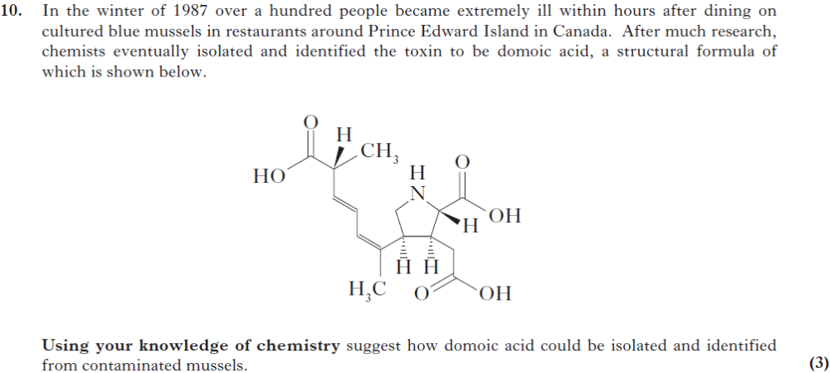 | 2014  Rev/10 | As above
5 | 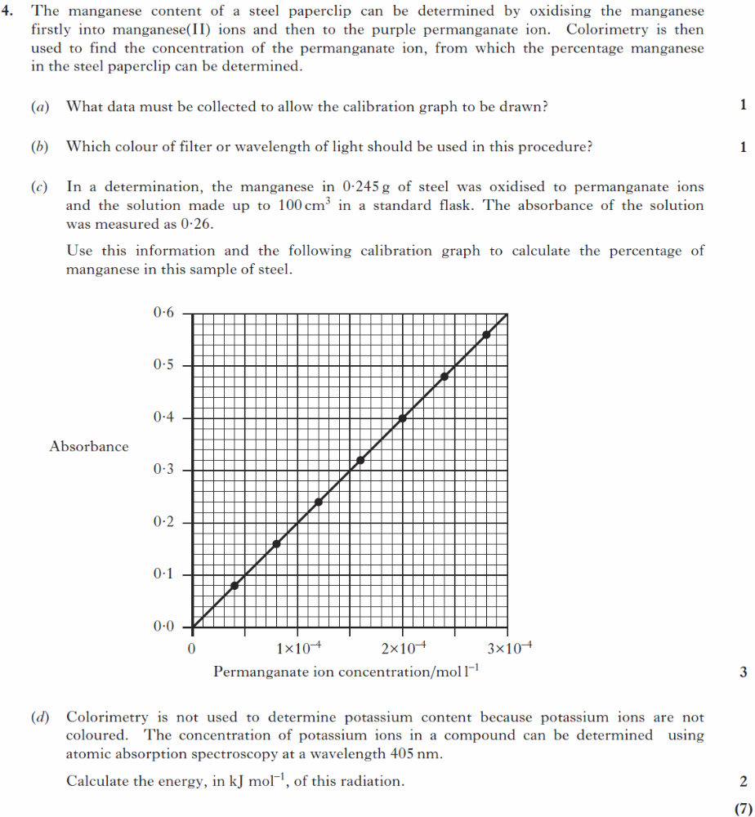 | 2013  Rev/4 | a)  A series of standard solutions of different concentrations of KMnO4 is made up and their absorbances measured.  Absorbances of permanganate solutions of known concentrations/variety of concentrations  (must mention permanganate or manganate or purple solutions)  Accept absorbancy/absorption/transmittance/ transmission  b)  Green or 500 to 560 nm  (Accept blue-green or green-yellow)  Unacceptable – complementary colour  c)  (Absorbance = 0·26) so [MnO4−] = 13 × 10−5 (mol l−1) 1  In 100 cm3, n = 1·3 × 10−5 mol  mass of Mn = 1·3 × 10−5 × 54·9 = 0·0007137 1  % Mn = (0·0007137/0·245) × 100 = 0·29 % 1  d)  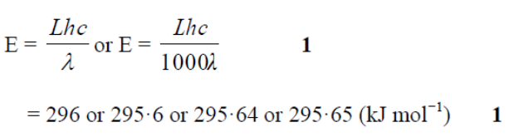
6 | 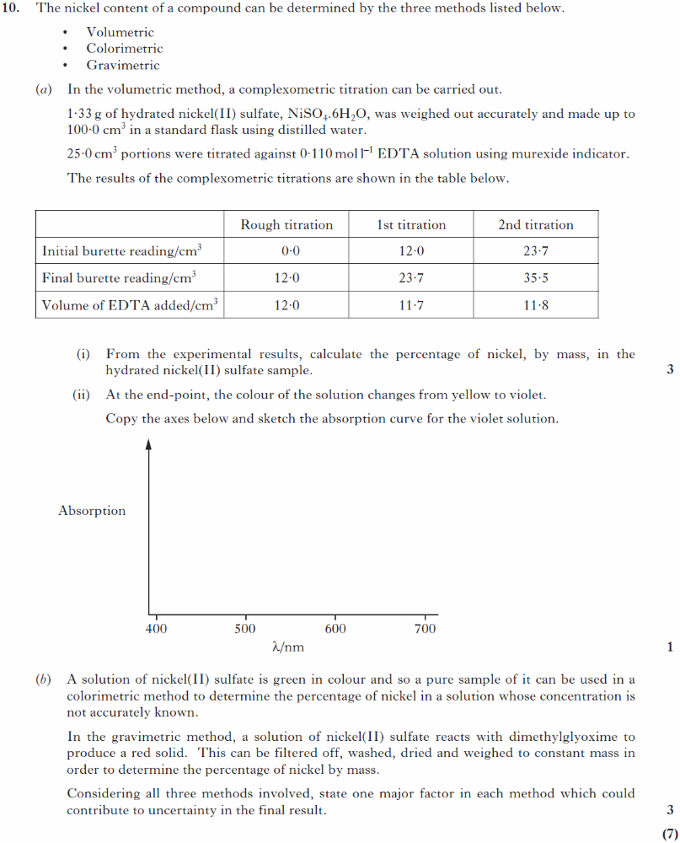 | SQP/  10 | ai)  1 mark for  n(EDTA) = c × V = 0·11 × 0·01175 = 1·29 × 10^{–3}  n(Ni) = 4 × 1·29 × 10^{–3} = 5·16 × 10–3  1 mark for  mass Ni = 5·16 × 10–3 × 58·7 g = 0·303 g  1 mark for  % = (0·303/1·33) × 100 = 22·8 %  ii)  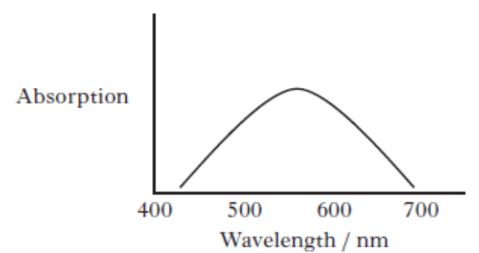  b)  Acceptable answers include:  Titration: end-point uncertainty  Colorimetric: reliability of calibration graph or  dilute solution giving low absorbance  Gravimetric: small mass of sample giving large uncertainty in balance  readings/mass transfer or mechanical losses  1 mark per method

Stoichiometric Calculations
Section A Answers
Q |  | Source | Answer
1 | 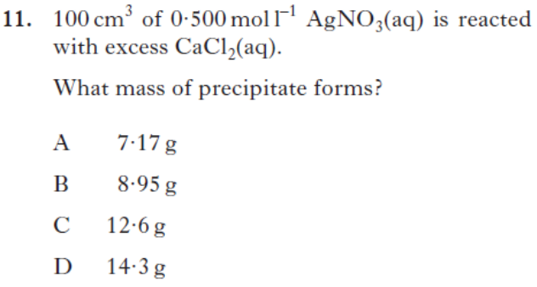 | 2013Rev/11 | A

Across Units
Section A Answers
Q |  | Source | Answer
1 | 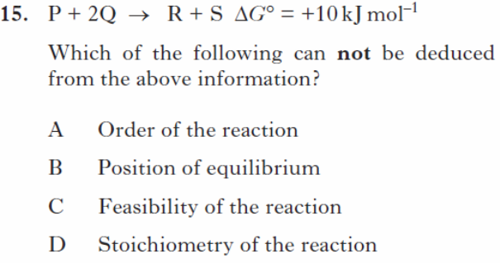 | 2013Rev/15 | D
2 | 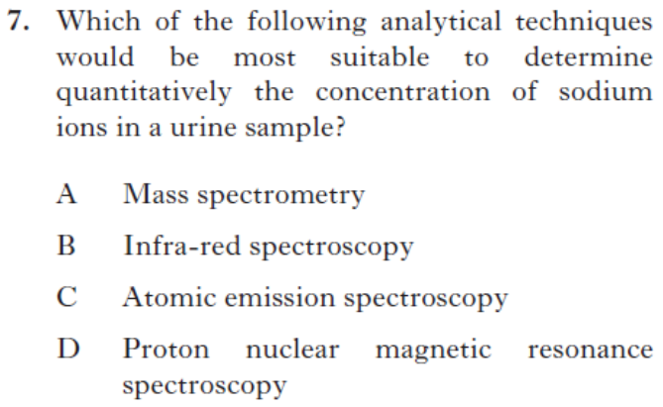 | 2013Rev/7 | C

Section B Answers
Q |  | Source | Answer (from SQA Mark Scheme)
1 | 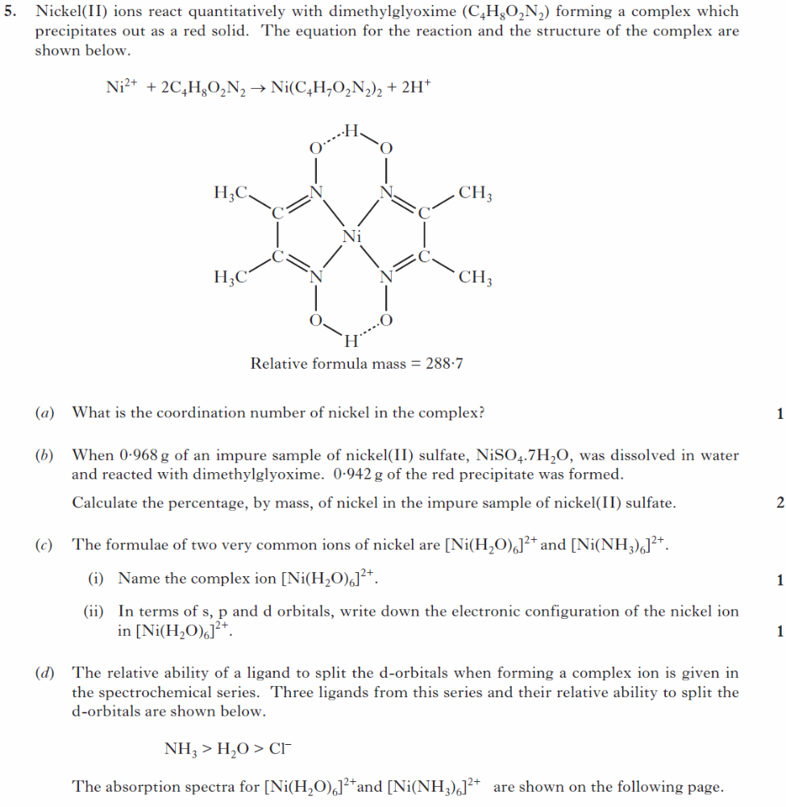  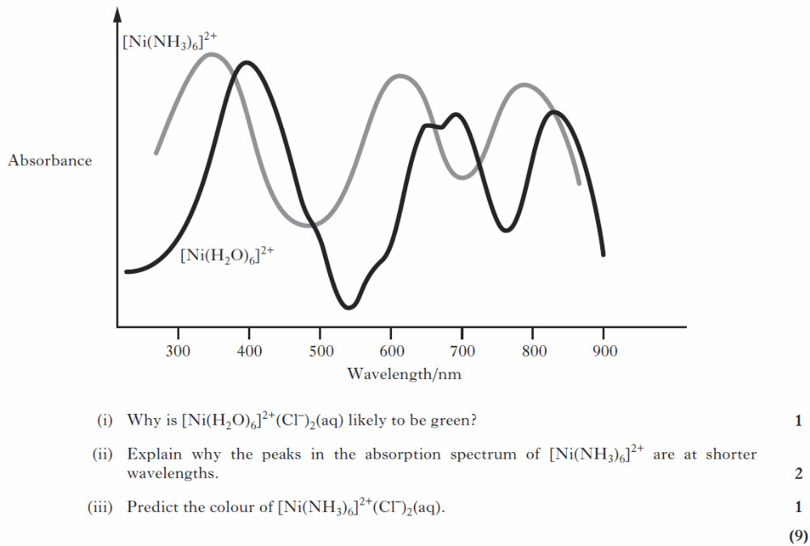 | 2013  Rev/5 | a)4 or four  b)  Mass of nickel in DMG complex  = 0·942 × (58·7/288·7) = 0·1915 g or 0·192 g 1  % Ni in impure salt = (0·1915/0·968) × 100 = 19·8 % 1  (Accept 19·79 % and 19·786 % and 19·835 % or 19·83 %)  (Deduct 1 mark per error up to a maximum of 2 marks)  c)i)  Hexaaquanickel(II)  Unacceptable  Hexaquanickel(II)  Hexaaquonickel(II)  Hexaaquanickel(2)  ii)  1s² 2s² 2p⁶ 3s² 3p⁶ 3d⁸  1s² 2s² 2p⁶ 3s² 3p⁶ 3d⁸ 4s⁰  d)i)  Red and blue are absorbed/green light transmitted or not absorbed  Light of approx. 500 – 600 nm transmitted/not absorbed  Unacceptable  Absorbs wavelength complementary to the wavelength of green  ii) 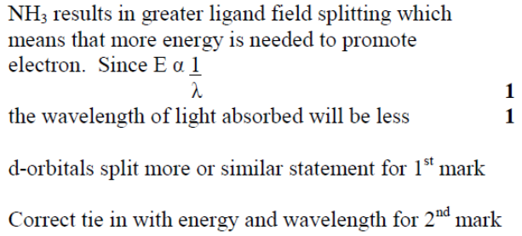  iii)  purple/blue-green/blue/blue-violet
2 | 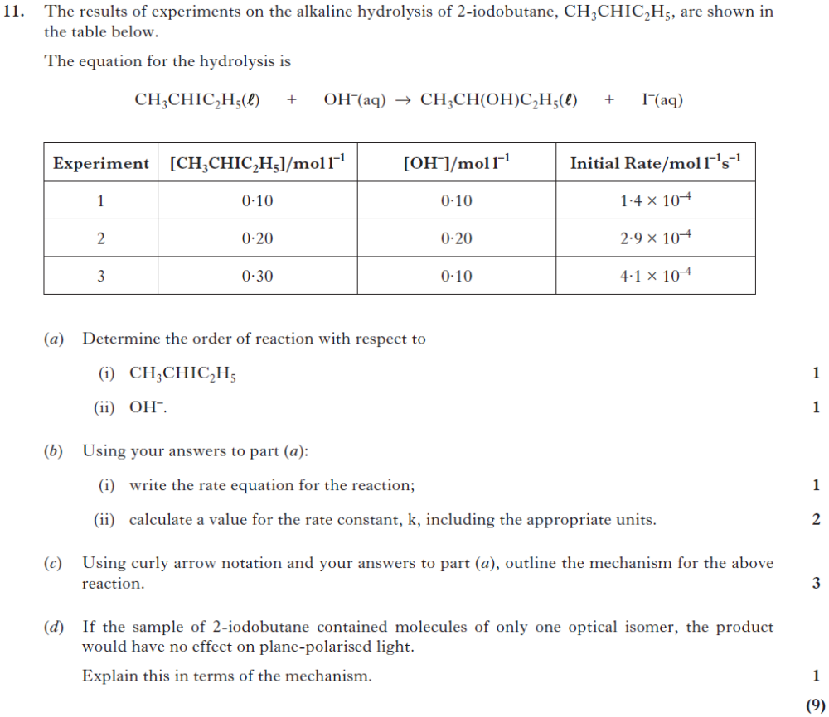 | 2014  Rev/11 | Ai)1 or first  ii) 0 or zero  unacceptable – no order  b)i) Rate = k[CH3CHIC2H5]  must follow from answer a)  must be small k  b)ii) Accept (1·37 − 1·45) × 10−3  Units = s−1  1·4 × 10−3 using first line of the table.  Follow through from (a) and/or (b) (i)  c)  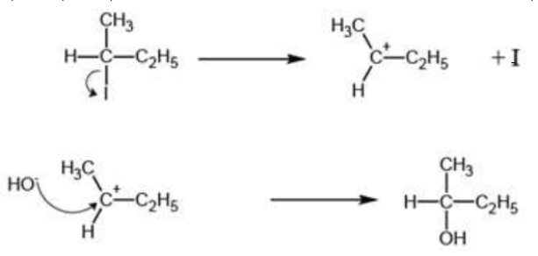  1 for correct use of curly arrows.  Follow through from (a) – 2nd order – SN2  mechanism.  Carbocation on its own = 1  Second line with both reactants and product  = 1  Ignore bonds to wrong atoms in carbocation  only.  Shape of carbocation is not important  For SN2, 1 mark for correct 5-membered  transition state with bracket and –ve charge.  Dotted bonds not needed.  1 mark = correct reactants and products

