**National 5 Chemistry**

**Mearns Castle H.S**



Calculations Booklet

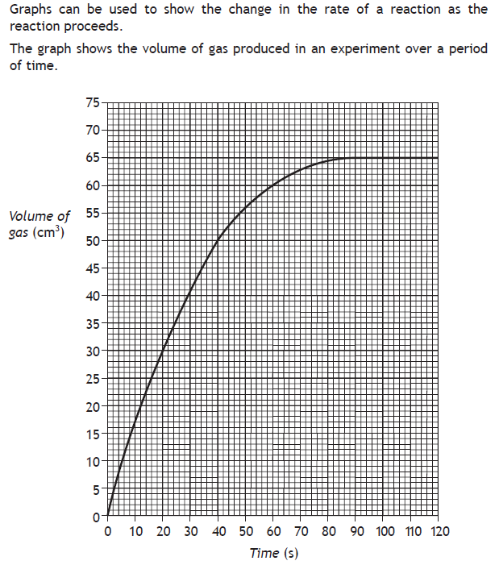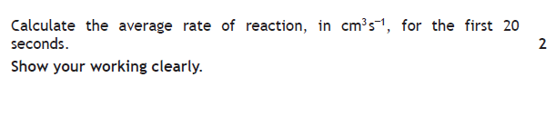

**1.**

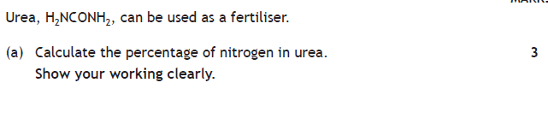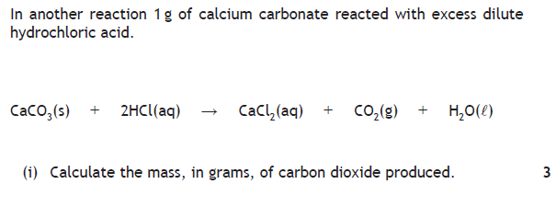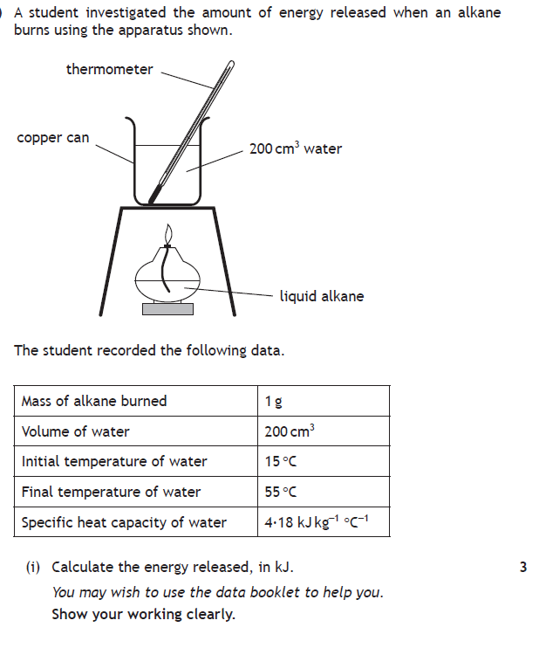

**2.**

**3.**

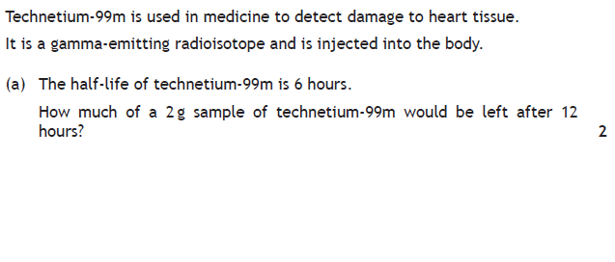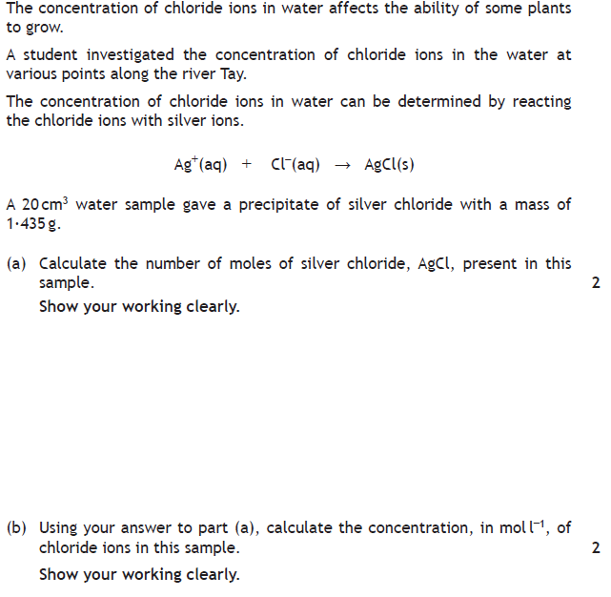

**5.**

**4.**

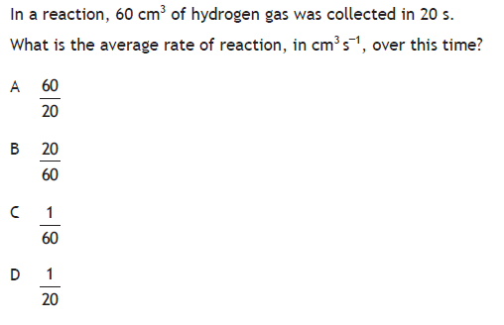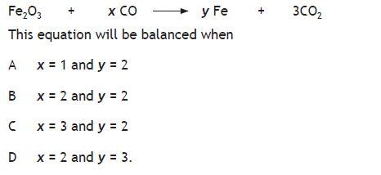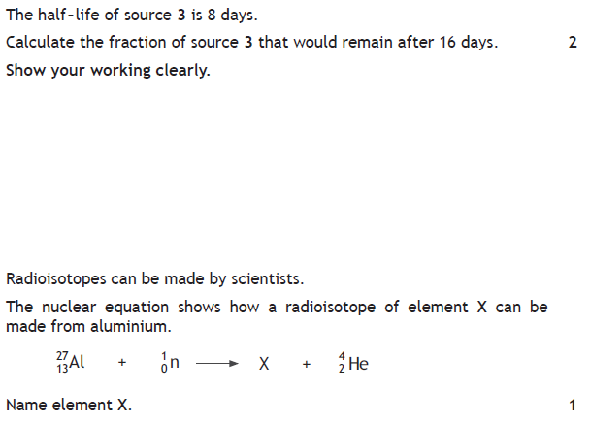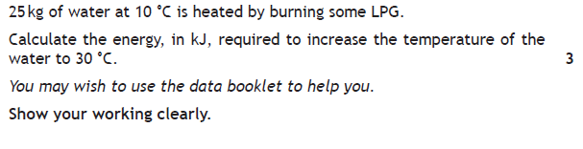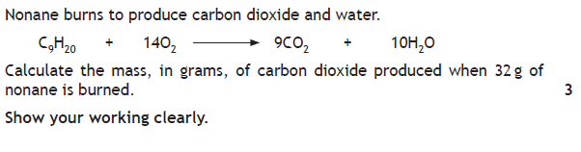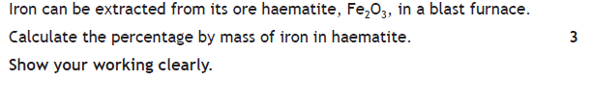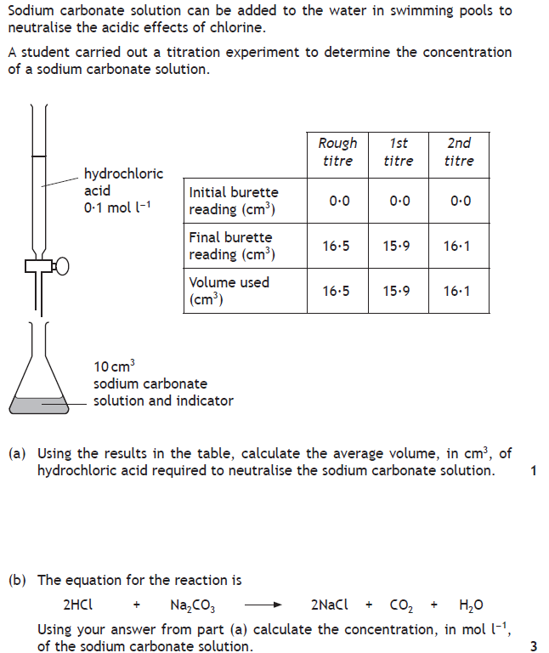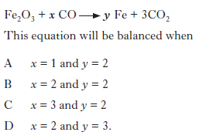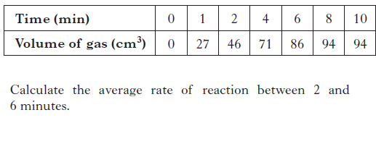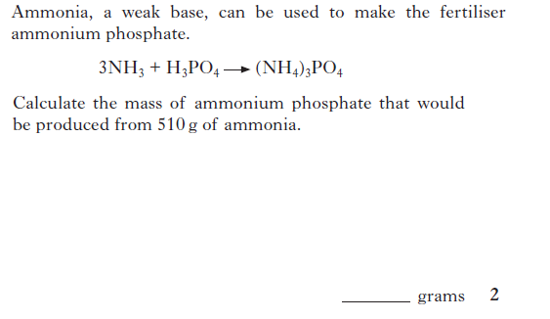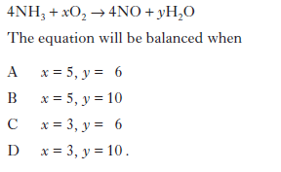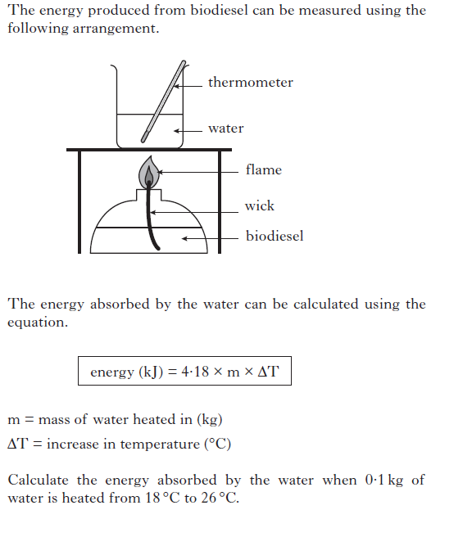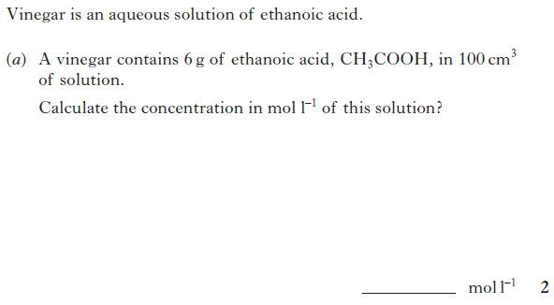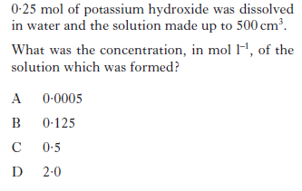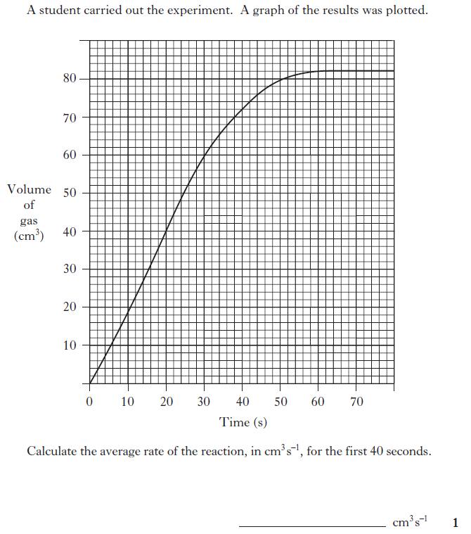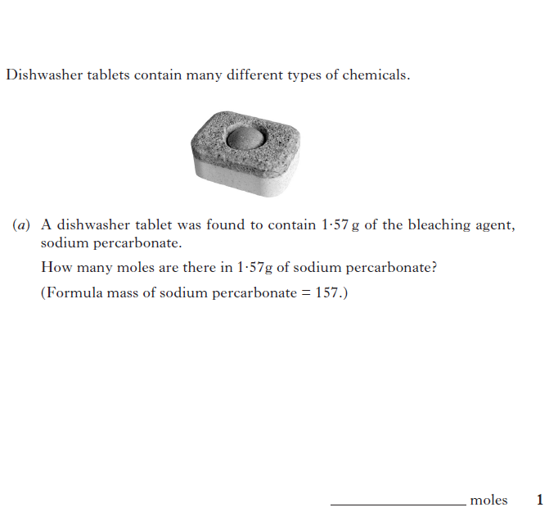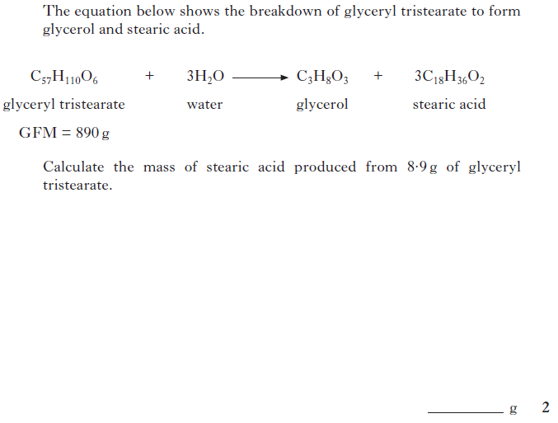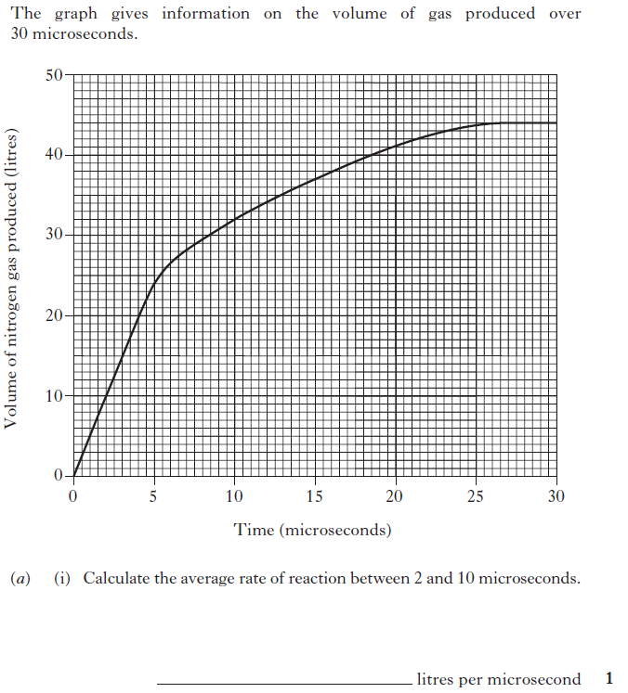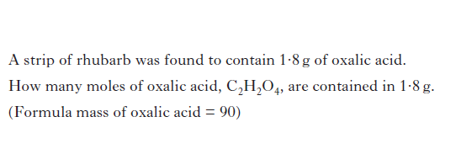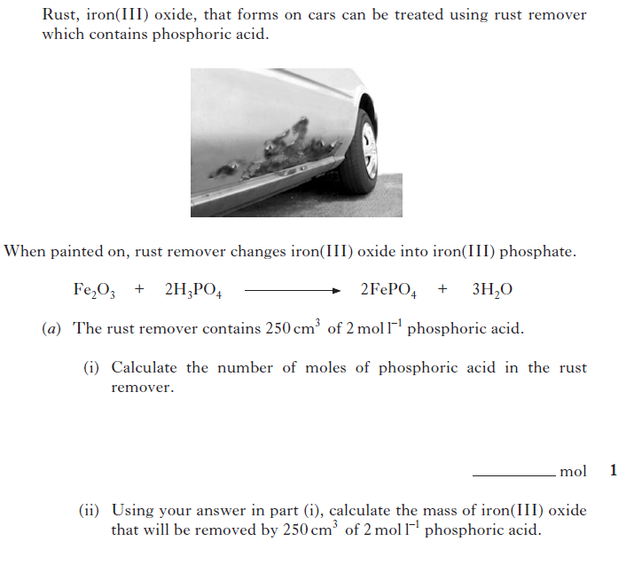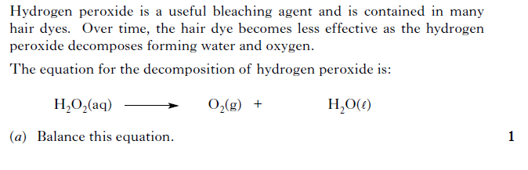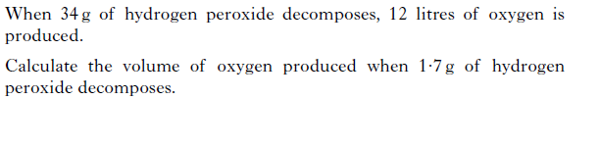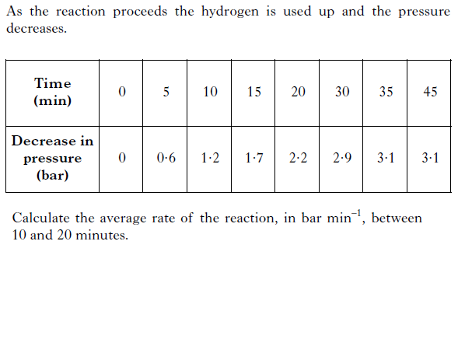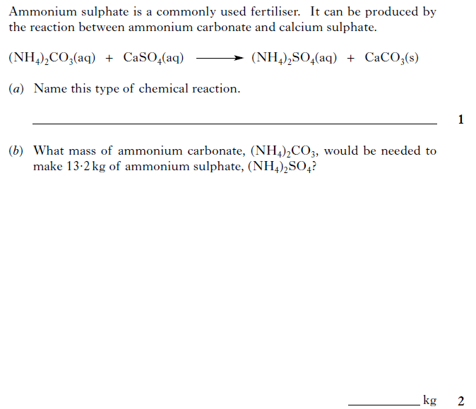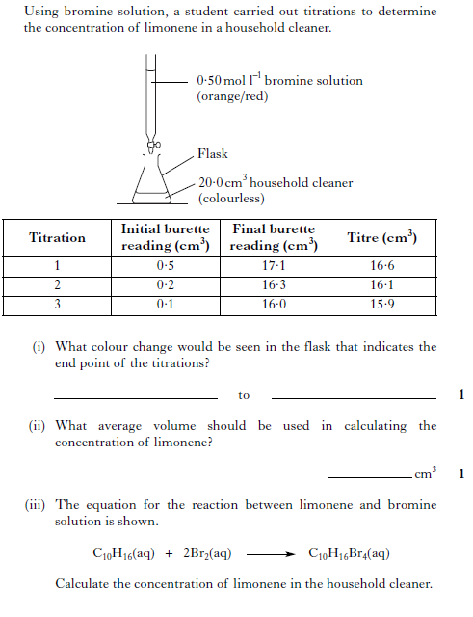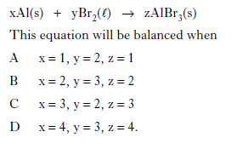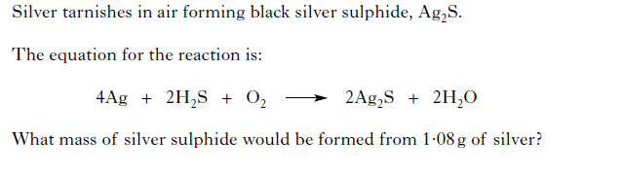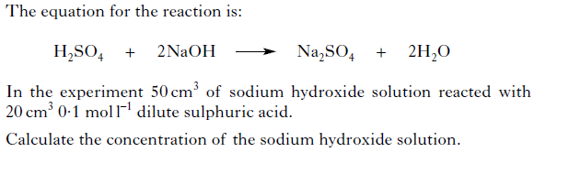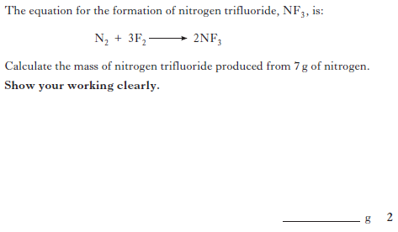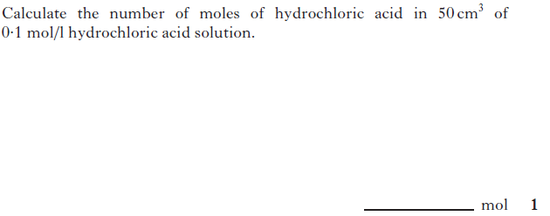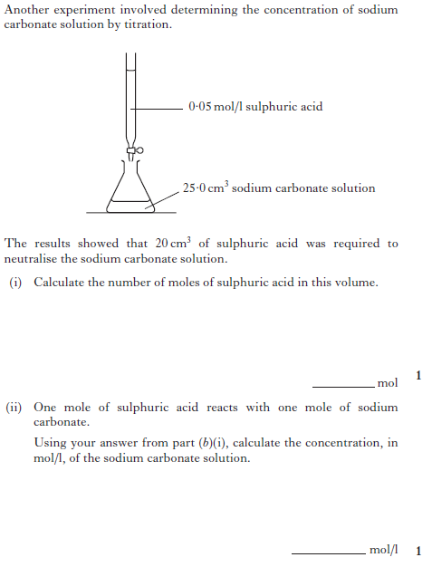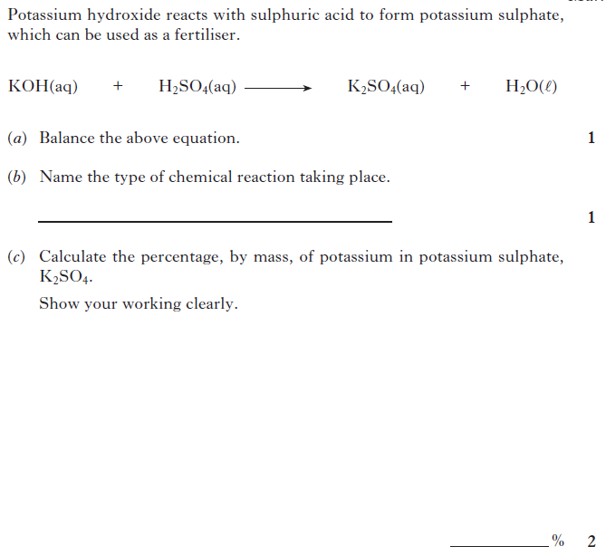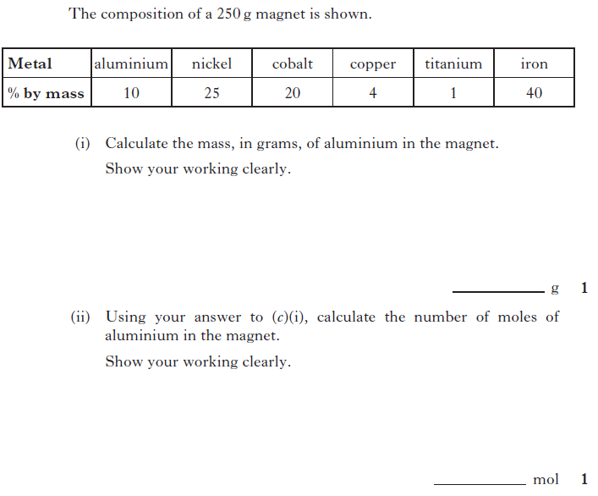

**7.**

**6.**

**9.**

**10.**

**8.**

**11.**

**12.**

**14.**

**13.**

**16.**

**15.**

3

**17.**

**18.**

**19.**

**20.**

2

**21.**

2

**22.**

3

**23.**

2

**24.**

**25.**

2

**27.**

**26.**

**28.**

**29.**

3

**30.**

**31.**

**33.**

**32.**

**34.**

3

**36.**

**35.**

2

2

2

**37.**

**38.**

2

**39.**

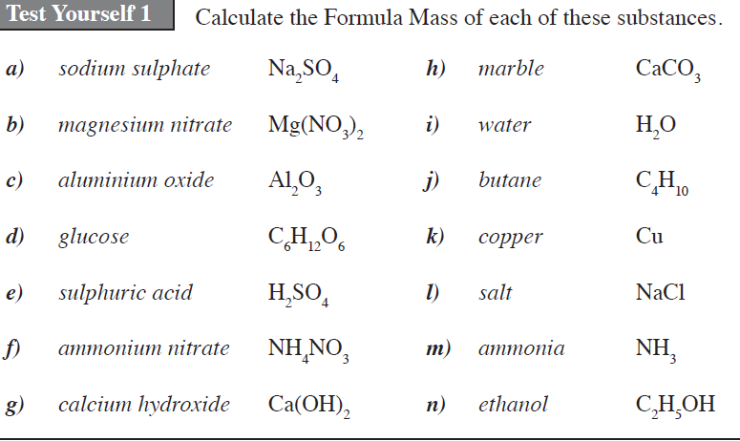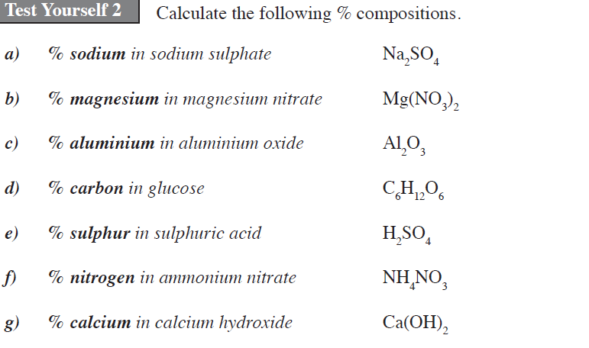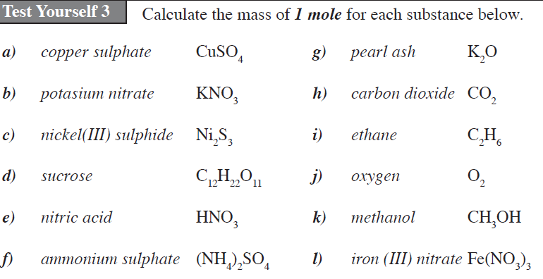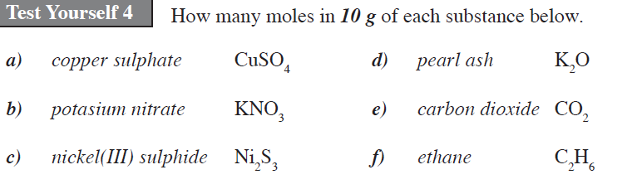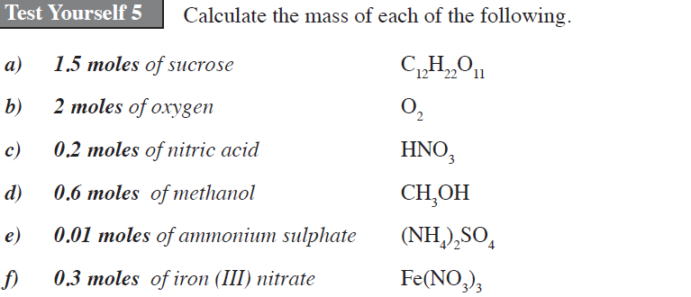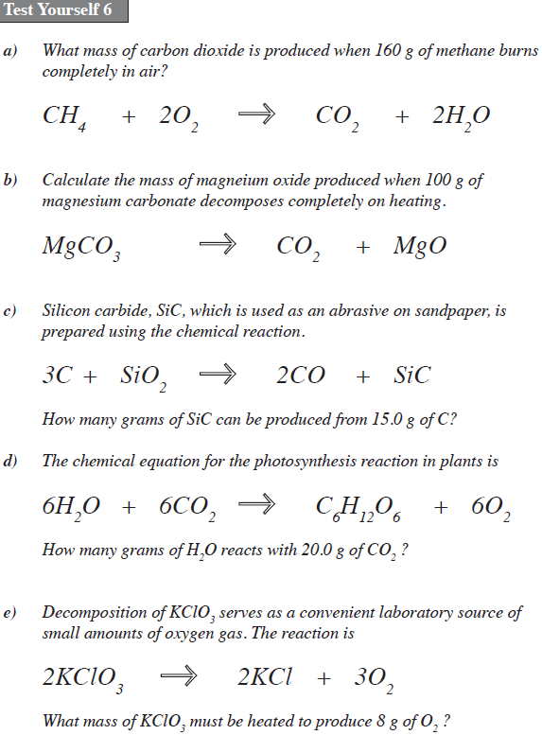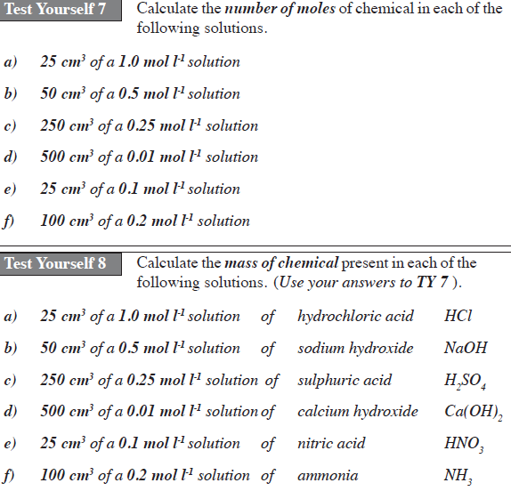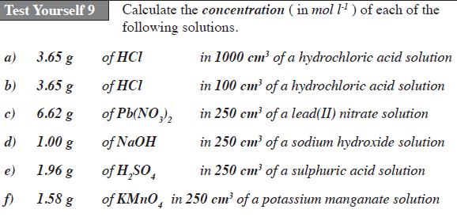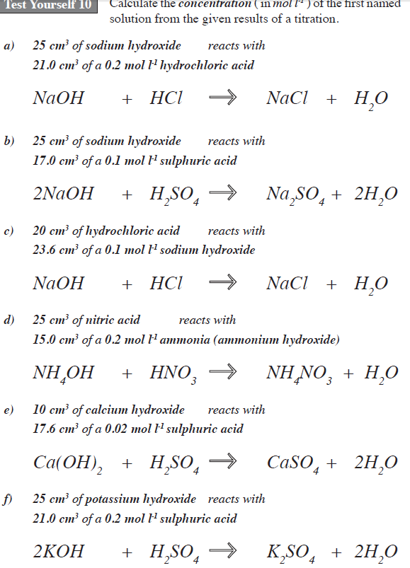

**TEST YOURSELF QUESTIONS:** Sourced from http://www.new.chemistry-teaching-resources.com/Resources/N5/N5Calculations_Book1.pdf

**Test Yourself 11: Percentage Composition**

a) Calculate the percentage of potassium in potassium phosphate, K3PO4.

b) Calculate the percentage of nitrogen in ammonium nitrate, NH4NO3.

c) Calculate the percentage of carbon in glucose, C6H12O6.

**Test Yourself 12: Half- Life**

a) The mass of a radioisotope falls from 1.6g to 0.1g in 2 hours. What is the half-life of this radioisotope?

b) If a 1g sample of a radioisotope with a half-life of 3 days has an activity of 32 counts sec-1, how long would it take for the activity of a 2g sample to fall to 8 counts sec-1?

c) After 24 days, the mass of a radioisotope was found to be one quarter its original mass. What is the half-life of the radioisotope?

d) A medical radioisotope has a half life of 1.5 hours. Its radioactivity was recorded as 10,000 counts min-1 at 9am. What will the count rate be by 3pm?