Mearns Castle H.S l

**NATIONAL 5 CHEMISTRY**

Unit 2

ANSWERS

Nature’s Chemistry

[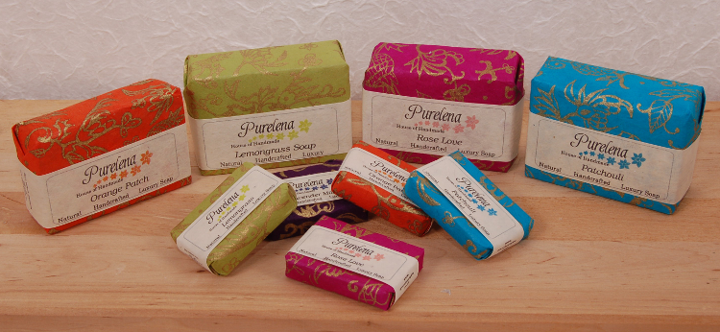](http://www.google.co.uk/url?sa=i&rct=j&q=&esrc=s&frm=1&source=images&cd=&cad=rja&uact=8&docid=1uF9D_rcCRFZIM&tbnid=bkVdmMLw1FUkeM:&ved=0CAUQjRw&url=http://blog.greenheartgifts.co.uk/2012/02/handmade-mini-soaps-from-dorset/&ei=dAc9U7HHNezb7AaH6YFo&psig=AFQjCNHAHlmzy0rNCAW3knzAG5w7vAIVcg&ust=1396594905041737)

Exam Questions

**Homologous Series**

1. A (1) 2. B (1) 3. C (1)

4. D (1) 5. C (1) 6. D (1)

7. C (1) 8. B (1) 9. C (1)

10. A (1) 11. A (1) 12. D (1)

13. (a) F (1)

(b) B and D (1)

14. Presence of carbon monoxide/ CO present/ 5% CO present (1)

15. 2,3-dimethylbutane/2,3 dimethylbutane/2-3 dimethylbutane/23-dimethylbutane (1)

Accept loose spelling of methyl and butane but ane must be present

Accept (di)

16. Full or shortened structural formula of cyclopropane (1)

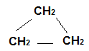



17. (1)

18. (a) Same general formula and same/similar properties OR same/similar chemical properties

Both required (1)



(b)

(1)

(c) addition (1)

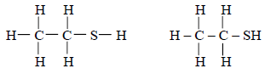

19. (a) (1)

(b) 2-methylpropane-1-thiol (1)

2methylpropane-1-thiol

2methylpropane 1 thiol

(or any of the above without the 2)

(c) Sulphur dioxide/SO2 (1)

20. (a) saturated

Bromine decolorises

No change

Unsaturated (2)

(b) Safety gloves

Wash off any spills with sodium thiosulphate (1)

(c) Hexene or any isomer of hexene with double bond (1)

21. (a) Tetrahedral (1)

Tetrahedron

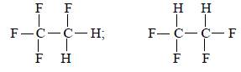

(b) (i)

Allow shortened structural formula CF3CH2F or CHF2CHF2 (1)

(ii) Chlorine/Cl/Cl2 (1)

(iii) Shorter atmospheric life/biodegrades faster (1)

22. (a) Man-made/made by chemists/scientists/man (1)

Does not occur naturally

Not natural

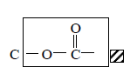

(b) (1)

(c) Glycerol/glycerine/Propan-1,2,3-triol (1)

23. (a) A substance that is burned/combusts to produce energy/heat (1)

(burning and energy both required)

any mention of molecule, element, hydrocarbon or compound will not conflict

(b) (i) Above zero → 35 (1)

If outwith range, check candidate’s working

(b) (ii) The smaller the number of carbons in the molecule, the more

efficient/useful/better (the fuel) (1)

The smaller the structure/molecule, the more efficient/useful/better it is

**OR**

If a molecule has a branch/or methyl group in the hydrocarbon it is more efficient/useful/better (fuel)

The more yl groups the more efficient…

The more complex, the more efficient/useful/better

The less hydrogens the more efficient…

24. (a) Ethyne/etyne (1)

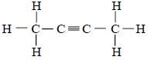 (b) (i)

Allow one missing bond (C-H) or allow one missing H

Shortened structural formula accepted

(b) (ii) Bromines are not attached to adjacent carbon atoms ` (1)

Bromines not beside each other/not together

Bromines have hydrogen between them/hydrogen in the middle

Bromines too far apart/not close enough to react

25. (a) Heat the catalyst and then the liquid paraffin/mineral wool or heat catalyst first (1)

(b) To prevent suck-back or some description (1)

(c) (i) Aluminium oxide/A12O3/ formula must be correct (1)

(Aluminium) silicate or other silicate

(c) (ii) Allows reaction to occur at lower temperature (1)

Lower energy required/ Lower activation energy

(d) Addition/ Bromination/ Halogenation/ Addition/ Brominisation (1)

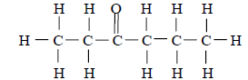26. (a) (1)

Allow one slip:

one missing bond but not in carbonyl group **or** one missing hydrogen

Accept correct (partial) shortened structural formula

(b) Heptan-4-one/heptan4one /heptane-4-one/hept-4-one/hept4one/hepta-4-one (1)

Must have hept, 4, and one

(c) 147 – 155 approx 150 or any number within the range (1)

**Everyday Consumer Products**

1. B (1) 2. C (1) 3. A (1)

4. A (1) 5. C (1) 6. D (1)

7. A (1) 8. B (1) 9. A (1)

10. A (1) 11. B (1) 12. C (1)



13.

(1)

14. (a) Hydration / Catalytic hydration (1)

 (b)

(1)



15. (1)

16. (a)

(1)

 (b)

(1)

17. (a) Aluminium oxide (Al2O3) (1)

If formula given, must be correct

Steel wool

Wrong formula, name correct

(b) (i) Butene/C4H8  (1)

Full or shortened structural formula accepted

Allow one missing bond/H

(b) (ii) (Bromine solution would) decolourise/change from brown to colourless (1)

turns bromine colourless

loses colour

allow follow through from b (i) ie no change/stays brown

18. (a)

(1)

(b) Pentyl butanoate (1)

19. (a) Starch + water → glucose (1)

Ignore non conflicting additional information eg hot water in equation and mashing

above arrow

Reversible arrow acceptable

If formulae is given, must be correct

Mix of formulae and words is acceptable must be correct

(b) Fermentation or Anaerobic respiration (1)

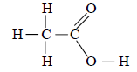 (c) (1)

Allow shortened structural formula CH3COOH

Bond does not need to be shown between O and H

llow one slip eg missing bond (C to H), missing atom but not carbon to carbon bond or carbon atom

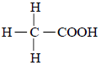

(d) Methyl ethanoate (1)

20. (a) (i) Fermentation/ Anaerobic respiration (1)

(ii) Enzyme/biological catalyst/Enzyme protein (1)

Ignore names of enzymes given

(b) Yeast is denatured/destroyed/loses its shape (1)

Enzyme is denatured/destroyed/loses its shape

Yeast dies/is killed

(c) Distillation (1)

Correct description of the distillation process to include both boiling and condensation stages

Fractional distillation

21. (a) Esters or Alkyl alkanoates (1)

(b) (i) Hydrolysis/ Hydrolysed (1)

Accept spelling variations of the above

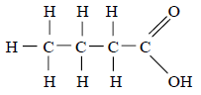

(b) (ii) (1)

Allow 1 slip –

missing bond but not from COOH group or missing H but not from COOH group

Accept (partial) shortened structural formula

Ignore any attempt to draw alcohol

**Energy from Fuels**



1. (a)

(1)

(b) 2800 to 3200 (1)

2. The energy of the products is less than the reactants (1)

Energy decreases from reactants to products therefore energy is lost

Reactants have higher chemical energy

3. (a) Endothermic (1)

(b) E = mcΔT

45 = 0·2 × 4·18 × ΔT

ΔT = 53.8 oC (53 or 54)

(Units not required)

4. (a) Answer within range -2640 to -2690 (1)

No units required

(b) E = mcΔT = 0·2 × 4·18 × 40 = 33·44 (units not required) (1)

5. (a) Heat lost to surroundings (1)

Incomplete combustion (of alcohol) (1)

Ethanol impure (1)

Loss (of ethanol) through evaporation (1) ANY TWO

(b) 1 660 000 (kJ – units not required, ignore incorrect units)

Partial marks -- 1 mark for ratio 50/0.00145 or 50000/1.45

or 34500 or 34.5 appearing in working