CfE Higher Chemistry
Unit 2
Nature’s Chemistry

Topic | Page
1 – Esters, Fats and Oils | 2
Minitest | 7
2 – Proteins | 9
Minitest | 12
3 - Oxidation of Food | 13
Minitest | 23
4 – Soaps, Detergents and Emulsions | 24
Minitest | 29
5 – Fragrances and Skin Care | 31
Minitest | 35
Glossary | 36

Information sourced from
Scholar
BBC Bitesize – Higher Chemistry

1 – Esters, Fats and Oils

a) Esters
Esters are formed by the condensation reaction between an alcohol and a carboxylic acid. This is known as esterification. Esters have characteristic smells and are insoluble in water.
(means a reversible reaction)
They have the functional group:
The functional group (-COO) is known as the ester link. The main use of esters is for flavourings and perfumes, however they can also be used in the chemicals industry as solvents.

Structure of esters
To make an ester, a hydrogen atom must be removed from the hydroxyl group (–OH) of the alcohol.

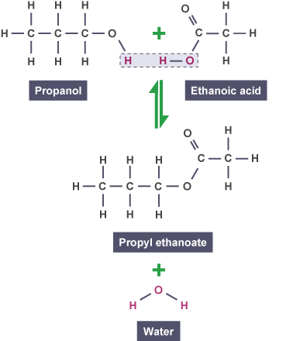
The –OH portion of the acid's carboxyl group must also be removed. The hydrogen atom and the -OH combine to form a water molecule (H₂O).
This same change can be represented using shortened structural formulae:
When looking at the structure of an ester, you can easily name it. Remember that the C=O part of the molecule came from the acid.

In the molecule below, the ester link (-COO) separates the two parts of the molecule.
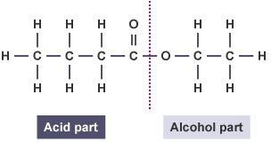
Since the C=O came from the parent acid, there were four carbon atoms in the acid molecule (butanoic acid) and two carbon atoms in the parent alcohol (ethanol).
This ester is called ethyl butanoate.

Naming esters
To name an ester:
- change the name of the parent alcohol to end in –yl
- change the name of the parent acid to end in –oate
- alcohol name goes to the front, acid name to the back
For example:

The names and structures of some other esters are shown below.
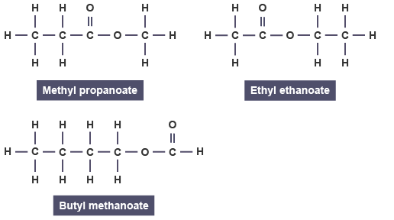

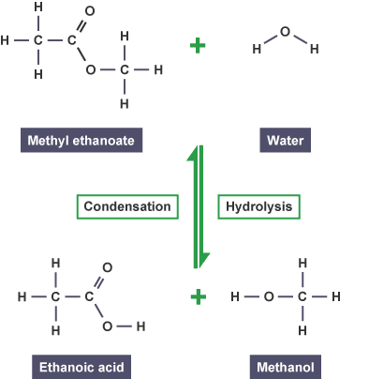
Hydrolysis of esters
The breaking up of an ester can be achieved by heating the ester with an alkali such as sodium hydroxide.
This is an example of a hydrolysis reaction (the opposite of a condensation reaction) as a water molecule is added and breaks up the structure.

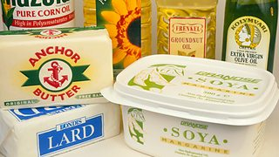
b) Fats and oils
Fat and oil-based food products
Fats and oils are used in our diets to provide us with energy. They play an important role in the transport of vitamins which are soluble in fats around the human body.
Many fats and oils are obtained from plant sources (sunflower oil, palm oil, coconut oil) and animal sources (lard, cod liver oil).

Structure of fats and oils
All fats and oils are naturally occurring esters, formed from condensation reactions between the alcohol glycerol and different long chain carboxylic acids (fatty acids).
Glycerol is also known by its systematic name propane-1,2,3-triol. It is a triol, meaning that it has three hydroxyl functional groups.

glycerol
Fatty acids are long chain carboxylic acids ranging from C₄ to C₂₈. Common fatty acids including stearic acid and oleic acid have eighteen carbon atoms in their chains.
The acid molecules can either be saturated or unsaturated. The fats and oils formed are also known as triglycerides.
Like other esters, fats and oils are formed by a reversible reaction.

Oils (liquids at room temperature) contain more carbon to carbon double bonds than fats (solid at room temperature).
The lower melting point of oils is related to the higher degree of unsaturation. The presence of carbon to carbon double bonds in the oil molecules distorts the long fatty acid chains and the molecule’s shape. As a result the molecules cannot pack closely together.

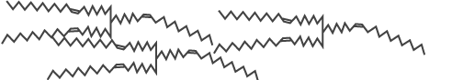

Fat molecules do not have the same degree of distortion and can pack closely together. This increases their melting point.

The poorer packing in oils makes London dispersion forces between the oil molecules weaker than between fat molecules. Less heat energy is needed to separate oil molecules, so oils have lower melting points than fats

Esters, Fats and Oils Minitest

1 Methanol + ethanoic acid methyl ethanoate + water.

What type of reaction is this an example of?
- Addition
- Hydrolysis
- Condensation

2 Which of the following products are most likely to contain esters?
- Flavourings, perfumes and solvents
- Flavourings, toothpaste and solvents
- Flavourings, perfumes and toothpaste

3 Which of these structures shows the ester ethyl methanoate?

4 What is the name of the ester formed when butanol and ethanoic acid react together?
- Ethyl butanoic acid
- Ethyl butanoate
- Butyl ethanoate

5 What is the name of this molecule?
- Propyl methanoate
- Methyl propanoate
- Methyl ethanoate

6 Why do fats have a higher melting point than oils?
- Fat molecules are more saturated than oils
- Fats have a lower melting point than oils
- Oils are more closely packed than fats

7 What is the ratio of glycerol molecules to fatty acid molecules that are produced when a fat/oil is hydrolysed?
- 1:1
- 1:2
- 1:3

8 Glycerol can be obtained from fats by which process?
- Hydrolysis
- Condensation
- Esterification

9 Which of the following is the structural formula for glycerol?

10 Which of the following is the name for the reaction when vegetable oils are “hardened”?
- Addition
- Hydrolysis
- Condensation

2 - Proteins

Protein formation
Proteins are the major structural material of animal tissue. Fibrous protein molecules are long, spiral chains that are folded to form strong structures such as hair, fingernails and muscle tissue.
In addition to this, proteins play an important role in the maintenance and regulation of life processes.
These globular proteins have the spiral chains folded into spherical shapes and are responsible for substances in the human body such as haemoglobin, enzymes and certain hormones like insulin.
Proteins are natural condensation polymers formed by joining together thousands of amino acid molecules.
Amino acid molecules have two functional groups - the amine group (-NH₂) and a carboxyl group (-COOH).
Proteins are formed in a condensation reaction when amino acid molecules join together and a water molecule is removed.
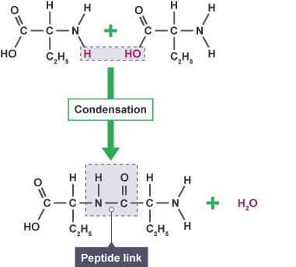
The new bond formed in protein molecules where amino acids have joined (-CONH) is called an amide link or a peptide link.

Essential amino acids
Different amino acid molecules can be joined together in different orders within our bodies to form different proteins.
The body cannot make all the amino acids required to build different proteins. It relies on protein intake from our diet to supply the essential amino acids.
Amino acids can then be used in sequence to build up protein in the body.

Breaking down proteins
Similar to esters, protein molecules can be broken down by hydrolysis (the opposite of condensation). Water molecules break apart the peptide links of the protein molecule, leaving separate amino acid molecules.
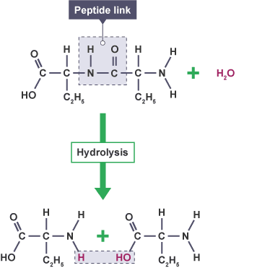
Given the structure of a protein molecule, the structures of the amino acids used to form it can be shown by simply breaking every peptide link to leave amine and carboxyl groups.

Digestion of proteins
During digestion, enzymes in our bodies break the proteins we eat down into amino acids (by hydrolysis).
These amino acids are transported around the body by blood. In the bloodstream, condensation reactions build the amino acids up to produce proteins required by the body.
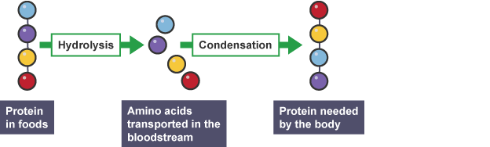

Proteins and food
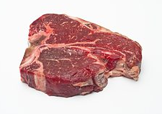
When cooking or preparing meats, different temperatures must be used depending on how much protein is found in the tissue.
Tender, lean meats such as fillet steak must be cooked at lower temperatures to retain their texture. This is because the protein molecules in the meat will chemically change when exposed to heat.
While proteins are long, spiral molecule chains, there are two main types of protein molecules.

Fibrous proteins
These molecules are the major structural material of animal tissue and are found in animal hair, nails and muscle.
Fibrous proteins have their long, spiral chains folded to form long, thin shapes. They are strong and are generally insoluble in water.

Globular proteins
Globular proteins are molecules involved in the regulation of life processes. For example, haemoglobin, and certain hormones like insulin and enzymes are all examples of globular proteins.
They have their spiral chains folded intro spherical shapes and are generally soluble in water.
However the protein chains are arranged, they are held in these shapes by intermolecular bonding between the side chains of the amino acids involved.
During cooking, when the proteins are heated, the molecules become agitated and move around causing the intermolecular bonds between molecules to be broken.
This allows the protein to denature (change shape) which changes the texture of foods. This explains the difference in structure between a raw egg and a fried egg.

Proteins Minitest

1 Which chemical change happens to proteins in meat as it is being cooked?
- Hydrolysis
- Oxidation
- Denaturing

2 Which elements are present in proteins?
- Carbon, hydrogen and oxygen
- Carbon, hydrogen, nitrogen and oxygen
- Carbon, and hydrogen only

3 Which type of reaction occurs when proteins are formed?
- Condensation polymerisation
- Hydrolysis
- Addition polymerisation

4 What is the name of this functional group found in proteins?
- Amide link
- Ester link
- Peptide link

5 Which type of molecule is this?
- Protein
- Carboxylic acid
- Amino acid

3 – Oxidation of Food
When chemicals in food are exposed to oxygen in the air, their chemical composition changes and they begin to break down.
Animal and plant tissues contain antioxidant molecules to prevent this from happening. These molecules can slow the rate of oxidation in our foods.
But left unattended, foods will lose their nutritional value as they begin to discolour and break down.

a) Alcohols
Alcohol molecules all contain the hydroxyl (-OH) functional group. They are a homologous series and have the general formula C_{n}H_{2n}+₁OH. Their names all end in -ol.
The rules for naming an alcohol are:
- Find the longest carbon chain and name it.
- Number the carbon atoms in the chain so that the functional group (in this case, the hydroxyl group) has the lowest possible number.
- Identify any branches joined onto the main chain and name them.
- Identify each branch by a number indicating its position. If more than one branch is present then a prefix must be used.

This simple alcohol molecule is called butan-2-ol.

The names, molecular and structural formulae of some straight chain alcohols are shown in the table below.
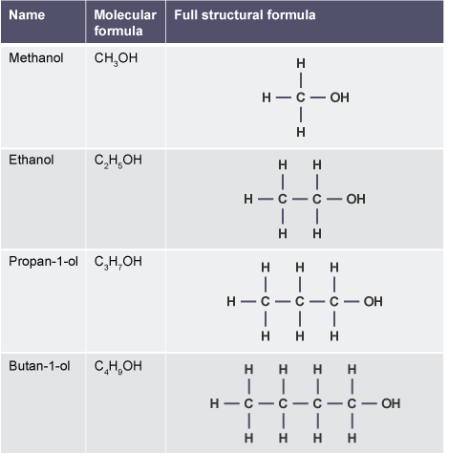

When naming branched chain alcohols, be careful to number the longest possible carbon chain first.
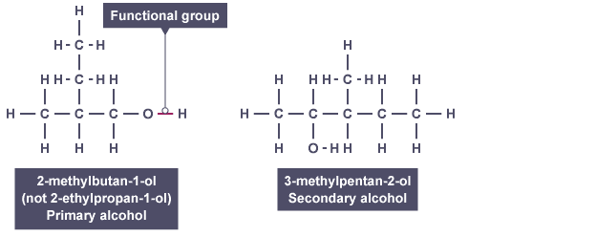
When writing the name, you follow the convention of using commas between numbers and dashes between numbers and words.

Types of alcohols
There are three types of alcohol molecules. The type of alcohol is determined by the position of the hydroxyl functional group.

Primary alcohols
A primary alcohol is one in which the hydroxyl group (–OH) is attached to a carbon atom with at least two hydrogen atoms.
This will only occur when the hydroxyl group is at the end of the molecule chain.
Propan-1-ol is a primary alcohol.

Secondary alcohols
A secondary alcohol is one in which the hydroxyl group (-OH) is attached to a carbon with only one hydrogen atom attached.
This can happen somewhere in the middle of a carbon chain.
Propan-2-ol is a secondary alcohol.

Tertiary alcohols
A tertiary alcohol is one in which the hydroxyl group is attached to a carbon with no hydrogen atoms attached.
This will normally mean that the hydroxyl group is joined to the same carbon atom as a branch.
2-methylpropan-2-ol is a tertiary alcohol.

Properties of alcohols
Compared with alkanes, alcohols have significantly higher boiling points. The hydroxyl groups in alcohol molecules are responsible for hydrogen bonding between the alcohol molecules.
As greater energy is required to overcome these strong intermolecular forces, the melting points and boiling points of alcohols are higher than those of alkanes with a corresponding chain length.
Alcohols with a greater number of hydroxyl groups will have even higher boiling points. When an alcohol has two hydroxyl groups it is called a diol. A molecule with three hydroxyl groups is a triol.
Compare these three molecules:
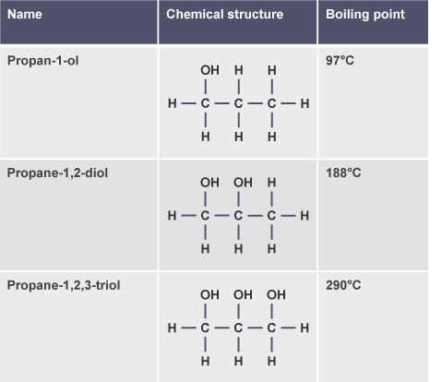
The large increase in the boiling point of alcohols as the number of hydroxyl groups increases is caused by a greater degree of hydrogen bonding between the molecules.

b) Oxidation of alcohols
The partial oxidation of an alcohol can be brought about by using an oxidising agent.
Some typical oxidising agents are:
- acidified potassium dichromate solution
- acidified potassium permanganate solution
- hot copper (II) oxide (black solid)
- Benedict’s reagent
- Tollen’s reagent (silver-mirror)

Primary alcohols
Oxidation of primary alcohols forms two products in a two stage reaction.
When carbon compounds are oxidised, the oxygen to hydrogen ratio increases, so either oxygen atoms are being added to the compound, or hydrogen atoms removed.
The first stage oxidation of a primary alcohol involves the molecule losing two hydrogen atoms to form an aldehyde.

Consider the oxidation of propan-1-ol.

Stage one
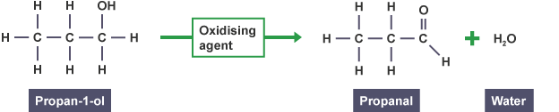

Stage two
In the second stage, oxygen is added to the aldehyde molecule to form a carboxylic acid.
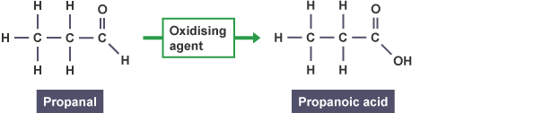

Secondary alcohols
Unlike primary alcohols, secondary alcohols can only be oxidised once.
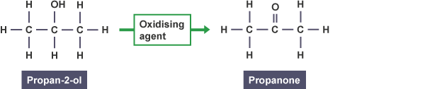

Summary of oxidation
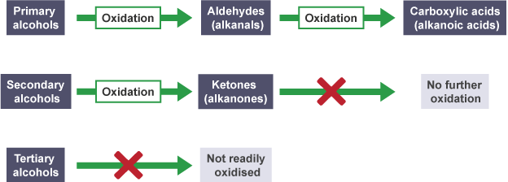

c) The Chemistry of Cooking
Many common flavours from different foods are caused by molecules within the foods called aldehydes and ketones.
Both of these molecules contain the same functional group (the carbonyl group) and are named in similar ways.

Aldehydes
Aldehyde molecules (which are also sometimes known as alkanals) have their carbonyl functional group (C=O) at the end of the carbon chain. Their names all end in -al.

Naming any molecule is straightforward if you follow these rules:
- Find the longest carbon chain and name it. For example, a chain of five carbon atoms will have a name based on pentane.
- Number the carbon atoms in the chain so that the functional group has the lowest possible number. For aldehydes, since the carbonyl group is at the end of the chain, the carbon of the C=O is always on carbon number one.
- Identify any branches joined onto the main chain and name them.
- Identify each branch by a number indicating its position. If more than one branch is present then a prefix must be used (Di = 2 branches, Tri = 3 branches, Tetra = 4 branches).
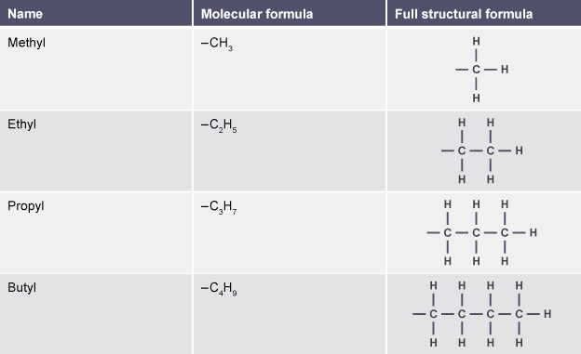
When naming aldehyde molecules, the carbonyl functional group does not need to be numbered as it will always be on the end carbon.
Look at the following aldehyde molecules. The above naming rules have been applied to give them their systematic names.
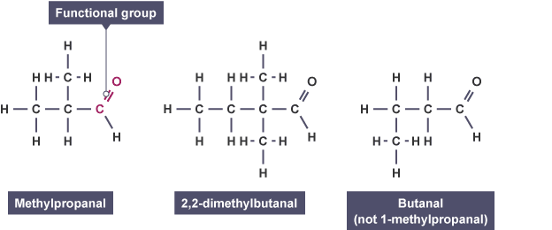
Be careful when naming molecules to number the longest possible carbon chain, and that when writing the name, you follow the convention of using commas between numbers and dashes between numbers and words.

Ketones
Ketones (which are also sometimes known as alkanones) are similar to aldehydes as they also contain the carbonyl functional group.
When naming ketones, the same rules as before are followed, however the position of the carbonyl functional group is usually always identified.
In ketones the carbonyl group is never at the end of the carbon chain. Their names all end in -one.

Look at the following ketone molecules. For unbranched propanone and butanone molecules, no numbers are required as the carbonyl group must be on carbon number two in both molecules.
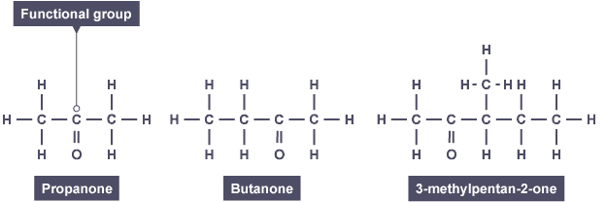

Aldehydes and ketones - Telling the difference
While they both contain the same functional group, aldehyde and ketone molecules react differently.
Telling the difference between the structures of the molecules is simple enough based on the position of the carbonyl group. Chemically you can tell them apart using an oxidising agent.
Only aldehyde molecules will show any reaction when heated with an oxidising agent.
Some typical oxidising agents and their colour changes are shown in the table below.

Oxidising agent | Colour change
Acidified potassium dichromate solution | Orange → Green
Fehling's solution | Blue → Brick red precipitate
Tollen’s reagent | Clear → Silver mirror precipitate

d) Carboxylic Acids
Carboxylic acids all contain the carboxyl group (-COOH). When naming carboxylic acids, the same rules as before are followed, but the position of the carboxyl group does not need to be identified, as it is always on C₁.
For example, propanoic acid (CH₃CH₂COOH)
Carboxylic acids with branches can also be named following the rules.
The longest carbon chain in the molecule below contains four carbon atoms. As the carbon of the carboxyl group is the first of the chain, then both branches are on the third carbon.
This molecule is therefore called 3,3-dimethylbutanoic acid.

Reactions of carboxylic acids
Carboxylic acids can undergo reduction reactions. Reduction is the opposite of oxidation.
For example, ethanoic acid (CH₃COOH) can be formed by the oxidation of ethanol as shown below.
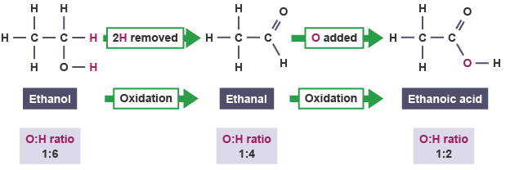

As reduction is the opposite of oxidation, it can be defined as the removal of oxygen or the addition of hydrogen to a molecule.
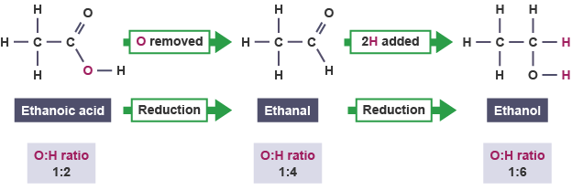
Carboxylic acids can also react with bases to form a salt and water in neutralisation reactions. When long chain 'fatty' acids are used, the salt formed is a soap.
For example:

e) Oxidation reactions in food
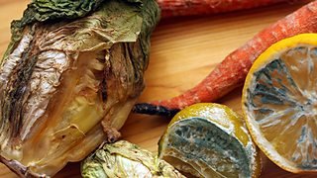
Foods which contain edible oils will spoil once exposed to oxygen from the air due to oxidation reactions.
This chemical change results in a bad flavour and smell from the food. If left exposed to air for even a short time, butter will spoil due to the formation of butanoic acid as the butter is hydrolysed.
Antioxidants are molecules that play an important role in preventing our food from spoiling too quickly by stopping oxidation reactions from taking place.
The antioxidant molecules are reducing agents, they cause other substances to be reduced while being oxidised themselves.
Many brightly coloured fruits and berries are rich in complex antioxidant compounds called polyphenols. One of the simplest antioxidants is vitamin C.

Vitamin C molecules can react to form dehydroascorbic acid by losing two hydrogen atoms from the hydroxyl groups attached to the ring part of the molecule, forming two additional ketone (carbonyl) groups.
The loss of hydrogen indicates an oxidation reaction (increasing the oxygen to hydrogen ratio) and the molecule will also lose two electrons.
This supply of electrons will prevent oxidation in other chemicals, causing them instead to be reduced.
This change from vitamin C to dehydroascorbic acid can be represented by an ion-electron equation:
Both the loss of electrons and the removal of hydrogen from the molecule indicate that this is an oxidation reaction, showing that as an antioxidant, vitamin C is itself oxidised.

Oxidation of Food Minitest

1 Which of the following could represent an alcohol molecule?
- CH₃CH₂OH
- CH₃COOH
- CH₃COOCH₂CH₃

2 What is the name of this molecule?
- 2-methyl-butanol
- 2-methylbutan-3-ol
- 3-methylbutan-2-ol

3 What type of alcohol does this structure represent?
- Primary
- Secondary
- Tertiary

4 Which of these alcohol molecules will have the highest boiling point?
- CH₃CH₂CH₂OH
- CH₃CH₂CH₂OH
- CH₂(OH)CH(OH)CH₂OH

5 Why do diols have a higher boiling point than alcohols?
- More hydrogen bonding
- They are less viscous
- They contain no double bonds

6 Which molecule could not be formed by oxidising propan-1-ol?
- Propanal
- Propanone
- Propanoic acid

7 Which molecule does not contain a carbonyl group?
- Butanol
- Butanal
- Butanone

8 What is the name of this molecule?
- Butanone
- Butan-2-one
- Butan-3-one

9 Which group of compounds does this molecule belong to?
- Aldehydes
- Esters
- Ketones

10 Which of the following could be used to tell the difference between an aldehyde and a ketone?
- Bromine water
- Iodine
- Acidified potassium dichromate

11 What colour change will be observed when propanal is warmed with Fehling's solution?
- Orange to Green
- Blue to Brick red
- A silver mirror precipitate forms

12 What is formed when a long chain carboxylic acid is neutralised by an alkali?
- Salt and hydrogen gas
- Soap and water
- Salt, water and carbon dioxide gas

13 What type of molecules are antioxidants that can be added to our food to prevent the chemical in it from oxidising?
- Proteins
- Oxidising agents
- Reducing agents

14 Which of these equations shows an antioxidant working?

15 Which compound would not react with Tollen’s reagent?
- CH₃CH(OH)CH₂CH₃
- CH₃C(CH₃)(OH)CH₂CH₃
- CH₃CH₂CHO

3- Soaps, Detergents and Emulsions

Soaps
Soaps play a vital role in keeping clean. They are salts made from the alkaline hydrolysis of fats and oils (triglycerides).
Fat molecules contain three ester links. These can be hydrolysed when they are heated with sodium hydroxide or potassium hydroxide. This results in the formation of glycerol and a salt - soap.
Fats and oils are esters made from glycerol and long chain fatty acids.
Consider the hydrolysis of this triglyceride found in animal fat.
This molecule can be hydrolysed to give stearic acid (C₁₇H₃₅COOH). Under alkaline conditions, the three ester links break, and, if sodium hydroxide is used, then sodium stearate (C₁₇H₃₃COONa) is formed as well as glycerol.
Sodium stearate (a white solid) is the most common type of soap. Each molecule consists of a long non-polar covalent hydrocarbon ‘tail’ and a polar, ionic ‘head’ where the charge is.
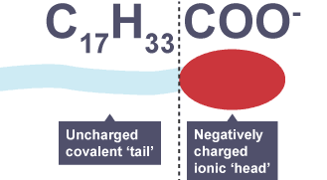
This structure explains the cleansing action of soap as the non-polar ‘tail’ dissolves in non-polar substances such as grease while the polar ‘head’ will not.
The non-polar tail of the molecule can be called hydrophobic as it is repelled by water.
However, the polar, ionic head is hydrophilic and does dissolve in polar solvents such as water.
Once scrubbed or mixed properly, the grease is broken up into droplets and held in suspension in the water by the repulsion of the negatively charged ionic heads.
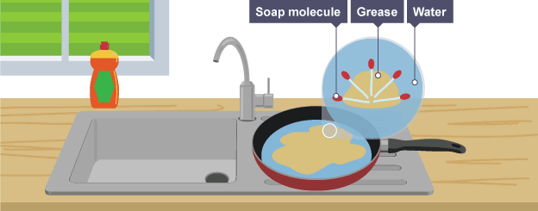
This suspension of small grease droplets in water is called an emulsion.

Detergents
Detergents are a family of compounds that are similar to soaps and work in a similar way. They are more useful in areas where hard water is present. They are most commonly used in our homes when washing clothes, dishes or as surface cleaners.
They also contain specific hydrophilic (ionic) and hydrophobic (covalent) parts.

Emulsions
Emulsions are formed when tiny droplets of one liquid are suspended within another liquid. A mixture of oil and water is a good example of an emulsion.
It is not uncommon for foods that we eat to contain emulsions of oil and water. To prevent the oil and water from separating (and thus the food spoiling), soap-like chemicals called emulsifiers are added. Many common foods like bread, ice-cream, sauces and biscuits contain emulsifiers.
Emulsifiers have a similar structure to fats and oils. One or two fatty acid groups can be added to a molecule of glycerol.

While they form ester links with the glycerol backbone, there are still unused hydroxyl group(s) on the molecule.
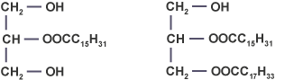
One emulsifier that is commonly listed as a food additive is E471.
The two molecules above are a monoglyceride (with two hydroxyl groups remaining) and a diglyceride (with one hydroxyl group remaining). Hydroxyl groups are hydrophilic, whilst fatty acid chains are hydrophobic.
This results in E471 being a very effective emulsifier. It holds together oil and water emulsions to prevent food from spoiling.

Soaps, Detergents and Emulsions Minitest

1 Which of the following reactions can produce soaps from fats and oils?
- Alkaline hydrolysis
- Catalytic cracking
- Condensation

2 Why are soap molecules effective cleaning agents?
- They have a grease-soluble non-polar ‘tail’ joined to a water-soluble ionic ‘head’
- They have a water-soluble ‘tail’ joined to a grease-soluble ‘head’
- They have a grease-soluble ionic ‘tail’ joined to a water-soluble non-polar ‘head’

3 What name is given to the product formed when tiny droplets of one liquid are suspended within another liquid?
- An ester
- A detergent
- An emulsion

4 What two products are formed when a fat/oil reacts with sodium hydroxide?
- An ester and water
- A soap and glycerol
- Glycerol and three fatty acid molecules

5 Which of the following is a type of soap?
- Ethyl ethanoate
- Sodium hydroxide
- Sodium stearate

6 Which of the following is the correct description of the parts of a soap molecule?
- The head of the molecule is non-polar and hydrophobic and the tail is ionic and hydrophilic
- The head of the molecule is ionic and hydrophilic and the tail is non-polar and hydrophobic
- The head of the molecule is non-polar and hydrophilic and the tail is ionic and hydrophobic

7 Where would detergents be a preferable alternative to soaps?
- In areas with hard water
- In public toilets
- For people with sensitive skin allergies

8 How do emulsifiers prevent food from spoiling?
- Prevent oil and water from separating
- Break up emulsions that may form in food
- Improve the taste of the food

9 Which of the following structures is a monoglyceride?

10 Which of the following is an example of an emulsifier?
- C₁₇H₃₃COONa
- C₃H₈O₃
- E471

5 – Fragrances and Skin Care

a) Fragrances
Essential oils are useful compounds that can be extracted from plants. They are widely used in perfumes, cosmetics, cleaning products and as flavourings in foods.
Essential oils are concentrated extracts of the aroma compounds from plants that are not water soluble.
While they contain a mixture of organic compounds, one of the primary constituents of essential oils are terpenes.
Terpenes are unsaturated hydrocarbons, formed by joining together units of 2-methylbuta-1,3-diene. This molecule is also known as isoprene.
These unsaturated C₅H₈ units can add together head to tail to form terpenes. Both long, straight chain molecules and cyclic molecules can be formed.
After being oxidised within plants, terpenes are responsible for the flavours of many distinct spices such as ginger, cloves and cinnamon.
Including
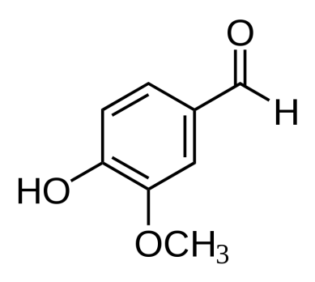 | 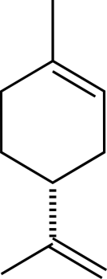 | 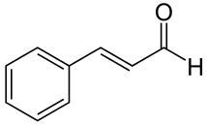 | 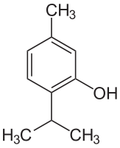
Vanillin | Limonene | Cinnamaldehyde | Thymol
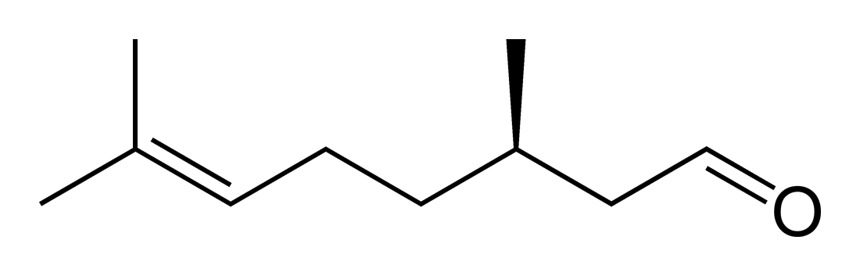 |  | 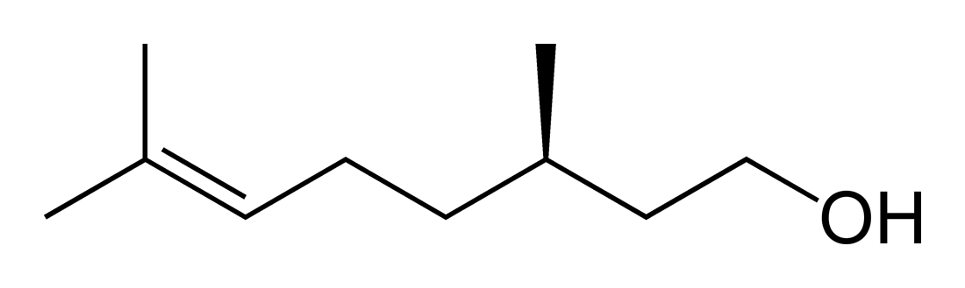
Citronellal |  | Citronellol

b) Skin care
Ultraviolet radiation (UV) from the sun is a high energy form of light. There are three types of UV radiation. In order of increasing energy, these are classed as UVA, UVB and UVC.
While UVC is the highest energy form of UV light, over-exposure to UVA and UVB have been linked with numerous health problems involving the skin and eyes of humans.
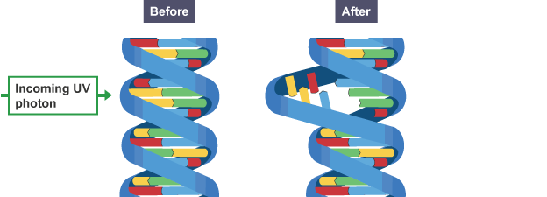
All three forms affect the breakdown of collagen in our skin, which can lead to premature ageing.
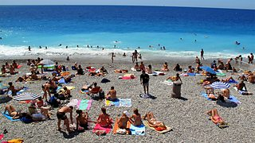
Sunblock is commonly used to prevent damage to the skin by preventing harmful UV radiation from being absorbed.
In the past it was thought that UVB was the most harmful. Over-exposure to UVB is known to cause skin problems including sunburn and in extreme cases, skin cancer.
More recently, UVA has been shown to contribute to skin cancer by indirectly breaking down DNA in a process that involves free radicals.

c) Free radicals
Free radicals are highly reactive atoms that have one unpaired electron. They are unstable as there is a tendency for unpaired electrons to pair up and so the free radicals react very quickly.
Radicals can be formed when a covalent bond is broken by energy supplied by UV light. Due to their reactivity, they are able to cause chain reactions, as they often react to produce other free radicals. These reactions happen in a three stage process.

Stage one: Initiation
The dot next to each of the bromine atoms in the above equation represents the unpaired electron each has from the shared pair of the covalent bond. Dividing one bromine molecule produces two highly reactive radicals.
While UV light is needed to begin the process, further reactions do not need UV light, and so the chain reaction can continue, even in total darkness.

Stage two: Propagation
The highly reactive radicals formed can remove atoms from other (stable) compounds to re-establish stable covalent bonds. This reaction will produce a new free radical.
For example, a bromine radical can react with an alkane, like methane.
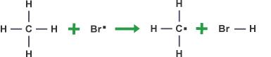
The new radical formed can in turn react with another bromine molecule. This is also a propagation step as it also generates a radical product.
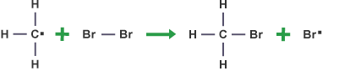

Stage three: Termination
The chain reaction will only end when a reaction takes place in which no new radicals are formed. This can occur whenever radicals react with each other.
For example, a bromine radical can react with an alkane, like methane.
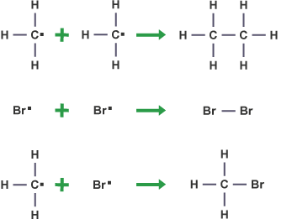

d) Free radical scavengers
Free radical scavengers are chemicals (usually vitamins, minerals or enzymes) that react with and destroy free radicals.
This is often desirable to help protect our skin (so they are present in cosmetics) and our food (present both in some foods and in plastics).
By reacting with any free radicals present, the free radical scavengers prevent a chain reaction from occurring.
Many free radical scavengers are antioxidants. For example, green tea contains polyphenols which act as free radical scavengers. These react quickly with two of the most common radicals, hydroxyl radicals () and oxygen radicals (), formed from the breakdown of water and oxygen respectively. When polyphenols react with these radicals, further reactions are prevented.

Fragrances and Skincare Minitest

1 Where can essential oils be extracted from?
- Plant tissue
- Animal tissue
- Soil

2 What is the correct systematic name of this molecule?
- 2-methylbut-1,3-ene
- 2-methylbuta-1,3-diene
- 3-methylbuta-1,3-diene

3 What type of molecules can be formed by joining isoprene (C₅H₈) molecules together?
- Esters
- Proteins
- Terpenes

4 How do isoprene (C₅H₈) molecules join together?
- Addition reactions
- Condensation reactions
- Oxidation reactions

5 Which of the following products is least likely to contain essential oils?
- Perfume
- Lip balm
- Cooking oil

6 Which type of UV light is the highest energy?
- UVA
- UVB
- UVC

7 Which of the following represents a hydrogen free radical?

8 What of these is not a step in a free radical chain reaction?
- Radicalisation
- Propagation
- Initiation

9 Which of the following represents a propagation step in a free radical chain reaction?
- --

10 What type of compound is added to products to prevent free radical chain reactions from occurring?
- Sunblock
- Free radical scavenger
- Terpene

Term | Meaning
Aldehyde | an organic compound with a carbonyl functional group (C=O) at the end of the molecule
Alkanals | a homologous series of aldehydes based on the corresponding alkanes by changing one of the terminal carbon atoms into a carbonyl group
Alkanones | a homologous series of ketones based on the corresponding alkanes by changing one of the middle chain carbon atoms into a carbonyl group
Amide links | a group of atoms formed by condensation polymerisation of amino acids during the formation of proteins. The amide link can be identified as -CO-NH- and occurs where each pair of amino acids has joined together
Condensation | reaction in which two molecules combine to form a larger molecule at the same time eliminating a small molecule such as water
Denaturing | physical alteration of the molecular shape of a protein (or other molecule) as a result of temperature or pH changes
Electronegativity | a measure of the ability of an atom to attract a bonded pair of electrons - the more electronegative, the stronger the attraction
Enzymes | protein molecules which act as catalysts in biological processes
Essential Amino Acids | is a necessary material required by living organisms for normal growth
Free radicals | atoms or molecule containing unpaired electrons
Free radical scavengers | molecules which can react with free radicals to form stable molecules and prevent chain reactions
Heterolytic fission | both of the shared electrons go to only one of the two atoms producing ions
Homolytic fission | the two shared electrons separate equally, one going to each atom
Hydrogenation | the addition of hydrogen to a carbon to carbon multiple bond
Hydrolysis | the breakdown of a molecule by reaction with water
Ketone | an organic compound with a carbonyl functional group (C=O) within the carbon chain (ie. not on one of the end carbons)
Oxidation | when applied to carbon compounds, oxidation reactions result in an increase in the oxygen to hydrogen ratio
Peptide links | an amide link which is found in a living organism (in proteins
Polyunsaturated | molecule which has more than one carbon to carbon unsaturated bond
Proteins | biological polymers of small molecules called amino acids
Redox reaction | a reaction in which one reactant gains electrons and another reactant loses electrons
Reduction | reactions result in a decrease in the oxygen to hydrogen ratio, when applied to carbon compounds
Saponification | the process by which soaps are made from fats and oils in a hydrolysis reaction
Terpenes | One of the primary constituents of essential oils. Unsaturated hydrocarbons, formed by joining together units of 2-methylbuta-1,3-diene (isoprene)
Triglycerides | molecules formed through the condensation of one glycerol molecule with three fatty acid molecules
Unsaturated | Molecule with at least one carbon to carbon double bond. An unsaturated hydrocarbon does not contain the maximum number of hydrogen atoms for a given carbon atom framework
Volatile | a volatile substance evaporates very easily to form a gas
Volatility | a measure of how easily a molecule will evaporate

