Software DEsign and development

National 5 Computing Science

Alison Cowie

Portobello High School, Edinburgh

Contents

Development Methodologies 4

Analysis 5

Assumptions 5

Inputs 5

Processes 5

Outputs 5

Design 6

Data types and structures 6

Preparing a test table 7

Structure diagrams / Flowcharts 8

Pseudocode 8

Efficient solutions 10

User interface design 11

Implementation (data types and structures) 12

Data types and structures 12

One dimensional (1-D) arrays 12

Implementation (computational constructs) 14

Assignment statements 14

Arithmetic operators 14

Concatenation 14

Inequalities 15

Conditions 15

Logical operators 15

Selection constructs (IF … THEN … ELSE … END IF) using conditions 15

Fixed loops 16

Conditional loops 16

Pre-defined functions and parameters 17

Implementation (algorithm specification) 18

Output 18

Input validation 18

Running total (using a loop) and finding the average 18

Traversing a 1-D array: Linear search 18

Traversing a 1-D array: Counting Up 19

Nested loops 19

Testing 20

Test data 20

Errors 20

Evaluation 21

Fitness for purpose 21

Efficient use of coding constructs 21

Robustness 22

Readability of code 22

## Development Methodologies

Developing a piece of software usually has six phases. These are:

**1. Analysis**

**2. Design**

**3. Implementation**

**4. Testing**

**5. Documentation**

**6. Evaluation**

For example, Andrea is a Project Manager at AppsForLawyers. Jenny is a manager in a law firm and has asked Andrea at AppsForLawyers to develop a piece of software that will automate some legal documents for her firm.

Analysis: Andrea and Jenny will meet to decide exactly what Jenny wants the software to do. They will create a document called the **software specification** that lists the **functional requirements** of the software. This is often done by identifying the **inputs, processes and outputs** of the software.

Design: Andrea will pass the software specification to her design team who will **plan the** **data structures** to hold the data that will be processed by the software. They will also **plan the user interface** and they will **plan the modules of program code** that will be required.

**Iteration**:Jenny may be involved in checking the design and she may ask for changes at the design phase based on what she sees and this could mean going back to the analysis phase with Andrea. **Iteration** means ‘to do over again’. The software development process is described as **iterative** because **each stage may have to be revisited as a result of new information coming to light**.

Implementation: The design is passed to the programmers who **write program code to implement the functional requirements of the software**. The programmers may create **prototypes** for Jenny to see. If the programmers need the design clarified for them, Jenny and Andrea may have to meet with the design team again (iteration). This may even require them to go back to the original analysis (iteration).

Testing: The **programmers will be testing the code continually** while they are working. When they are finished, Andrea will make up a test team from AppsForLawyers that can test the software as a whole. They probably won’t know the actual code in detail – this is sometimes called **alpha testing**. Once again, this may throw up issues that require previous phases to be revisited (iteration). For example, the programmers may have to re-code some parts. Finally, the software will be passed to Jenny’s law firm for **beta testing**.

Documentation: This includes a **technical guide** and a **user guide**. The technical guide explains **how to install the software** and **what the system requirements are** e.g. operating system, amount of memory etc. Theuser guide will **help the user to use the software successfully**.

Evaluation: This is to decide whether the software is **fit for purpose**. That means: Does it meet its **functional requirements**? Is it **robust** (runs successfully without crashing)? Is it **readable** code in case people need to edit it?

## Analysis

In reality, for big software development projects, the analysis phase can take months to complete. Let’s look at a *much* simpler example:

Mrs Bird is taking 15 students on a school trip. The cost of the trip is £50 but the students can pay by installment. Mrs Bird has called a meeting to take the **first** installment and she wants a piece of software (a program) to let her enter the amount paid by each student. At the end of the meeting she would like to be able to display how much each student has left to pay. She also wants to know how many students still have the full £50 left to pay.

The **analysis** for this program might produce a **software specification** that looks like this:

### Assumptions

Assumptions often arise as the analysis proceeds. For example, “I will assume …”

* “all 15 students are at the meeting”
* “some students may have forgotten to bring the money with them”
* “that the student’s name will need to be input as well as the amount they pay”

Functional requirements

### Inputs

Each student’s name (15 students) and store

The amount paid by each student

### Processes

Validate the amount paid in the range 0 to 50 inclusive

Subtract the amount paid from 50 and store

Count up how many students still have £50 left to pay

### Outputs

Display list of names with amount still owing

Display number of students who still have the full £50 left to pay

## Design

### Data types and structures

Example 1: You are asked to write a program that finds the **average** age of ten people and **whether or not** any of the 10 people are of average age.

One of your first steps would be to *draw* and *define* the data structures (the holding places) for the data that will be used. You should include example data or test data in the diagram.

N.b. *var* is short for variable

age

*var age : array[1..10] of integer*

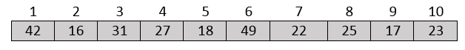

total

270

averageAge

27

anyOfAverageAge

TRUE

*var total : integer*

*var averageAge : integer*

*var anyOfAverageAge : boolean*

Example 2: The data structures for Mrs Bird’s school trip (see page 5)

|  |  |
| --- | --- |
| 1 | “Bilal”  studentName |
| 2 | “Harpreet” |
| 3 | “Joshua” |
| 4 | “Kieran” |
| 5 | “Lucy” |
|  | .  .  . |
| 12 | “Paolo” |
| 13 | “Robin” |
| 14 | “Yousif” |
| 15 | “Zach” |

|  |  |
| --- | --- |
| 1 | 25.0  amountLeft |
| 2 | 35.0 |
| 3 | 20.0 |
| 4 | 16.75 |
| 5 | 50.0 |
|  | .  .  . |
| 12 | 40.0 |
| 13 | 0.0 |
| 14 | 50.0 |
| 15 | 15.0 |

stillToPayFull

2

*var* stillToPayFull *: integer*

*var amountLeft : array[1..15] of real*

*var studentName : array[1..15] of string*

**Data structures** are the groups of storage locations in memory that will be used by the software. The choice of name is very important – the names of the data structures can significantly help people read and understand the code.

Once the data structures have been defined, the modules of code are planned out. This might be in the form of a diagram like a flowchart or a structure diagram or it might be in pseudocode.

### Preparing a test table

See page 20 – Testing. It is useful to draw up a test plan that includes a test table at this stage. This can help with the planning as it will clarify what is expected in terms of output.

### Structure diagrams / Flowcharts

These use specially shaped boxes to show loops, decisions etc. in the program. The boxes are linked together to show how the program fits together. Apart from **structure diagrams** and **flow charts**, other graphical design methods include linked charts and block diagrams.

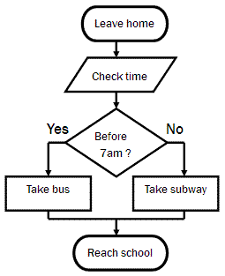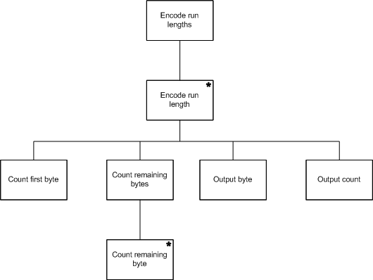

**Advs:** the structure and program flow is very clear

**Disadvs:** adding more detail means the diagrams can become very complicated

### Pseudocode

Pseudocode is an English-like language used to define problems. It can be laid out to reflect the structure of the actual program.

**Advs:** close to English >> easy to understand

easy to stepwise-refine the design (break the steps down into smaller and smaller steps)

e.g. RECEIVE c FROM KEYBOARD

SET f TO ( 9 / 5 ) * c + 32

SEND f TO DISPLAY

The lines above are written in a language called Haggis. You could write this in pseudocode as follows:

input c

put ( 9 / 5 ) * c + 32 into f

send f to display

input c

f = ( 9 / 5 ) * c + 32

output f

or…

Pseudocode, structure diagrams and flowcharts are just some of the design tools used to **think through the action of program code** before having to actually program it in a specific high level language such as Python or Java.

Mrs Bird’s program: (written in Haggis) (see *software spec* and *data structures* on pages 5 and 7)

SET stillToPayFull TO 0

FOR studentNumber FROM 1 TO 15 DO

RECEIVE studentName[studentNumber] FROM (STRING) KEYBOARD

RECEIVE installment FROM (REAL) KEYBOARD

WHILE (installment < 0) OR (installment > 50) DO

SEND “Invalid data – out of range” TO DISPLAY

RECEIVE installment FROM (REAL) KEYBOARD

END WHILE

SET amountLeft[studentNumber] TO 50 – installment

IF amountLeft[studentNumber] = 50 THEN

SET stillToPayFull TO stillToPayFull + 1

END IF

END FOR

FOR studentNumber FROM 1 TO 15 DO

SEND studentName[studentNumber] TO DISPLAY

SEND amountLeft[studentNumber] TO DISPLAY

END FOR

SEND stillToPayFull TO DISPLAY

### Efficient solutions

Efficient solutions often involve using loops. If the same action is carried out over and over again, it would be inefficient to keep writing the same code over and over again in the program.

Suppose we wanted to add 20% to all the prices of 2000 hats on a shopping site. It would **not** be efficient to write code like this:

SET hatPrice[1] TO hatPrice[1] * 1.20

SET hatPrice[2] TO hatPrice[2] * 1.20

SET hatPrice[3] TO hatPrice[3] * 1.20

.

.

.

SET hatPrice[2000] TO hatPrice[2000] * 1.20

It would be better to write this:

FOR hatNumber FROM 1 TO 2000 DO

SET hatPrice[hatNumber] TO hatPrice[hatNumber] * 1.20

END FOR

Why is the second way more **efficient**?

**Editing:** The second way is more efficient from an **editing** point of view (i.e. **time**). It is **easier to read** than pages of the same statement, and, if you needed to change the percentage, then only one line of code needs to be edited instead of 2000 lines.

**Memory usage:** It is more efficient from a memory point of view. Each line of code is held in memory while the program is running so to have just 3 lines instead of 2000 lines of code in memory means that memory usage is more efficient.

**Processor time:** A processor-time efficient program will be one where the processor is not busier than it needs to be. This is especially important in time-critical situations (like a nuclear reactor). When a program is translated into machine code, a loop can be translated into machine code that takes less processor time to run than code that’s carrying out the same task but without a loop.

### User interface design

Here are some examples of wireframes of user interfaces

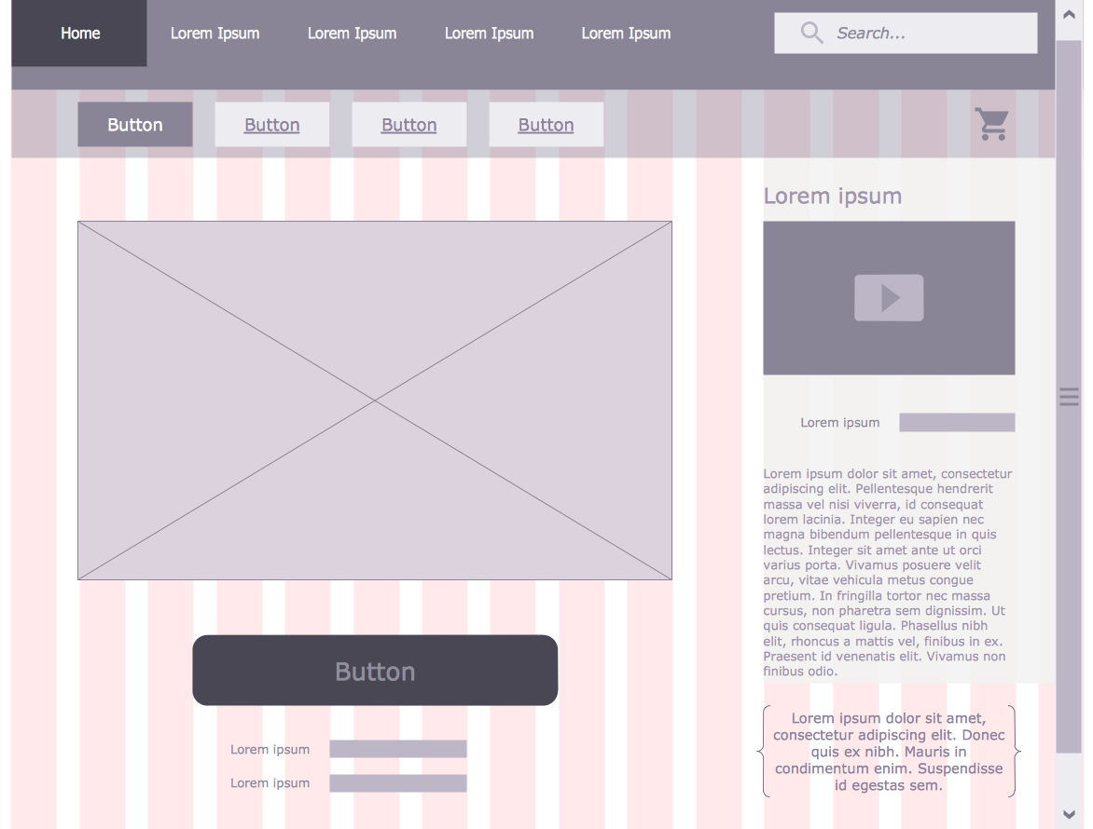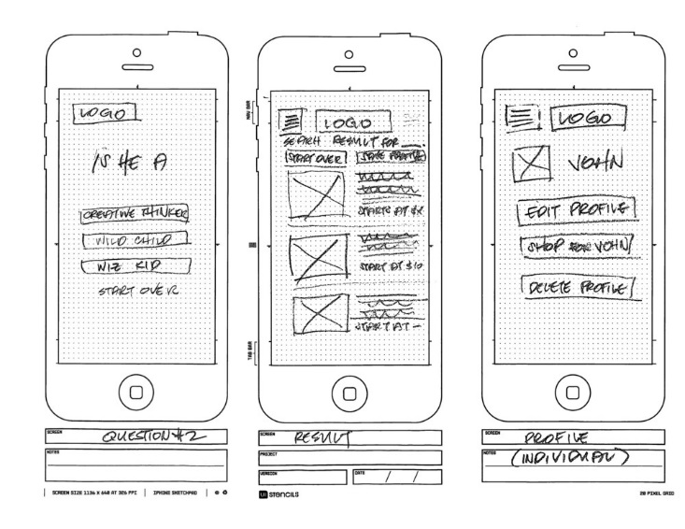

## Implementation (data types and structures)

### Data types and structures

Data structures holds data for the programmer to use. They are called **variables** in programming.

Different types of structures can be created using the storage locations in memory. The simplest structures are variables that hold just one single value.

global count *//integer* (a number with no fractional part e.g. 20, -36)

global average *//real* (a number with a fractional part e.g. 65.7)

global key //char (a single character e.g. “R” or “*” or “8”)

global name *//string*  (a group of characters e.g. “0131 669 2324” “EH16 5PJ”)

(n.b. the numbers are not being used for calculations)

global passed *//boolean* (either TRUE or FALSE)

### One dimensional (1-D) arrays

An array is used when a *list* of values is required rather than one single one. It is a group of storage locations all storing **the same type of data**. The group is given a group name and an index number is used to determine which element is being referenced.

e.g. put “0602” into studentID[4] *//studentID is a one dimensional array of 6 strings*

RAM

|  |  |  |  |  |  |  |  |  |  |  |  |
| --- | --- | --- | --- | --- | --- | --- | --- | --- | --- | --- | --- |
|  |  |  | 1 | 2 | 3 | 4 | 5  << studentID array >> | 6 |  |  |  |
| … |  |  |  |  |  | “0602” |  |  |  |  | … |

Square brackets are often used to indicate an array. Some examples are as follows:

global marks *//array[20] of integer* (a list of integers)

put 58 into marks[1] *//assigns the value 58 to element #1 of the array called “marks”*

put 96 into marks[15] *//assigns the value 96 to element #15 of the array called “marks”*

put total + marks[10] into total

*//adds the value of the 10th element of “marks” to the variable called “total”*

Note that some languages start their arrays at 0 rather than 1. For example:

repeat with product = 0 to 9

put cost[product] * 0.50 into cost[product]

end repeat *//multiplies all 10 elements of “cost” by 50%*

cost

|  |  |  |  |  |  |  |  |  |  |
| --- | --- | --- | --- | --- | --- | --- | --- | --- | --- |
| 0 | 1 | 2 | 3 | 4 | 5 | 6 | 7 | 8 | 9 |
| 3.45 | 6.50 | 7.75 | 1.25 | 5.00 | 2.50 | 4.35 | 7.20 | 2.00 | 4.10 |

1-D stands for one-dimensional (For interest: 2-D would be two-dimensional)

|  |  |  |  |  |  |  |  |  |  |
| --- | --- | --- | --- | --- | --- | --- | --- | --- | --- |
|  |  |  |  |  |  |  |  |  |  |
|  |  |  |  |  |  |  |  |  |  |
|  |  |  |  |  |  |  |  |  |  |

|  |  |  |  |  |  |  |  |  |  |
| --- | --- | --- | --- | --- | --- | --- | --- | --- | --- |
|  |  |  |  |  |  |  |  |  |  |

## Implementation (computational constructs)

### Assignment statements

This is when a *value* is put into a *variable* (a variable is the name of a storage location in memory).

e.g. put 58 into total // *total is a variable (storage location in RAM) holding the value 58*

e.g. put “Paul Sinclair McTavish” into nameUser

*//direct assignment to the string variable called “nameUser”*

e.g. put total / 20 into average

*//divides the value of the variable “total” by 20 and stores the result in the variable called “average”*

e.g. ask “please enter your name” *//prompts the user to enter their name*

if the result = “cancel” then exit to top *//allows the user to exit the program*

put it into nameUser *//**stores the* ***data*** *that is* ***input*** *from the keyboard*

*in a string variable called “nameUser”*

### Arithmetic operators

These are: + - * / ^

e.g. put 1/2 * length * breadth into area

e.g. put priceOfCamera – priceOfCamera * 0.05 into priceOfCamera

^ is used for exponents. For example, 2^8 = 256

### Concatenation

The & symbol is used to combine strings and arrays.

For example, concatenating two strings put “Hello “ & “Mary” into greeting

Here, the variable **greeting** will be assigned the value “Hello Mary”

For example, concatenating two arrays

var girls = ["Cecilie", "Lone"];  
var boys = ["Emil", "Tobias", "Linus"];  
var cousins = ["Robin"];  
var children = girls & boys & cousins;

The values of the children array will be: ["Cecilie", "Lone", "Emil", "Tobias", "Linus", "Robin"]

### Inequalities

<> (not equals to) > (greater than) < (less than) <= (less than or equal to) >=

### Conditions

Simple condition – just one set of brackets e.g. (cost < 15.99)

Complex condition – more than one set of brackets joined by logical operators

e.g. (cost > 15.99) AND ((age <= 8) OR (age >= 65) )

e.g. (temperature > 100) OR NOT(state = “working”)

### Logical operators

These are: AND OR NOT

e.g. repeat until (time > 0) AND (time < 20) AND NOT(time = 10)

### Selection constructs (IF … THEN … ELSE … END IF) using conditions

if (cost < 5) then *//simple condition*

answer “That’s quite cheap!”

end if

if (age >= 17) then *//if the variable “age” is at least 17*

answer “ you are old enough to drive” *//program outputs “you are old enough…”*

else *//and, if the variable “age” is less than 17,*

answer “sorry – not old enough to drive yet” *//program outputs “sorry – not …”*

end if

if (scoreOne > 60) AND (scoreTwo > 60) then *//complex condition*

if (age >= 10) AND (age <= 14) then

answer “Congratulations - you are through to the Junior Final”

else if (age >= 15) AND (age <= 18) then

answer “Congratulations - you are through to the Senior Final”

else

answer “You are not the right age to be in this competition!”

end if

end if

else

answer “Sorry – you didn’t score high enough to be in either Final

end if

### Fixed loops

These are used when code is to be repeated an *exact number of times*.

e.g. put 0 into total

repeat with count = 1 to 10 *//there are exactly 10 people*

ask “What is your age?”

put it into ageUser

if ageUser >= 18 then add 1 to total

end repeat

e.g. repeat with questionNumber = 1 to 20 *//there are exactly 20 questions*

put question[questionNumber] & “?” & return after field “Questions display”

end repeat

*//the variable “questionNumber” is used as an index into the array called “question”*

### Conditional loops

These are used when it is *not known how many times* a block of code is to be repeated. The loop repeats until a condition is met.

ask “please enter your password: “ *//prompts the user to enter a password*

put it into password *//stores the value entered in the variable password*

repeat until (password = “Porty High”) *//start of conditional loop*

answer “That’s incorrect – try again” *//error message to alert user*

ask “please re- enter your password: “ *//prompts the user to enter password again*

put it into password *//stores the password entered*

end repeat *//end of conditional loop*

### Pre-defined functions and parameters

These are modules of code that have already been written for programmers to use. They are held in a library of pre-defined functions and save the programmer time when coding. They are also useful because the programmer does not need to know in detail how to write all parts of the program.

Examples of some common pre-defined functions: length, cos, sin, div, sqrt, round, random, integer

Quite often, the programmer needs to pass some information to the module e.g. the value 35 is passed to the square root function like this: sqrt(35) In this example, 35 is called the **parameter**.

5.916079783099616

e.g. put sqrt(35) into field “display”

5.92

e.g. put round(sqrt(35), 2) into field “display”

e.g. put random(100) into guess

This function will assign a random number between 1 and 100 to the variable called *guess*. The parameter, 100, is in brackets.

e.g. put length(“EH15 3AS”) into numChars

This function works out the number of characters in the parameter. The parameter is the string “EH15 3AS” and the number of characters in “EH15 3AS” is 8 so the value 8 is assigned to the variable called *numChars*.

## Implementation (algorithm specification)

### Output

put “Welcome, ” & nameUser & “!” & return into field “Welcome message”

*//outputs the word* Welcome *and the value of the string variable “nameUser” followed by an exclamation mark to the display field. The concatenation operator & is used to combine values.*

put empty into field “Student marks”

repeat with count = 1 to 20 *//”count” is used to process each student in turn*

put count & “:” & tab & mark[count] & return after field “Student marks”

end repeat

*//clears the display field and then outputs the number of each of the 20 students and their corresponding mark to the display field. A new line is taken between each one.*

### Input validation

ask "How many students? " //allowing 1 to 5 students

if the result = "cancel" then exit to top

put it into numStudents

repeat until (numStudents >= 1) AND (numStudents <= 5) //validating input in range 1 to 5 inclusive

answer "Invalid number - try again"

ask "How many students? "

if the result = "cancel" then exit to top

put it into numStudents

end repeat

### Running total (using a loop) and finding the average

put 0 into total *//initialises the variable “total” to 0*

repeat with count = 1 to 20 *//loops for each of the 20 students*

put total + marks[count] into total //*adds each student’s mark to the total*

end repeat //*“count” is used as the index into the array*

put total / 20 into average

*//calculates the average mark by dividing the total by the number of students*

### Traversing a 1-D array: Altering the values in the array

ask “Enter your percentage increase”

put it into increase

repeat with itemNumber = 1 to 40

put price[itemNumber] * increase + price[itemNumber] into price[itemNumber]

end repeat

### Traversing a 1-D array: Linear search

ask “Enter your search value”

put it into target

repeat with count = 1 to 100

if name[count] = target then answer “Yup – that person is in the list”

### end repeat

### Traversing a 1-D array: Counting Up

put 0 into total

repeat with count = 1 to 10

if age[count] >= 18 then add 1 to total *//counts how many people are at least 18*

end repeat

### Nested loops

This is when there is one loop inside another.

**repeat** **with** classNumber = 1 to numberOfClasses

ask "How many students in class number “ & classNumber & “?"

if the result = "cancel" then exit to top

put it into numStudents

**repeat** **until** (numStudents >= 1) AND (numStudents <= 5) //validates for 1 to 5 students

answer "Invalid number - try again"

ask "How many students? "

if the result = "cancel" then exit to top

put it into numStudents

**end repeat**

.

.

.

**end repeat**

## Testing

### Test data

The purpose of test data is to determine whether or not the program is **fit for purpose**

For example: to test input validation code for data in the range 30 to 60 inclusive

test data: **normal** values 45, 33, 57, … *// these should be accepted*

**extreme** values 30 and 60 *//these should be accepted*

**exceptional** values 29, 61, -0.008, “AAA” *//these should be rejected*

A test table is made to show the test results. For example, test data for validating integer data in the range 100 to 200 inclusive might look like this:

|  |  |  |  |
| --- | --- | --- | --- |
| **Type of test data** | **Values used** | **Expected results** | **Actual results** |
| Normal | 150, 182, 101 | Value accepted by program | <<Screenshot showing the result when the program runs>> |
| Extreme | 100, 200 | Value accepted by program | <<Screenshot showing the result when the program runs>> |
| Exceptional | 99, 201 | Value not accepted by program | <<Screenshot showing the result when the program runs>> |
| Exceptional | -500, “£”, 0.045 | Value not accepted by program. System error? | <<Screenshot showing the result when the program runs>> |

### 

### Errors

Syntax errors (e.g. spelling mistake) e.g. pat 30 into length

Logic errors (i.e. faulty logic by programmer) e.g. put length + breadth into area

Runtime/execution errors (errors that cause the program to fail while it is running)

Examples: a display field doesn’t exist, dividing by zero, a file used by the program doesn’t exist

## Evaluation

### Fitness for purpose

The test table results can be used as evidence for this. For example, you might say:

“My code needed to validate data in the range 100 to 200 and the test table shows that my code works for normal data. In order for the code to work for extreme data, I had to have the condition >= 100 not just >100. I fixed this logic error and my code now works for extreme data. My code does not work well for exceptional data – it rejects 99 and 201 which is correct – but I didn’t know how to have the code reject other types of data such as strings and reals. So my evaluation is that my program is reasonably fit for purpose but not completely”

### Efficient use of coding constructs

See *Efficient Solutions* in the Design section

This part of the evaluation would be where you judge whether or not you managed to write efficient code. Efficient code would involve using loops where possible, organising IF statements properly, using pre-defined functions, parameters and so on.

For example,

IF (x >=0) THEN

IF (y >= 0) THEN

IF (z >= 0) THEN

….

END IF

END IF

END IF

would be more efficient written as

IF (x >= 0) AND (y >= 0) AND (z >= 0) THEN

…

END IF

This code is more readable (therefore easier to edit), it is more memory-efficient (fewer lines of code) and more processor-time efficient (processor has less work to do).

### Robustness

A robust program is one that can cope with errors during execution and with unusual input. It doesn’t fail (crash) when running.

For example, if a program needed to access another file to run and that file didn’t exist, a robust program would alert the user to the fact whereas a non-robust program would probably just crash.

If the program needed the printer to be online while it was running, a robust program would cope with the situation if the printer wasn’t connected – maybe alert the user and make suggestions.

Another situation that can make a program crash is trying to divide by zero.

When you are testing your programs, you should try different ways to make them crash to see how robust they actually are. Then you can make evaluative statements such as “it is robust for normal and extreme data but using “£” as exceptional test data made the program crash so my program is not completely robust”.

### Readability of code

It is very important to make your code readable, in case another programmer (or even yourself!) has to edit your code. Code can be made more readable by using:

* Meaningful variable names
* Internal commentary
* Indentation
* white space

Your evaluation should judge whether or not you have made your program readable and, if so, in what ways.