Healthy Promotion Policy March 2020

Rationale
“Every child has a right to nutritious food. When children eat better, they do better: they’re in better shape to reach their potential. By getting them eating well today, we’re creating the healthier adults of tomorrow: adults who are less likely to suffer health conditions linked to poor diet. “
Children’s Food Trust (2016)

Introduction
At Maidenhill Nursery Class we believe in encouraging children to eat a wide range of healthy foods to provide the balance of nutrients their growing bodies require. Our children have opportunities to find out about the origins of certain foods, to grow and harvest their own crops, to prepare healthy snacks for their peers and to share food together as a nursery community. We value and appreciate that the eating habits and lifestyles formed in the Early Years often last into adulthood and therefore our aim is to promote and establish positive eating habits from an early age. In this way we hope to enable our children to make healthy and informed decisions about their food choices.

“I like to sit with my friends at snack time and
we cut the fruit and put it in the bowls. I am very
careful with the knife.
My favourite thing to cut is banana.”
Isla age 4

What is the current nutritional health status of young children in Scotland?
- The choice between breast- and formula feeding has an impact on the health of both the mother and the baby. Scotland has some of the lowest rates of breastfeeding in Europe, with only 26.2% babies being exclusively breastfed for the first six to eight weeks of life in 2012/13 (Information Services Division, Scotland).
- 77% of children receive solid food before the recommended age of six months (Diet and Nutrition Survey of Infants and Young Children 2011, Scottish Government, 2013).
- In 2011, 31.6% of children aged 2–15 years were overweight or obese, a slight increase since 1998 when the prevalence was 28.0% (Information Services Division, Scotland).
- Children in Scotland are still consuming too much sugar. The major sources are soft drinks, confectionery, biscuits, cakes and pastries, yogurt with added sugars and fruit juice (Food Standards Agency, 2012).
- The amount of fruit and vegetables young children are eating has remained almost constant since 2003, with children aged 2–15 eating an average of only 2.7 portions (Scottish Health Survey, 2012).
- Inequalities also have an impact on the resources available to families to provide healthy food options. Inequalities also have an impact on obesity, with children living in the 15% most deprived areas in Scotland having a significantly higher prevalence of obesity than those living elsewhere (Scottish Health Survey, 2011).
- Children living in more deprived areas have poorer diets; as deprivation increases, intakes of sugary drinks increase and fruit and vegetables decrease (Food Standards Agency, 2012).
- In recent years, children’s diets have contained less iron, zinc and vitamin A, and more saturated fat and salt (Low Income Diet and Nutrition Survey, 2007)

“I have the right to good quality health care,

to clean water and good food”
UNCRC Article 24

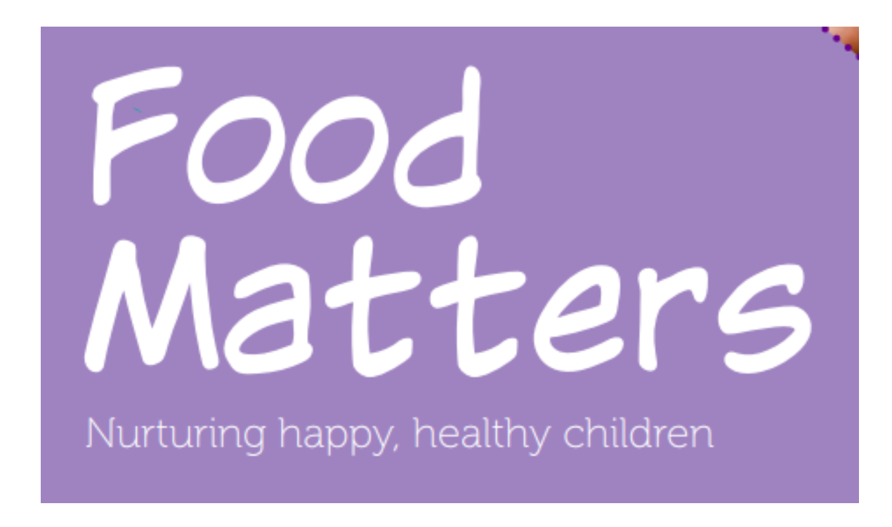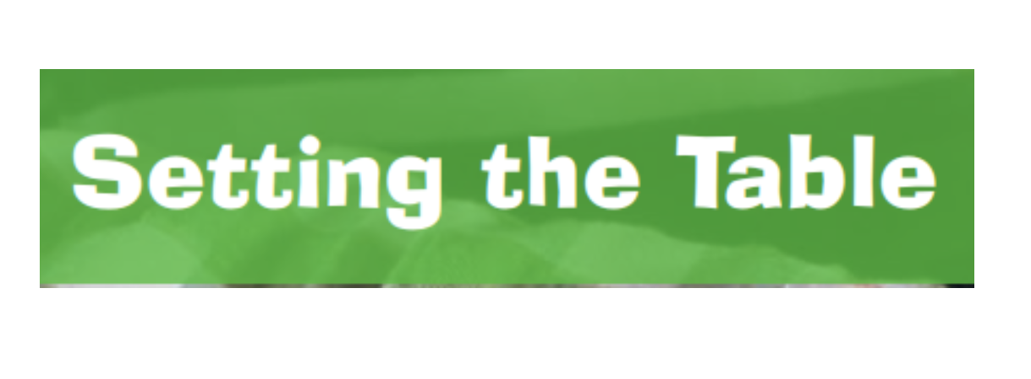
Food Matters Setting The Table
Click for links to these National Documents

Links to Curriculum for Excellence

Together we enjoy handling, tasting, talking and learning about different foods, discovering ways in which eating and drinking may help us to grow and keep healthy.
HWB 0-30a
I know that people need different kinds of food to keep them healthy. HWB 0-32a
I explore and discover where foods come from as I choose, prepare and taste different foods.
HWB 0-35a

Health and Social Care Standards
1.33 I can choose suitably presented and healthy meals and snacks, including fresh fruit and
vegetables and participate in menu planning.
1.35 I can enjoy unhurried snack and meal times in as relaxed an atmosphere as possible.
1.36 If I wish, I can share snacks and meals alongside other people using and working in the
service if appropriate.
1.38 If appropriate I can choose to make my own meals, snacks and drinks with support if I need
it, and can choose to grow cook and eat my own food where possible.
1.39 I can drink fresh water at all times.
2.21 I take part in daily routines, such as setting up activities and mealtimes, if this is what I want.

Snack Time
We promote, embrace and nurture healthy lifestyles in Maidenhill and therefore strive to ensure that all aspects of food and nutrition provision in the setting work to promote the health and wellbeing of children, families, visitors and staff. We aim to do this by:
- Encouraging children to make healthy choices about what they eat and drink and supporting them in adopting eating habits which will lead to lifelong health and well-being.
- Promoting the message to parents and staff the fact that healthier children learn more effectively.
- Having an impact on health related issues such as childhood obesity.
- Providing for a wide range of families from different cultures and ethnic backgrounds.
- Providing health awareness for all service users.
- Promoting breast feeding by providing facilities, information and support (see breast feeding policy).

Consultation with the Children
Children will work alongside staff to order snacks online and to prepare ‘menus’. They will be consulted on their choice of snack for each session using visual boards to support choice across a range. A variety of ‘healthy’ snacks will be on offer and children will be encouraged to select a carbohydrate and a piece of fruit or vegetable from the snack menu.
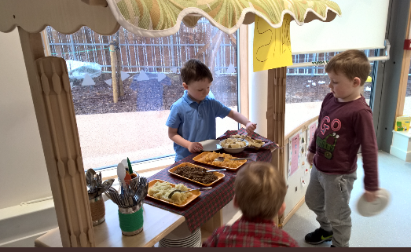

Snack Preparation
When preparing snack the children should be involved in the washing, cutting, serving and clearing up of snacks. Using the ‘serving hatch’ the children have the responsibility and ownership of preparing and serving snack to their friends. The children will have utensils, cutlery, chopping boards, bowls and jugs in order to develop the independence skills through preparing and serving their snacks to their peers and themselves.

When preparing and chopping fruit and vegetables, staff members will ensure that the children are using the ‘Setting the Table’ guidelines in order that fruits and vegetables do not become a choking hazard. The photos on the following page demonstrate how fruit and vegetable should be cut to ensure the children’s safety:

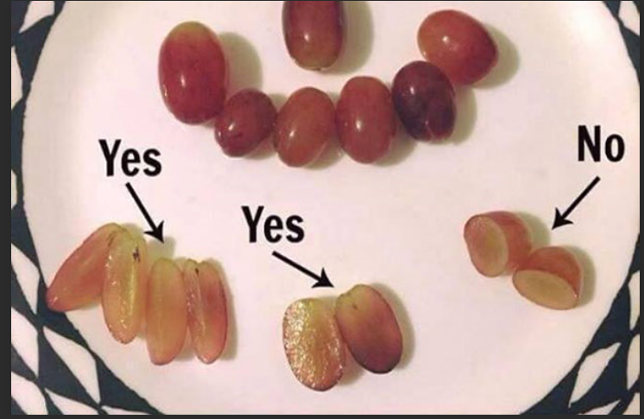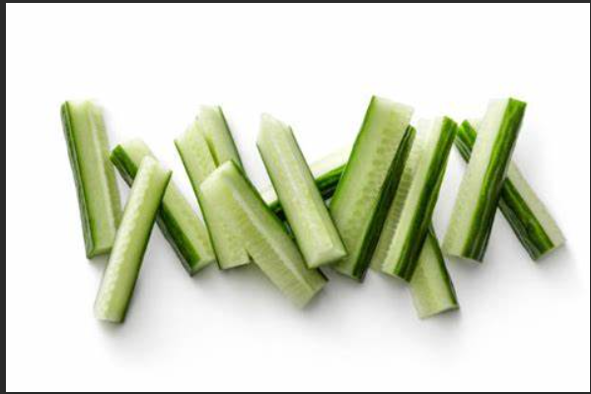
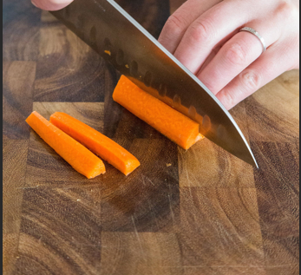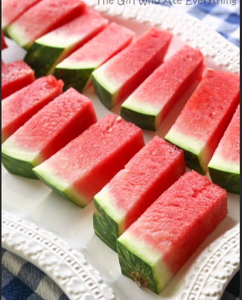

Outdoor Snack
Within the outdoor space of the nursery there is a snack table that can be used for children to eat their snack or lunch if they wish. Children must use the sinks in the creative area to wash their hands prior to eating snack outdoors. When the children have finished eating their snack/ lunch in the outdoor area staff must ensure that all food waste is cleared away fully to prevent attracting vermin.

Hand-Washing
Children and staff must always wash their hands, with warm water and soap, when coming over to the snack/lunch area, in a designated hand- washing sink. Children should dry their hands using the paper towels on offer and place the used paper towels in the recycling bins provided.

Self-Registration
When children come over to the snack area, they take the wooden spoon with their name on it to reserve their place at the table. When the child has finished their snack they should place their spoon in the ‘finished’ tub to show that they have has their snack.

Together we enjoy handling, tasting, talking and learning about different foods, discovering ways in
which eating and drinking may help us to grow and keep healthy. HWB 0-29a

Snack Experience
An area is provided for children to enjoy their snacks or lunch in a comfortable and social space in which the children can sit together to interact in a relaxed environment. Children will have the opportunity to serve themselves or their peers using the children’s serving hatch. China plates, bowls, glasses and metal cutlery are used to provide a ‘home-like experience’. Wipe-clean table cloths are used at both snack and lunchtimes and flowers are placed in the middle of the table. Milk and water are always on offer during snack times and are provided in glass milk bottles in the middle of the snack table. To enhance this experience a range of music can be played to provoke conversation with the children. At snack times adults can sit alongside the children, modelling appropriate eating habits but it is also vital that the children should be encouraged to lead their own snack experience, therefore adult involvement should be kept to a minimum.
The snack experience should be as relaxed as possible for the children and should not be rushed or hurried. The children should feel free to stay at the table and finish their food or drink in a way that is comfortable for them. Children’s awareness of when they are full up is respected; allowing them to make choices for themselves helps to develop this. However, it is important for staff to monitor how much food children have on their plate and how much they have eaten, to feedback to the parents on a daily basis.

Lunch Experience
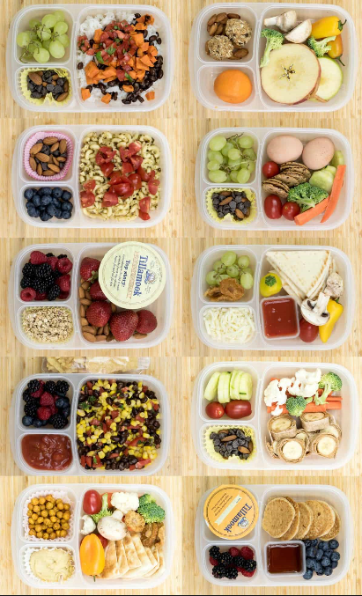
Children currently have a packed lunch provided for by their parents and each group has a box to put their packed lunches in at the beginning of the session. At lunchtime the children find a place at the table where they are comfortable and when they are ready they can collect their lunch boxes. Children are encouraged to place their food on the plates and keep their lunch boxes under their seat to prevent cross-contamination. Each lunch table will have a member of staff, who will sit at the table alongside the children, to support and encourage the children’s independence. Children have access to milk and water during lunchtime which will be available for the children to self-serve during their lunch. Lunchtime should be a social, relaxed occasion for the children and staff can promote this through calm conversations and a relaxing atmosphere.

Clearing up
Children are encouraged to help to clean up when they are finished snack and lunch in order to promote a sense of accountability. The nursery encourages an eco-friendly approach and therefore the children are aware of using the ‘food waste’ bin to put any food waste in and any other waste is appropriately disposed of in the correct recycling bin. The children then wash their plate and glass in the ‘dish-washing sink’ at the snack area and place it on the drying rack. When all children have finished their snack the staff member will put all the dishes in the dishwasher to ensure the high temperature cleaning of the children’s dishes. The table, chairs and surfaces are then to be cleaned using hot water and washing up liquid and anti-bacterial spray will only be used in the result of an outbreak of a contagious illness or infection within the nursery.

Allergies/ Dietary Requirements
Information regarding the children’s dietary requirements, allergies and intolerances will be attained at the child’s initial home visit and should be updated regularly. The child’s details will be added to the allergies/dietary requirement form and will be kept in the care information section of the filing cabinet in the nursery office. There will a copy of the allergy/intolerance sheet in the snack area that must be referred to by all. Staff or students who are completing snack must read this prior to the snack process. Any medication for the children’s allergies, such as piriton or Epi-pens will be kept in the medical fridge in the medical room of the school. Maidenhill Nursery Class is a nut and kiwi free nursery and parents are made aware of this during the initial home visit.

Tooth Brushing
During the children’s nursery session they will come together and brush their teeth using a fluoride toothpaste. The parents are offered this at their home visit and as the Child-smile programme is an ‘opt-out’, parents need to write a letter to the nursery or Child-smile Coordinator to say they do not wish their child to brush their teeth while at nursery. During tooth brushing sessions the children are made aware of the importance of oral hygiene and why we regularly brush our teeth.

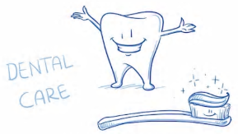

Breast- Feeding
Maidenhill Nursery Class is a breast-feeding friendly nursery and parents, visitors and staff should feel welcome to breast-feed their baby anywhere in the nursery. If they would prefer a private space the family room is available for use with comfortable seating and fresh drinking water provided. Breast-Feeding is promoted throughout the playroom and in the family room with information regarding the benefits to both Mother and Baby. Information about the local health team and breast-feeding support groups are also available on the welcome board and the family room wall.
(See Breast-Feeding Policy)

Monitoring and Review

The HT, DHT and SCDO will monitor this policy, engaging with relevant stakeholders and service users. The policy will be reviewed annually in August and updated as required.

Next review: August 2021

Policy author: D. Spence, March 2020

