Curricular Area | Tasks
Numeracy and Maths | Activity: Addition Impossible https://ec1.educationcity.com/content/index/25957/3/2/1/null/null/true/false/null/0//0  Activity: Addition Calculations Sheet (you can use number line to help)  Please copy and complete calculations using your yellow jotter. (If you don’t not have this you can use blank paper) Remember:  1 number in a box, miss a line when you move onto your next calculation.
Literacy and English | Activity: Correct the sentence punctuation. (Copy the sentence onto lined/blank paper)  Have a go at one sentence  Have a go at two sentences  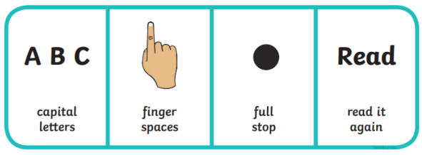  Have a go at all three sentences  Remember
Other Curricular Areas | Expressive Arts: Music  Interview your family members. Ask them what their favourite songs are. Listen to them together and have a dance party
Health and wellbeing
HWB: Physical Wellbeing
Joe Wicks: PE Live

Interview your family members. Ask them what their favourite songs are. Listen to them together and have a dance party

Spelling/phonics revision
Phonics Rule: sh
Practise formation remembering that ‘h’ is a tall letter
Can you think of 4 ‘sh’ words?
Have a go at writing these.
Common words: a, at, the
Practise these using rainbow writing
(These are for the whole week. We are not expecting these to be practised every day.)
Formation
Remember to complete letter and number formation daily using laminated sheet as a guide.
If you would like a paper copy you will find this on our class blog.
Primary 1A Daily Plan
Date: Tuesday 24th March 2020

