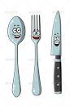  Sorting  Sort the cutlery at home into different sets.  Challenge: Have a go at ordering the cutlery according to size. | 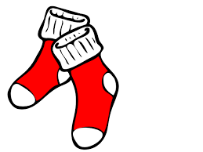  Matching  Match up pairs of socks.  Challenge: Can you count in twos while matching them? | 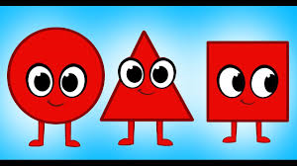  Shape  Find 5 objects at home which are circles.  Challenge: Can you find any other shapes?
Quantity  Can you find?  1 toothbrush  2 spoons  3 pegs  4 socks  5 books  Challenge: Can you do this for 6, 7, 8, 9, 10? | Pattern  Find a pattern in your house, e.g wallpaper, bricks etc.  Challenge: Can you make your own pattern? | 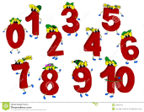  Number formation  Practice writing your numbers using the number rhymes.  Challenge: Can you make the numbers using different materials?
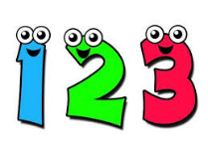  Finding Numbers  Find numbers in your house.  Challenge: Can you find numbers in the environment | Numbers in the Wider Environment  How many different places can you spy numbers?  Challenge: How many places can you find them in? | ICT Game  Play an ICT game of your choice using the Topmarks website.  https://www.topmarks.co.uk/  (We are working on Early Level)

