Rainbow Writing  Write your common words with coloured pencils, a different colour for each letter. | 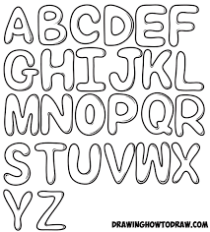  Bubble Writing  Write your common words using bubble writing. | Silly Sentences  Make up a silly senetnce using your common words. Share it with a grown up.  How many common words can you include?
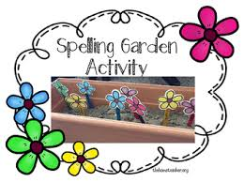  Garden Spelling  Use things you find in your garden/local park like sticks and stones to build you words. | Word Hunt  Read a book/magazine/newspaper with a grown up. How many of your common words can you find? | Typing  Use different fonts to type out your spelling words on a computer or tablet.
Chalk Writing  Use some chalk to write your spelling words outside. | Common Words in the Wider Environment  How many different places can you spy common words? | Make Your Own  Create your own activity to help learn your common words.

