Curricular Area | Tasks
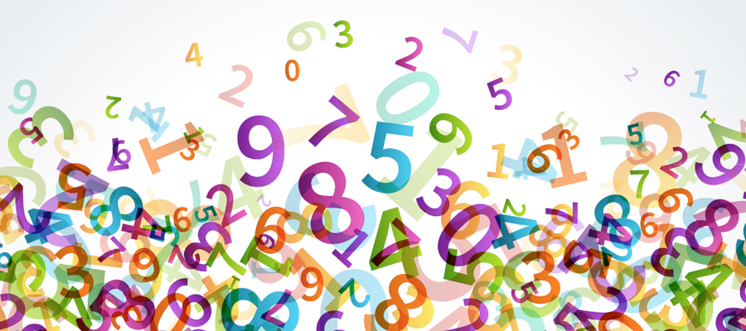  Numeracy and Maths | We are learning to identify halves.  Activity: http://www.snappymaths.com/counting/fractions/interactive/halfornotimm/halfornotimm.htm  Activity: Half not Half Sheet
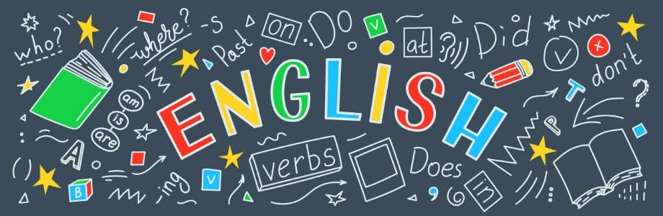  Literacy and English | Activity: Common Words Practise: Rainbow Writing  Practise the following Common words:  a at the  I in it  an is and  Pick two of these common words. Can you write a sentence with them?
Other Curricular Areas | HWB:  Listen to the book ‘Brave as can be: A Book of Courage’  https://www.youtube.com/watch?v=_i4L2mITBfE  Talk about a time when different family members felt scared or worried and they had to be brave. Brave when going for a job interview, going somewhere you didn’t know anyone etc) ‘What did you do to be brave?’ Learner should draw a picture of a time they were brave.
Primary 1A Daily Plan
Date: Monday 23rd March 2020

