Order It  Ask an adult for three items and put them in order from the shortest to longest. Then, ask for a different three items to put into order.  For an extra challenge, try to order five items.  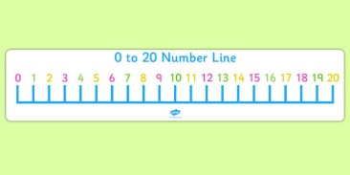 | Measure  Measure the length of five items. Use paper clips, coins, pens or something similar to measure the items. Line up the paper clips along the length of the item, then count the number of paper clips to see how long it is. Tell an adult what the longest item was and the shortest item was. | Creating Shapes  Can you create some of the shapes we have been learning about using everyday items in your house?  Eg. Can you make a square using pasta shapes  Challenge – Can you tell your homework helper how many sides/ corners it has?
Dice Numbers  Get six items such as beads, marbles or even small toys. Roll a dice then select that amount from your pile, e.g. if you roll a 4 on a dice, count out four items. Then put them back into the pile and roll again.  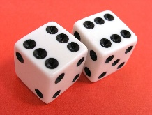  Challenge - Roll two dice and count the total number of dots before counting out your items. | Time  What types of clock do you have in your house? Analogue? Digital or both? Can you reads analogue and digital o’clock times (12 hour only)?  Practise naming the days of the week and months of the year. You might want to use these songs to help you:  Days of the week:  https://www.youtube.com/watch?v=spi77By9-iA  Months of the year:  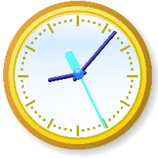  https://www.youtube.com/watch?v=omkuE6Wa5kQ | 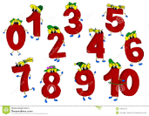  Number formation  Practise writing your numbers ensuring they are formed correctly. How high can you go?  Challenge - Have a go at writing your numbers in shaving foam or making your numbers using play doh.
Addition and Subtraction Challenge  Can you write some addition and subtraction calculations to challenge someone at home?  Remember you will need to know the answer to correct their answers at the end!  You might want to use a number line to help you. Here’s an interactive one you can use online: https://www.topmarks.co.uk/Flash.aspx?f=NumberLinev5  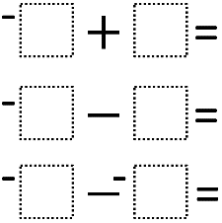 | Doubles  Can you recall your doubles to 10?  Challenge – Can you recall doubles to 20?  Here is a video that we have been singing in class.  https://www.youtube.com/watch?v=8jOzhiACB68  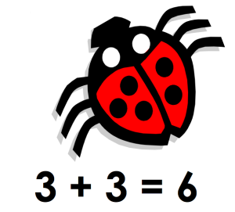 | ICT Game  Play an ICT addition game of your choice using the Topmarks website. Here are some examples of games we play in class:  http://www.ictgames.com/funkyMummy/index.html  https://www.topmarks.co.uk/Flash.aspx?f=PostSortingcalculationsv2

