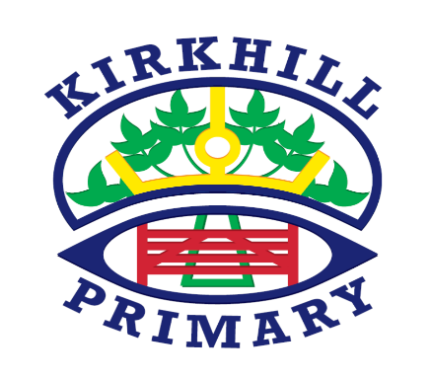

Literacy and English

* Consolidation of single sounds
* Digraphs
* Blending
* Reading – learning strategies to help us with unfamiliar words
* Having a go at writing sentences- using capital letters, full stops and finger spaces.

In Primary P1a in Kirkhill Primary skills, knowledge and understanding are developed through a range of teaching and learning opportunities. These include direct teaching, targeted group time and tailored learning areas in the classroom and outdoor environment.

UNCRC Articles

* I have the right to an education. Article 28
* I have the right to relax and play. Article 31

How you can help at home and opportunities for personal achievement

* Letter and number formation
* Sharing a story and discussing what you have read (Did you enjoy the story? Why? What was your favourite part? Who was your favourite character?)

Numeracy and Mathematics

* Doubles
* Subtraction using concrete materials
* Time
* 3D Shape and Data handling

Other Contexts

* IDL –Mythical Creatures
* Science –Sun, Moon and Stars
* French – colours and alphabet
* RME – Chinese New Year, Easter

Ethos and Life of the School

* Lining up quietly in the correct order
* Walking to the left
* Manners
* Expectations within the classroom

Health and Wellbeing

* Bounce Back
* Gymnastics and Rebound games

Skills for learning, life and work

* Good listening skills
* Personal organisation