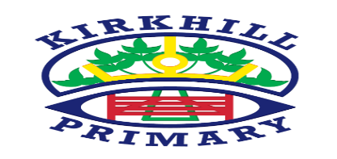

Numeracy and Mathematics

* Daily Numeracy and Mathematics inputs with a focus on number and number processes, mental maths and problem solving.
* Money – totalling amounts, calculating change.
* Volume

How you can help at home and opportunities for personal achievement

* Mental maths revision
* Practise tricky words and spelling rules.
* Reading regularly with your child a variety of texts.
* Using money in a real life context

Literacy and English

* Spelling and Handwriting – North Lanarkshire approach
* Writing – Functional (Instructions), Personal, Poetry
* Reading – Big Cat Scheme, Higher Order Questioning Skills
* Talking and Listening – Presentation and group sharing.
* French – Classroom Language, Revision and Units 13-14 – food and eating

Health and Wellbeing

* PE – Two periods of outdoor and one period of indoor, with a focus on Rebound Games and Gymnastics.
* Mental/Social and Emotional Wellbeing – Bounceback programme and mindfulness.
* Exploring school values

UNCRC Articles

* Article 28

You have the right to a good quality education. You should be encouraged to go to school to the highest level you can.

* Article 31

You have the right to play and to relax

Other Contexts

* Class topic of Weather and Climate.
* Expressive Arts – Music/Art and Design/Drama – Super skills on a Friday
* Science – Senses
* RME – Christian Stories and World Religions
* Technologies – ICT – coding, Power point

In Primary 2A in Kirkhill Primary skills, knowledge and understanding are developed through a range of teaching and learning opportunities. These include direct teaching, targeted group time and tailored learning areas in the classroom and outdoor environment.

Ethos and Life of the School

* Daily routines – lining up in order and staying on the left hand side of the corridor.
* Manners and morning greetings
* Positive behaviour strategies

Skills for learning, life and work

* Taking turns
* Sharing with others
* Personal organisational skills