Curricular Area | Tasks
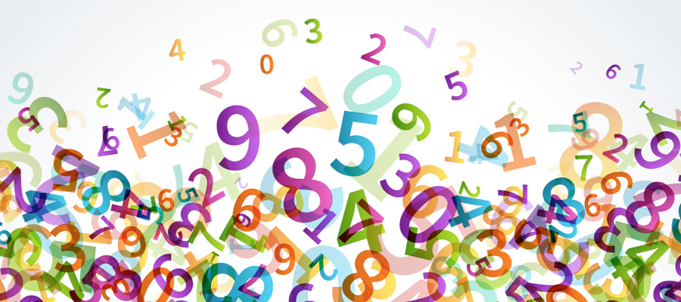  Numeracy and Maths | Log on to:  https://www.topmarks.co.uk/maths-games/subtraction-grids  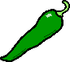  Up to 10  Up to 20  Up to 30  Angles revision - T.J. page 64 and 65
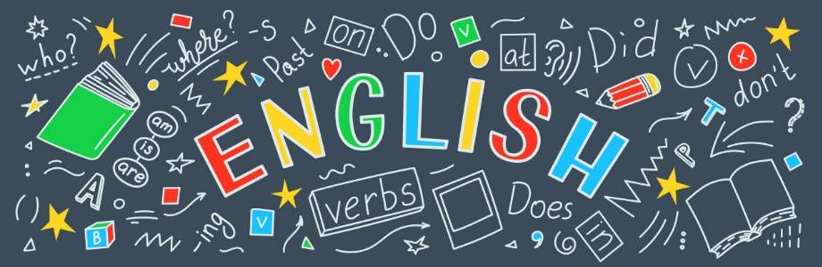  Literacy and English | Handwriting Unit 12  Practise the second join: ink, unk and complete the workbook pages in your jotter or a piece of paper.  The Owl who was Afraid of the Dark  Choose a Literacy task from the owl task board. Continue reading chapter 3.
I.C.T. | I.C.T. Dance Mat Typing  Continue to practise touch typing Level 1. Try to complete Level 1 Stage 2 today.  https://toybox.tools.bbc.co.uk/activities/id/activity-dance-mat-typing/exitGameUrl/http%3A%2F%2Fwww.bbc.co.uk%2Fguides%2Fz3c6tfr
Health and Wellbeing
Design your own soap bottle. Think about making your bottle eye-catching. What scent is your soap? Use your imagination!
Upload your creations onto Seesaw for us to see.
Primary 3b.2 Daily Plan
Date: Thursday 23rd April 2020

Spelling/phonics revision
ea sound
bread head deaf ready dead
wealth instead pleasant pheasant weather feather
Common Words
learn children because earth

Skills Development
Continue to help someone in your house with the laundry. You could pair the socks.

