Curricular Area | Tasks
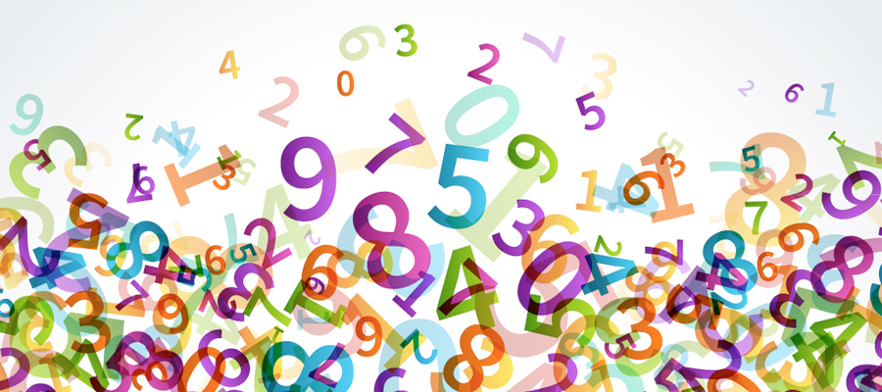  Numeracy and Maths | Today we will do some mental maths.  The questions are on Seesaw and on Glow. Please ask an adult to read them out to you. You can let me know how you get on.  Jack Hartman mental maths:  https://www.youtube.com/watch?v=3txlaYTye (count to 100)  https://www.youtube.com/watch?v=wMfAtlz-WJE (count in 2s)
Literacy and English | Comprehension  Today our focus is on sequencing.  Please read the passage ‘A Clean Weekend’ twice.  Then try out the practice page with an adult and have a go at ‘On your own’.  Write your answers on some paper or the jotter I gave you on the last day of school.
Skills Development | Set the table for breakfast, dinner and lunch and help your adult to clear, tidy and wash the table / eating area.
Health and wellbeing
Let’s get fit with Joe! You can tune in live at 9am to Joe Wicks on his YouTube channel: The Body Coach TV, or access his workouts through his YouTube channel later in the day.
Or if you fancy a dance lesson, join Oti Mabuse at 11.30 am for a dance class with a Disney theme. You will need your parent to log in to their facebook account if they have one and type in Oti Mabuse.

Primary 3b.2 Daily Plan
Date: Wednesday 25th March 2020

Spelling/phonics revision
Rule: tch

Words: match ditch patch witch stitch catch hatch snatch scratch kitchen

Backwards Writing
Write your spelling words forwards and then backwards. (e.g. match hctam)

