**Problem Solving Strategies**

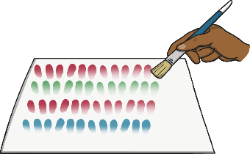

Make a table.

Use concrete objects.

Draw a picture or diagram.

Use a number sentence.

Find a pattern.

Guess, check and revise.



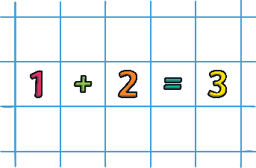

Words backwards.



Read the question twice.

Use logical reasoning.

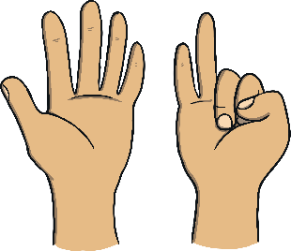

Count out loud.

Use your fingers.