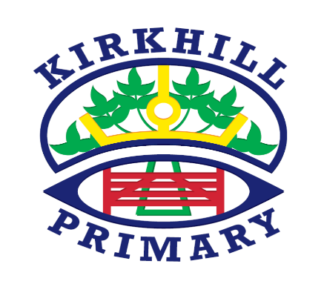

**How you can help at home and opportunities for personal achievement**

* Explore 2D shapes in your local environment.
* Work with money at home, counting coins, how can I make 70p etc
* Discuss the food chain of the food you eat at home.

**Literacy and English**

* Spelling – Frequent phonics practise – focusing on key sounds each week.
* Writing – Creating imaginative pieces focussing on punctuation.
* Reading skills targets— visualising, identifying the main idea and inference.
* Grammar targets — adjectives and self-editing.
* Novel Study – Fantastic Mr Fox

In Primary 3 in Kirkhill Primary skills, knowledge and understanding are developed through a range of teaching and learning opportunities. These include direct teaching, targeted group time and tailored learning areas in the classroom and outdoor environment.

**UNCRC Articles**

* Article 29 (goals of education) Education must develop every child’s personality, talents and abilities to the full. It must encourage the child’s respect for human rights, as well as respect for their parents, their own and other cultures, and the environment.

**Ethos and Life of the School**

* Meet the Teacher – 5th of September 6pm-7pm
* Numeracy & Mathematics Curricular Evening 6pm-7pm
* Parents Evening – 13th & 14th of November
* Open Classrooms – 29th of November
* Christmas Party – 19th of December

**Other Contexts**

* **Science** – Food Chains/Germs
* **R.M.E** – Places of Worship/Prayer and Worship
* **Social Science** – Plastic Warriors
* **Technology** – Craft, design, engineering and graphics

**Numeracy and Mathematics**

* Properties of 2D shape
* Money
* Shapes Patterns and Relationships
* Estimation and Rounding
* Measurement
* Number Processes

**Health and Wellbeing**

* Fitness
* Striking and Fielding
* Resilience
* Outdoor Learning

**Skills for learning, life and work**

* Enterprise Topic - Plastic Warriors