Monday 20th May 2019
(Homework due Friday 31st May 2019)
P2b Homework

Curriculum Area | Task | Traffic Light  & Signature
Topic | Our 2 week project task is to learn about an Egyptian Sarcophagus.  Please make a model Sarcophagus to bring into class. You could use a shoebox, Lego, card, Papier-mâché or whatever materials you choose.  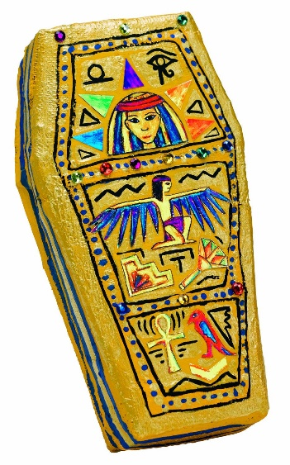  Remember to decorate it.  Here are some examples of models -  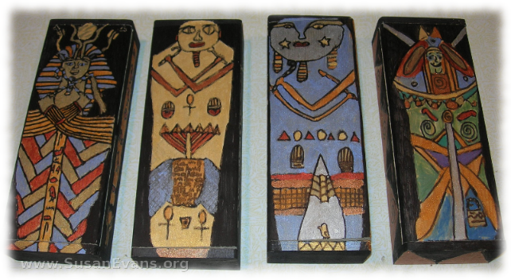  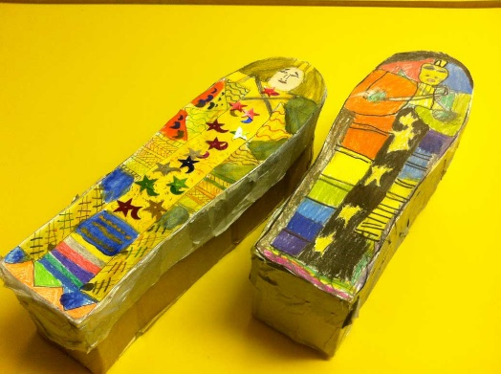 | Topic

