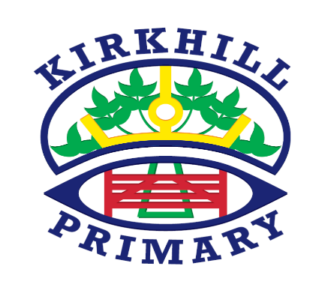

**How you can help at home and opportunities for personal achievement**

* Regularly ask your child to tell the time.
* Discuss facts and opinions at home, help your child to articulate their opinions.
* Discuss what your favourite memories from the 80‘s were.

**Literacy and English**

* Spelling – Frequent phonics practise – focusing on key sounds each week. Please check homework jotters for assessment updates.
* Writing/Grammar – Focusing on key skills such as capital letters and full stops. Working towards becoming more independent in writing tasks and continuing to self-edit.
* Reading skills targets— sequencing, fact & opinion and cause & effect.

* Novel Study – George’s Marvellous Medicine.

In Primary 3 in Kirkhill Primary skills, knowledge and understanding are developed through a range of teaching and learning opportunities. These include direct teaching, targeted group time and tailored learning areas in the classroom and outdoor environment.

**UNCRC Articles**

* Article 29 (goals of education) Education must develop every child’s personality, talents and abilities to the full. It must encourage the child’s respect for human rights, as well as respect for their parents, their own and other cultures, and the environment.

**Ethos and Life of the School**

* 28th Jan – nurse visit to P3 to discuss healthy eating and lifestyle.
* 6th March – p3a.1 9.30am class assembly
* 6th March – p3a.2 11.30am class assembly
* 1st April – last day of term

**Other Contexts**

* **Science** – Friday Science Swaps
* **R.M.E** – Welcoming a baby
* **Social Science** – The 1980’s
* **Technology** – Coding

**Numeracy and Mathematics**

* Multiplication and Division
* Right angles
* Symmetry
* Time – quarter past/to
* Number Processes
* Mental agility

**Health and Wellbeing**

* Fitness
* Healthy Eating
* Bounce Back
* Being ready, respectful and safe.

**Skills for learning, life and work**

Healthy eating and lifestyle for a lifelong understanding of good health.

