Mild Spelling Task – Follow the instructions on the Focus Resource sheet. Answers will be posted at 3pm. Have fun!

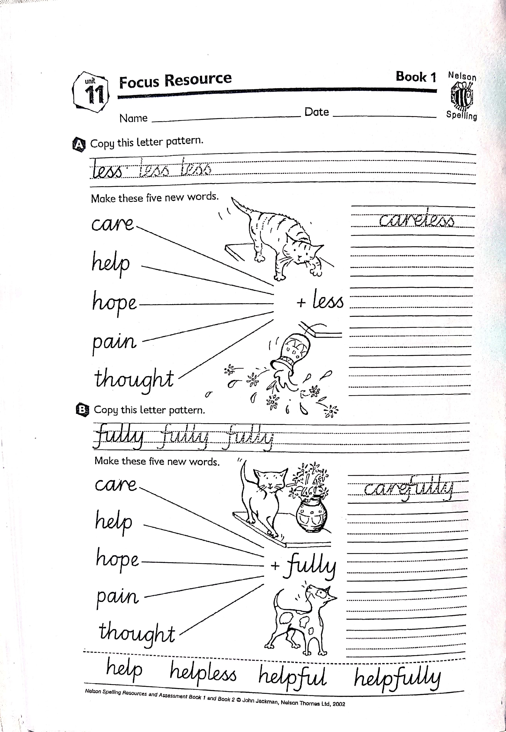

helpfully

hopefully

painfully

thoughtfully

Self - check

helpless

hopeless

painless

thoughtless

Self - check

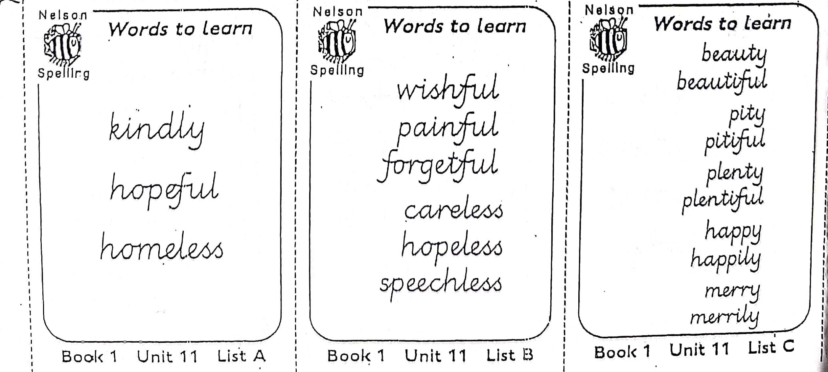

Self-check the Hot task. Did you remember to change the y to i for the root words in List C?

Hot Spelling Task – Can you think of more words with the spelling pattern for this week? Look at the root words on List C – what does the y change to when -ful is added?

Extra Hot Spelling Task – Follow the instructions on the Extension Resource sheet. Answers will be posted at 3pm. Have fun!

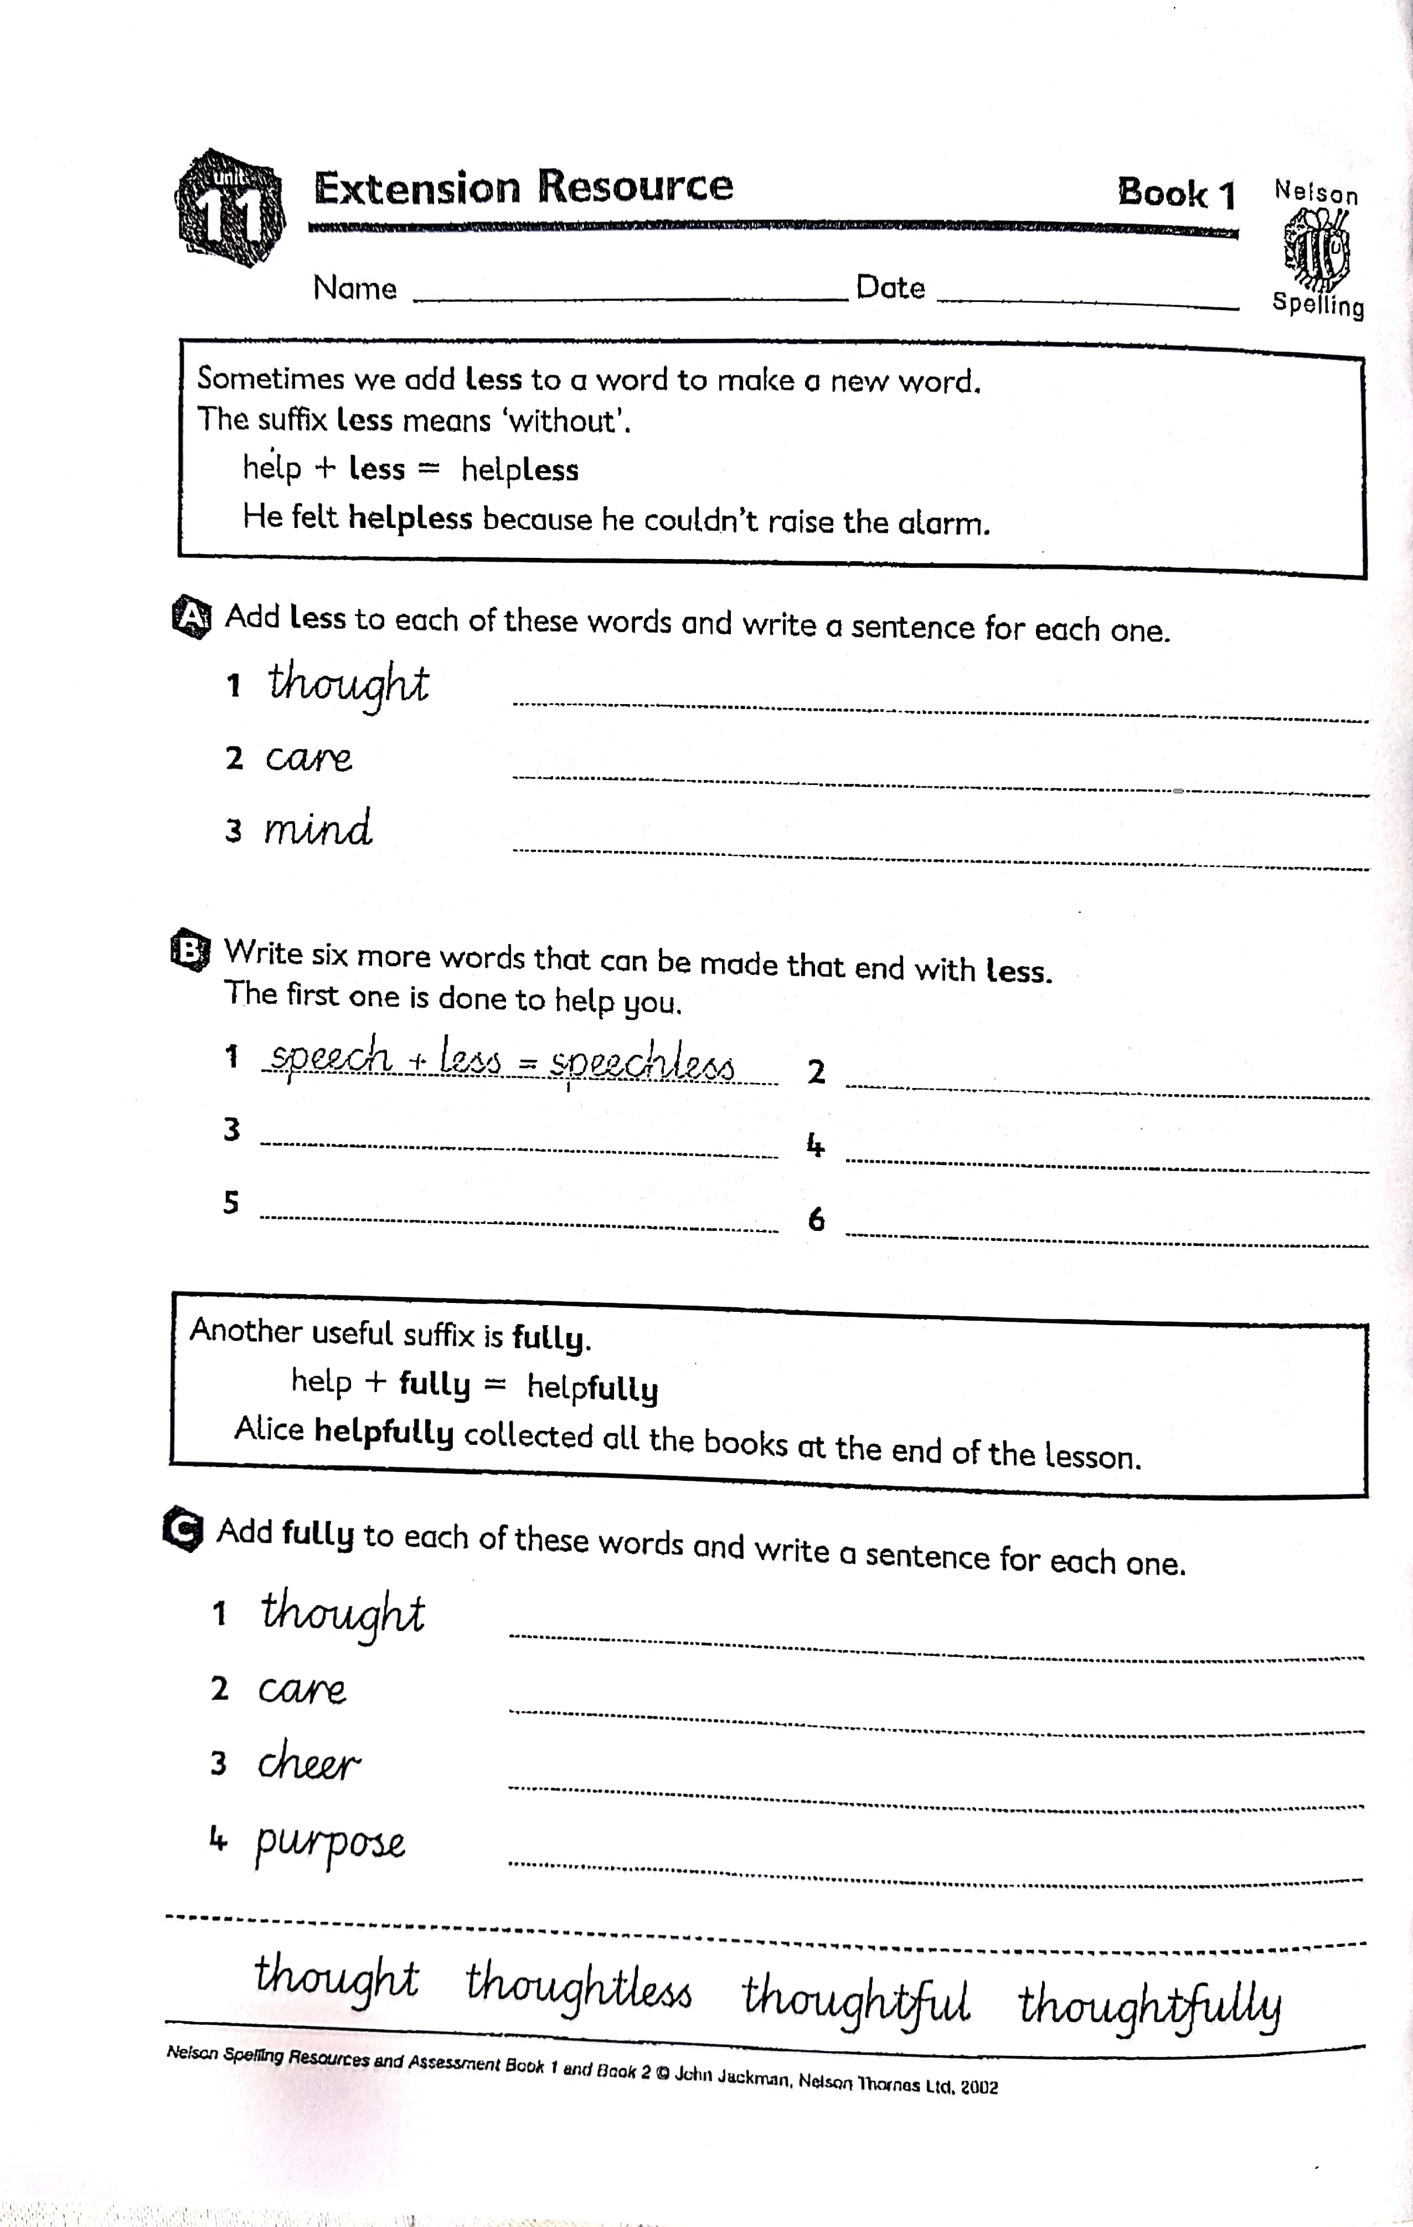

Self-check your words in a dictionary

thoughtfully

carefully

cheerfully

purposefully

thoughtless

careless

mindless