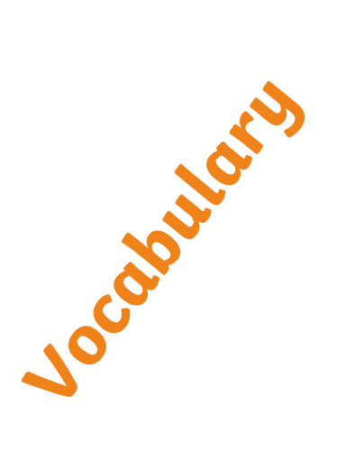
so
because
first lonely
afraid exciting
interesting next
beautiful adventure accident worst awful magic enormous fierce
gigantic weird bravely freezing baggage sadness joy shelter fear quietly companion silently happiness
thunderous fearful marvellous patiently echo attractive nervously worriedly furnishings generously experience container wasteland courage peak robe
sensitively timidly aggressively imaginatively unfortunate murderous echoing doubtful emotion anxiety longing progress system communication ingredient vibrations prefer nourish
outstanding/ly pathetic stern speculation tender/ly biological/ly formidable outspoken comical dine create adore forbidding yearning silhouette terrain apparel vision atmosphere


The...
My... I...
First... Then... If... Next... Last... When Because... Also... Last time... After... Another thing... Soon...
Although... Before... Afterwards Sometimes... Eventually ... After a while... often... Another thing...
Never… always… besides... even though/if… before... meanwhile… before very long… however… in addition… despite… an important thing… we always… if/the… I felt as… I discovered… having decided… I actually... due to… as time went…
Use complex sentences appropriately.
Vary sentence length and word order to keep the reader interested.

and
and but if so because when
Before even though after although while as well as
In spite of despite provided until once since
Use complex sentences appropriately.
Vary sentence length and word order to keep the reader interested.


.
. ? !
. ? , !
. ? , ! … ‘ “
. ? , ! …‘ “ : ; () -

