Numeracy | Science | Literacy
Find out simple number facts about the Titanic, for example:  • How many passengers were on board?  • How long was the ship?  • How many people survived?  • How many funnels did the Titanic have? | 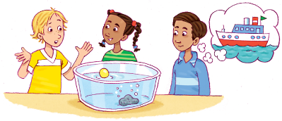  Explore sinking and floating. Use materials around the house to invent something that will allow a £1 coin to float. | Write an acrostic poem or a short story about the Titanic.
Literacy | Two Week Homework  The Titanic – Try to complete 2 or 3 of these tasks. Be ready to tell the class about the tasks you completed on the 14th February.  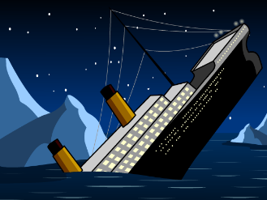 | Social Studies
Find an interesting Titanic website or book and show it to the class. Write down at least 3 facts you learned from it. Think of an interesting way to display these facts. |  |   Find out what sort of jobs people have on cruise liners today.
Art and Design | Art and Design | Art and Design
Create a collage of the Titanic. | Search for images of the wreck of the Titanic and use these to draw a picture of the wreckage. | Design a ticket to board RMS Titanic. Can you find out how much a ticket would cost different classes of passenger?

Parent/Carer signature______________________________________________
Comment

