Word Problems

1. A jug of water contains 1000 ml of liquid
- If I drink 250ml, how much water is left in the jug?
- If I then drink another 200ml, how much water is left in the jug at the end?

2. Tulips are sold in bunches of 5. Chris buys 30 tulips. How many bunches does he buy?

3. Iona picks 3 flowers a day starting on Monday. How many does she have by Sunday?

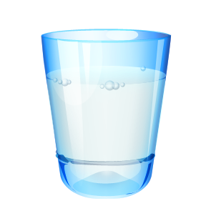
4. A waitress has to count the total number of glasses in a restaurant. There are 5 boxes with 9 glasses in each. She notices that 8 glasses are broken. How many are there to use in the restaurant?
5. A bag of potatoes weighs 32kg and a bag of onions weighs 25kg. What is their total weight in grams?

6. A tube of Smarties costs 27p, a bar of Dairy Milk is 64p more expensive. How much is a bar of Dairy Milk?
7. I swam for 50 minutes and had a break. I wanted to swim for 1 hour and 20 minutes. How much longer do I have to swim for?

8. Ben saves 1p coins in a jar. At the end of the month, Ben’s job is to sort them into bags of 50. This month, the jar had 300 coins in it. How many bags did he fill?
9. My shampoo bottle holds 400ml of shampoo. If I use 20ml each time I wash my hair, how many washes will I get from the bottle?

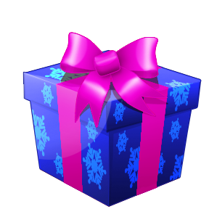
10. For Christmas, Taylor receives 20 boxes with 1 present in each one for Christmas. He decides to be generous and shares them equally with his 9 family members. How many presents does each person get?

