LI: To calculate the perimeter of shapes using doubling and adding
Find out what the perimeter and the areas are of each room.
8m
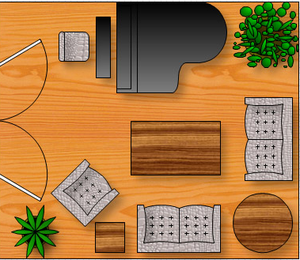
2.
3.
6m
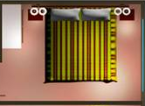
1.
9m
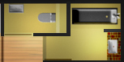
4m
3m
3m

4.
5.
6.
4m
5m
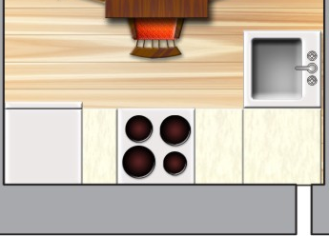
12m
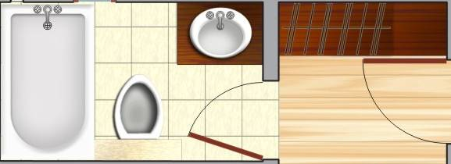
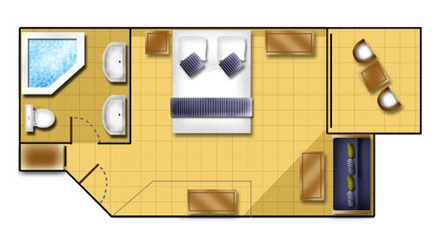

3m
2m
4m

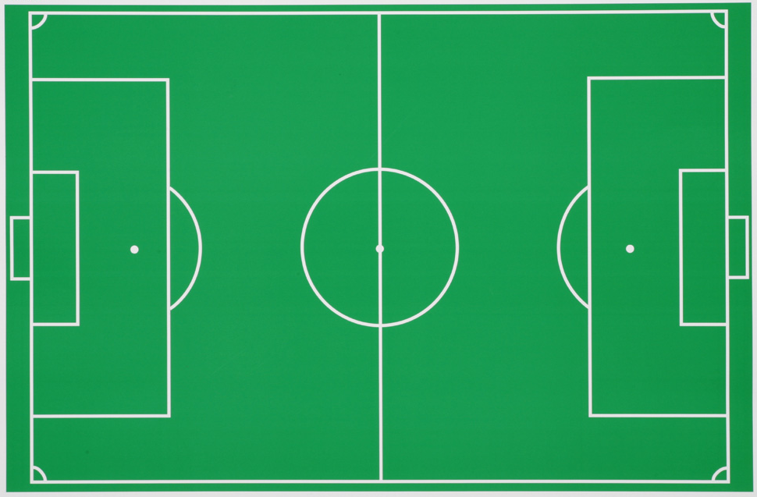
9m
26m
10m

7.
8.

8m

NOW: Measure 2 sides of these rectangles with a ruler and then calculate the perimeter and area of them.
9.
10.

11.
12
.

