Curricular Area | Tasks
Numeracy and Maths | Maths:  Task 1: 5 a day worksheet  Task 2: Emoji problem: can you solve the missing numbers?!  Task 3: choose a topic on Sumdog and play for 20 minutes.
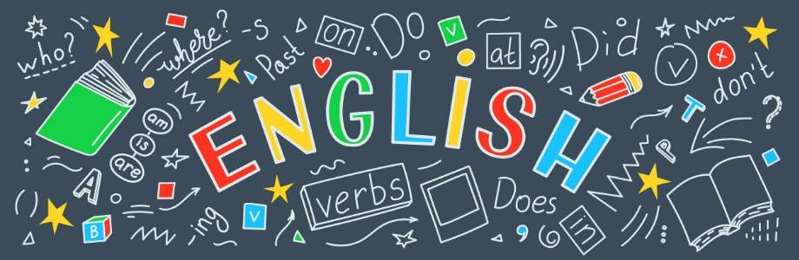  Literacy and English | Literacy:  First News: Read and answer the Look Closer comprehension questions  Check your answers when you have finished
Other Curricular Areas | Family Challenge: Music task  See: Out of the Ark! document
Health and wellbeing
Log in at 9am for Joe Wicks the body coach or Super Movers.
https://www.youtube.com/thebodycoach1
www.bbc.co.uk/supermovers

Primary 5 Daily Plan
Date: Wednesday 10th June 2020

Spelling/phonics revision
Rule: Homophones
Words: flour, flower, allowed, aloud, bored, board
new, knew, there, their, they’re
Be, bee, one, won, to, too

Skills Development
How responsible are you?
Can you:
- make your bed
- tidy your room
- help hang up the washing
- fold and put away clothes
- hoover or brush floors

