Social studies: Geography
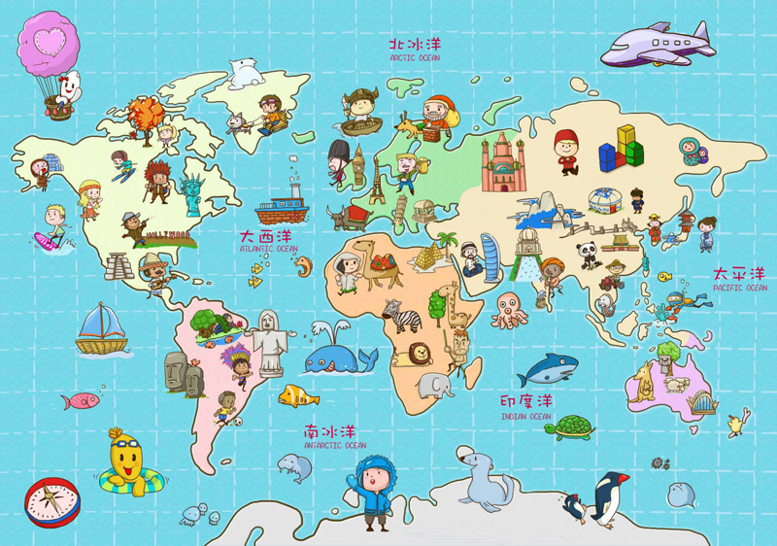
Task: Create a poster or fact file on a country you have never been to.
Research/Ideas to include:
- Country flag colour and design?
- The name of the capital city?
- Population of the country?
- Longest river in country?
- Highest mountain in country?
- Size of your country?
- Other countries that share a border with your chosen country?
- Seas/oceans that surround your chosen country etc?
- National animal of that country?
- What is the weather like? Temperature?
- Languages spoken?
- Any special cultures/ traditions? Dress?
- What are typical foods and drinks found here?
You do not have to use all of these bullet points: enjoy this activity- use lots of colour and pictures.
It can be hand drawn on paper and uploaded to Seesaw or you could type it and insert online pictures. (always ask an adult when researching websites online to make sure you are staying safe and using credible sources).
We’re looking forward to seeing what country you choose to research!

