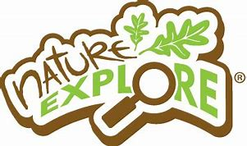
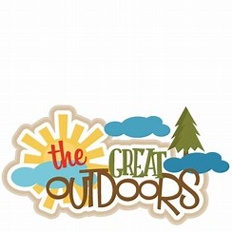
Health and Wellbeing 2
Nature Outdoor Walk and Art

This week your challenge is to look at nature, during one of your exercise days out of doors. You are asked to walk and to take a pencil, clipboard, or something to lean on, and paper to draw “something interesting” that you spot on route. You can make good use of some of your senses too. You might even take a photo. I have also enclosed two worksheet which may help, if required.
There is a lot more scientific research which highlights the advantages of getting outside - whether it be in a forest, a garden, a park or just walking around the streets where you live.
Nature and the outdoors enable us to improve ourselves -
- physical and mental health can be enhanced
- lowers blood pressure
- relieves some depression and anxiety issues
- helps us to relax
- helps us to be a happier person
- helps us to talk
Drawing and creating your own art can be beneficial too -
- calms a troubled mind
- help someone who has been ill to recuperate
For children especially it can help -
- creative development
- communication of their thoughts
- development of gross/fine motor skills
- concentration
- imagination
- improves social skills
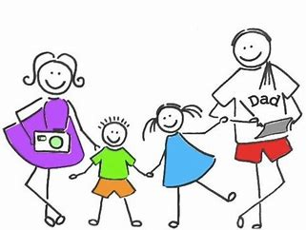
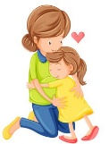
Enjoy getting out there and having fun with your family.

