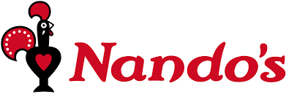

**Mild Challenge**

1. 1. Hello can I book a table please for 2 people. We’re going to leave the house at about 6.30pm and it will take 30 minutes to get to you. **What time will you reserve the table for?**

2. To start we would like 1x Halloumi sticks & dip. **How much is that?**

3. To drink, we would like 1x Diet coke and 1x Fanta. **How much will that be?**

4. For our main courses we would like, 1x Butterfly burger with 2+ reg sides and 1x grilled chicken with 2+ reg sides. **How much will that be altogether?**

5. We are on a tight budget. **What is cheaper: 1x whole chicken or 10 chicken wings?**

6a) **You have £20**. List what you would order if you went to Nandos. (Don’t forget to add up the prices to make sure you have enough)

b) Do you have any change?

**Mild Challenge**

1. 1. Hello can I book a table please for 2 people. We’re going to leave the house at about 6.30pm and it will take 30 minutes to get to you. **What time will you reserve the table for?**

2. To start we would like 1x Halloumi sticks & dip. **How much is that?**

3. To drink, we would like 1x Diet coke and 1x Fanta. **How much will that be?**

4. For our main courses we would like, 1x Butterfly burger with 2+ reg sides and 1x grilled chicken with 2+ reg sides. **How much will that be altogether?**

5. We are on a tight budget. **What is cheaper: 1x whole chicken or 10 chicken wings?**

6a) **You have £20**. List what you would order if you went to Nandos. (Don’t forget to add up the prices to make sure you have enough)

b) Do you have any change?